Shared Archive For Evidence

SAFE Reference manual for General Users
Version 10.26.2017

The purpose of this reference manual is to be an assistance to the most basic users of
the system. It is not intended to be an all encompassing manual used by system administrators. If you are tasked with training users with limited add only access or you are a person using the system to add items and print basic forms, then this is the manual for you!

Important! Because of the customization that is available to your agency, the screen shots and explanations covered in this guide may not be exactly what you will see when using your system. We did not design this guide to cover a specific user but to help all users. With this in mind, the guide you are reading in its current format should be a great resource for assisting you learning the software.
Table of Contents
Logging into the software (Shared Archive For Evidence) 4
Can the software store my Password? 4
Authenticating / Forgot Password? / Password RESET 5
Creating a shortcut on your desktop 7
Dashboard and Quick Menu 8
Creating a Case 9
Creating a Person 14
Adding a Person to a Case (from the Case View) 18
Creating an Item 21
Searching for a Case(s) 25
Cases found from a Search 29
Search \ Case \ Basic Info Tab 30
Search \ Case \ Persons Tab 31
Search \ Case \ Items Tab 31
Search \ Case \ Items Tab \ Actions Box 32
Viewing an Item 33
Checking an Item In 34
Checking an Item Out 35
Moving an Item 36
Moving an Item from one Office or Org. to another 37
Transferring Items 37
Disposition of Items 38
Undispose an Item 39
Duplicating Items 40
Splitting Items 40
Mass Update on Multiple Items 42
Adding an Item to a Case 43
Removing an Item From a Case 44
Changing the Primary Case 44
Search \ Case \ Items Tab \ Reports Box 45
Search \ Case \ Items Tab \ Reports Box \ Persons 45
Search \ Case \ Items Tab \ Export Box 46
Search \ Case \ Items Tab \ Options Box 47
Search \ Case \ Media Tab 48
Search \ Case \ Notes Tab 51
Search \ Case \ History Tab 52
Viewing Recent Cases 53
Searching for Items 54
Items Found from a Search - All Items 59
Items Found from a Search - Individual Items 60
Editing an Item and Manage Cases 63
Running a Report and Printing an Item Label 64
Search \ Item View \ Item \ Cases Tab 65
Search \ Item View \ Item \ Media Tab 65
Search \ Item View \ Item \ Notes Tab 67
Search \ Item View \ Item \ Tasks Tab 67
Search \ Item View \ Item \ Chain of Custody Tab 68
Search \ Item View \ Item \ Scan History Tab 68
Search \ Item View \ Item \ History Tab 69
Searching for People 70
People found from a Search 73
Searching for Disposals 74
Searching for Check Ins 76
Searching for Check Outs 78
Searching for Moves 80
Searching for Transfers 82
Searching for Notes 84
Searching for Media 86
Searching for Tasks 89
Searching for Exported Searches 91
Using Quick Search 91
Dashboard Icon and Creating Widgets 92
Deleting Saved Searches 97
Scan Icon 99
Scanning Items from another Office or Organization 100
Tasks 101
Typical Scenario: 101
Tasks Menu Option 101
Creating a Task 102
User Groups 103
Adding a Case, Person or Item from Menu 103
Viewing a Task 105
Task Email 106
Task email with more details 107
Edit a Task 107
Closing or Opening a Task 107
Task Security 108
Task Search 108
View a Task from with a Case, Person or Item view 110
Task Stream 110
Discrepancy Reports 111
User Settings and Multi-Factor Authentication 113
Collapsing the Quick Menu 114
Logging Out of the software (Shared Archive For Evidence) 115

Help Files For General Users (Add Item only status)

Logging into the software (Shared Archive For Evidence)
Logging into the software is as simple as opening your browser of choice and typing in your site link. Your network or organization administrator can provide this link. If this link is entered correctly, you will see a login page like the screen below. Enter your Email and Password to log into the system. If you see anything other than this login screen, you will need to contact your system administrator for assistance.

United States: https://secure.trackerproducts.com

Asia Pacific: https://apac.trackerproducts.com

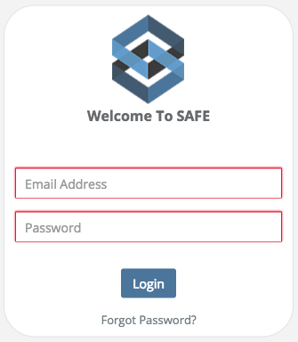

Can the software store my Password?
Saving Names and Passwords is NOT a feature of the software for obvious security reasons. Instead, this is a function of the web browser you are using. When any web browser asks if you would like to save your Name and Password, select No. If you have inadvertently saved your Name and Password, tell your Administrator immediately. They can delete the saved Name and Password and clear the web browser’s cache.

Authenticating / Forgot Password? / Password RESET
This is the initial email you will be sent before logging into the software for the first time.
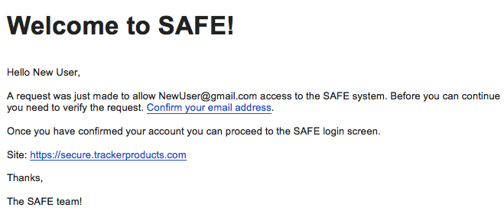
Once you receive this email:
1. Click the option to Confirm your email address.
2. Login with the Username and Password provided right below the confirmation.

This is the screen that will be shown after you verify your email address.
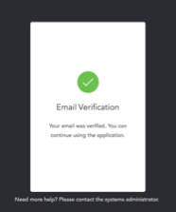

If you change your email address for any reason in the software, this will be the confirmation email.
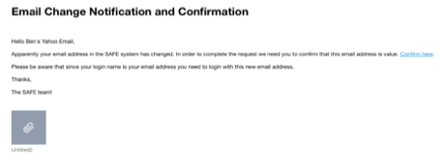
If you entered an incorrect name or password, the software will let you know that your “user name or password is incorrect”. If you have forgotten or wish to Reset your Password, CLICK THE WORDS “Forgot Password?”. Selecting this option will send you to the Password Reset page. After entering your email address and clicking the “Reset Password” box, an email with directions will be sent to you to reset your password.

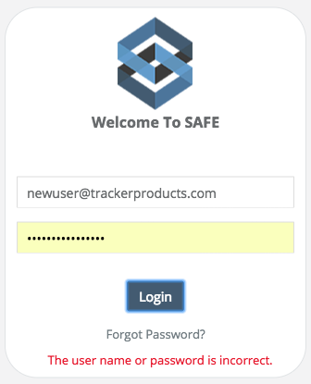
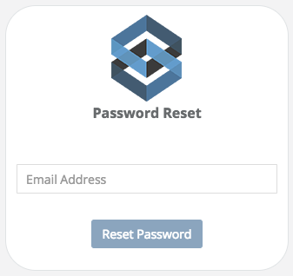

After entering your Email Address, this screen will be shown.

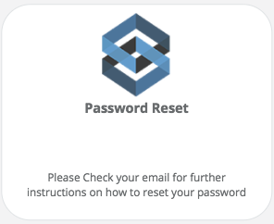

Once you receive the Password Change Request email, click the words “reset password” and you will be taken to the Password Reset page.
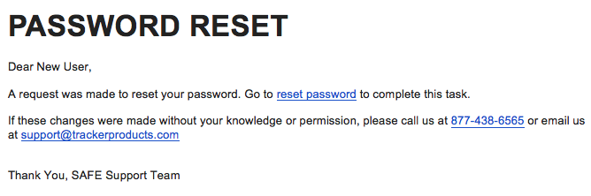
At the Password Reset page, the software requires each user to have a unique username and password that must be entered each time a user logs on. Password strength parameters are enforced by the application and include: Password lengths of 10-128 characters, passwords cannot contain 2 identical characters in a row, must contain at least 3 character types out of 4 (upper case, lower case, numbers, and special characters), and passwords cannot be “reused” for one year. In addition, accounts are locked after 5 failed login attempts for a duration of 10 minutes or until they’re unlocked by an administrator.

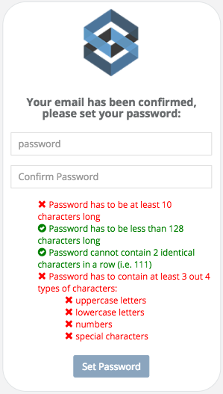
Failed Login example:
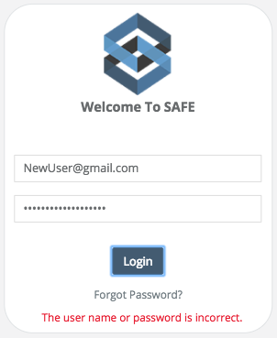

Upon successful new password entry and verification, you will be taken to a screen that says as much and you will then be able to log into the software.

Creating a shortcut on your desktop
The most efficient way to use the software is to create a desktop shortcut as follows:

Microsoft Windows
1. In Microsoft Windows, minimize all the programs that are open on your desktop.
2. Right click on an open spot on your desktop.
3. Select New.
4. Select Shortcut.
5. Enter your software link into the location box.
6. Click next when done.
7. This screen should contain the name for the link.
8. Click finish and test your icon.

Apple Mac
1.On a Mac, Launch the Safari Web browser on your Mac OS X system.
2.Navigate to the first page to which you want to create a shortcut.
3.Select the entire address in the address bar at the top of the browser.
4.Click and drag the address onto the Mac OS X desktop and release the mouse button.

Dashboard and Quick Menu
Users that have successfully logged into the system will initially see a blank Dashboard and a Quick Menu screen (on the left), as shown below. The Dashboard can be customized by the current user with Widgets (shortcuts/saved searches) to help save you time with searches! This procedure is fully explained in an upcoming section.

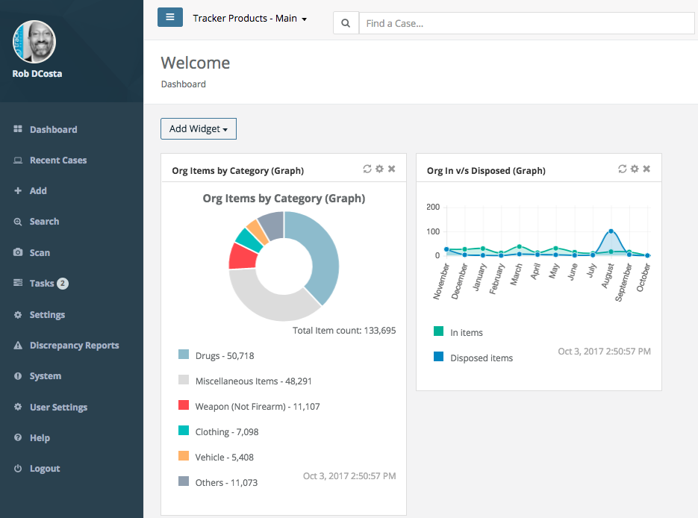

The Quick Menu Screen provides nearly all of the functionality in the system. This streamlined structure provides a great deal of time efficiency. Depending on your level of permissions, you may or may not see all the functionality listed on the left hand side of this screen.

Creating a Case, Item, or Person

Creating a Case, Item or Person are some of most fundamental and important areas of the software system. The next section will guide you through the basic setup required to get your system off the ground.

Client specific: The term Case is typically used by police agencies. This wording can be
changed to a variety of terms such as incident, matter, asset category, etc. This option will be set by the system administrator. For the purpose of this guide we will use the term Case.

Creating a Case
Quick Menu » + Add \ Case

When adding new items to the system, users begin by creating a new Case/Project to contain them. Depending on your organization's industry and preferences, your tracking containers may be referred to as either Cases, Incidents, Matters, or projects. All are exactly the same thing. Think of your Cases/Incidents/Matters/Projects as containers or folders for groups of Items and the Persons associated with them. Persons and items must be placed within previously established Cases/Incidents/Matters/Projects. Therefore, the Cases/Projects must be created prior to the Items and Persons that will be placed inside of them.

1. From the + Add menu on the left hand side of the screen, select Case. You are now on the Add Case screen. Enter a Required valid Case/Project Number based on your organization's naming strategy and an Offense Type. Consider that a consistent, well thought out naming strategy will increase your overall organization and ability to locate projects and items in the future. Example: 03-16-2010-A, 03-16-2010-B, 03-16-2010-C... incorporate the case/project creation date for the first part of the name and alphabetic increments to differentiate cases/projects entered on the same day.

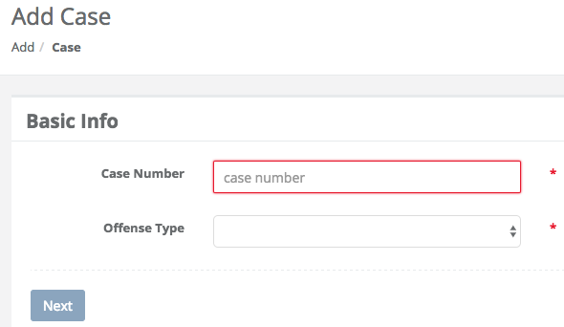

If you have entered a pre-existing Case, the following will appear, at which time you may View the pre-existing Case.

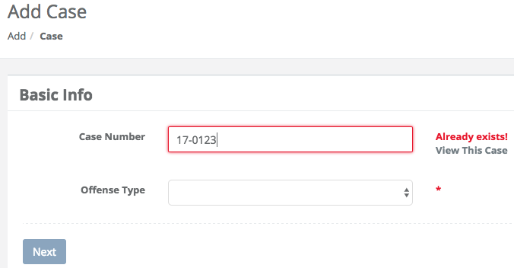
2. Once you have successfully entered a Required, valid Case/Project Number and Offense Type, and clicked Next, the software performs a check to ensure that the Case/Project Number entered does not already exist. Because the tracking system is designed to track unique cases/projects and items, it is essential that each Case/Project is given a unique number. This safety feature prevents Case duplication.

You must now enter a Required Case Officer, Offense Location, and Offense Date. Next, add any Tags and/or an Offense Description to the Case you just created. SAFE will generate a Review Date based on the specific follow up dates your administrator enters into the system for each Case Offense (in Auto Disposition). You may enter Review Date Notes, if you have permissions, then choose how you would like to proceed. Whether that is saving the Basic Info, then Adding an Item, or Adding a Person etc. When you have made your choice, click Save.
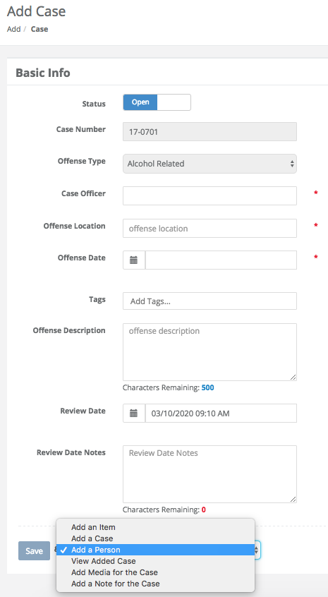
Fields on the Add Case Page
Status
Is this an Open or Closed Case?

Case Number
A unique number that differentiates cases/projects in the system. This is a Required field.

Offense Type
Click anywhere in the Offense Type field to bring up a list of offenses to choose from. This is a Required field.

Case Officer
Name of the person in charge of the case, which is Required (must be an Active User).

Offense Location
The location where the offense took place. This is a Required field.

Offense Date
The Date and Time the offense took place. This is a Required field. Click the calendar icon, then pick a time and day. If no time is selected, the system will default to the current time.

Tags
A searchable label any User can create that is attached to a Case or Item for the purpose of identification. Click anywhere inside the Tags field to bring up a list of available Tag options to choose from.

Offense Description
Type a brief description of the Offense which occurred.

Review Date
Based on the specific Follow Up Date(s) your administrator enters into the system for each Case Offense, SAFE will generate a Review Date which will show when the Case will be up for Review.

Review Date Notes
You may enter notes in this field that pertain to when the next review date is if you have the appropriate Permissions to do so.

3. In addition to the Basic Info Add Case fields, you may be asked to fill out additional Fields if you enter a Case containing a particular Offense Type. For example, if you choose the Offense Type Animal Hoarding, an administrator may have added a Form to be filled out.

FYI: Some data entry fields may have requirements set by your system administrator. For example, when entering numbers on a Custom Form, the field does not allow multiple dots to be entered. The field will allow a single dot like “12.1” but not “12.1.” or “12.1.2.” to be entered. There may be other requirements like a number field must be positive, in which case, you can’t enter a negative number. Any field that has not met the required standard will show a red glow around the field (telling you that it must be fixed before you can save).

This field does not meet the required validation and must be corrected before saving.

This is an example of a Case entry screen with a Custom Form at the bottom. This Case relating to Animal Hoarding was setup by the system administrator with a Custom Form designed to obtain additional information.

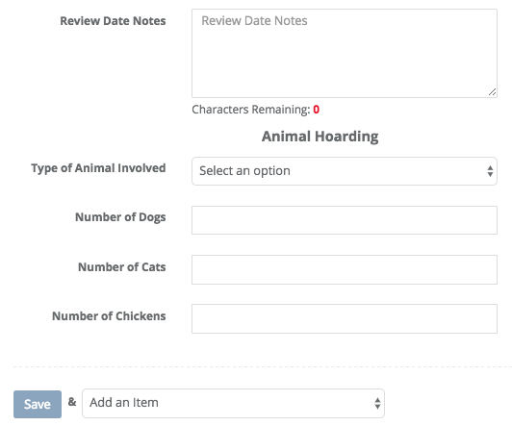

Saving a Case
Once you have filled in all of the required fields you will go to the bottom of the Case Entry screen and you will see a Save button.
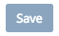
If that button is light in color (like this one is), something is not right and you must fix it. You can’t Save a Case until all fields have met the required validation.

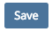
Now that the button is no longer lightly colored, click the Save button to save your Case.

After successfully saving your case you are now on the Case View screen. From here you can select many options from within the Case or go to your Quick Menu on the left to go elsewhere.

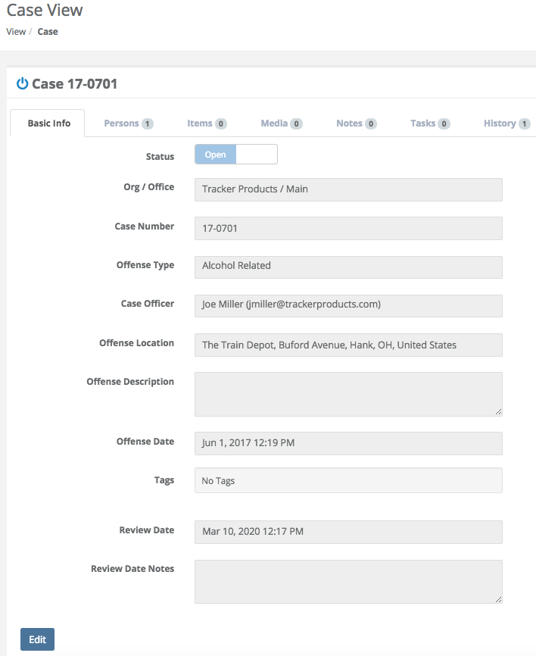

Creating a Person
- Quick Menu » + Add \ Person
- From the Case View (Previous Screenshot) click the Persons Tab

What is the difference between a Person in your Organization and a Person in a Case?

Person in your Organization – The software is set up in such a way that every person in your Organization is unique. This means you enter a Person one time and then use that one Person everywhere in the Organization. Therefore, if you create John Doe as a Person in the Organization, you can then use John Doe on the Checkout Screen, Item Entry Screen and many other places.

Person in a Case - So, just like I can check an item out to John Doe or enter an item for John Doe, I can also make John Doe a Type of person in my case.

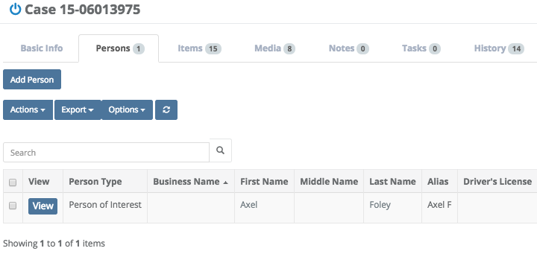

This is the Persons Tab from within the case I was viewing. You will not see these options if you go to the Quick Menu \ Add \ Person.

Adding a Person

- Quick Menu \ Add \ Person

Type the Required First Name and Last Name of the Person you would like to add. You may also choose to enter a Business Name, in which case First and Last name will not be required. Next, type in their Address and Add them to a Case or choose a Person Type. Finally, click Save & <Choose an Option>.
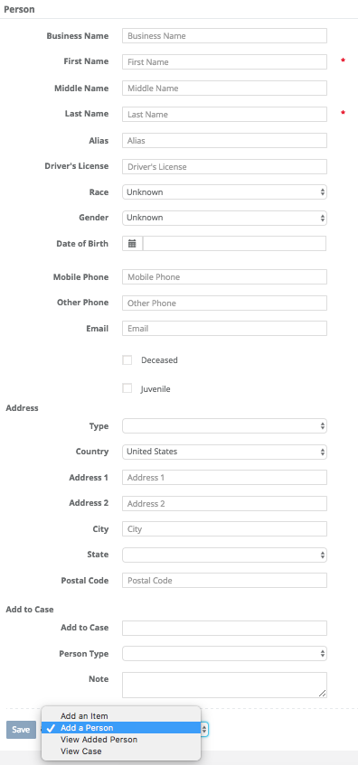
Fields on the Add Person Page
Business Name
Type the name of the business you wish to add. If you choose to do this, a first and last name will no longer be required, as it is irrelevant.

First Name
Type the first name of the person you wish to add. This is a Required field.

Middle Name
Type the middle name of the person you wish to add if you know what it is.

Last Name
Type the last name of the person you wish to add. This is a Required field.

Alias
Type in an Alias (other names this person goes by) for this person if they have them.

Driver’s License
Type in the Driver’s License number for this individual.

Race
Click anywhere in the Race field to bring up a list of options to choose from.

Gender
Click anywhere in the Gender field to bring up a list of options to choose from.

Date of Birth
Record their date of birth in this field. You may wish to use the calendar icon in this field, or enter the date manually.

Mobile Phone
Type in a mobile phone number that is associated with this person.

Other Phone
Type in a phone number that is associated with this person.

Email
If they have an email address they wish to disclose, enter that here.

Type
Type of Address associated with this Person/Business (Work, Home, or Other).

Line 1 / Line 2
Type the Work, Home, or Other Address of this c
City
Type the City this Person/Business is located in.

Postal Code
Type the Postal Code for this Person/Business (known as a zip code in the United States).

Country
The country this Person/Business is located in. Choose via the selectable list.

Deceased
Is this individual still alive?

Juvenile
Click the box next to juvenile if the individual is under age 18. This box is based solely on age, not attitude.

Add to Case
Type the exact Case Number you would like to add this individual to.

Person Type
Click anywhere in the Person Type field to bring up a list of options to choose from. This is a Required field.

Note
You may type a brief Note, perhaps with information regarding this individual.

Buttons on the Add Person Page
Save
This button saves the information you just entered about the Person. Next to it, you can make additional choices.

Adding a Person to a Case (from the Case View)

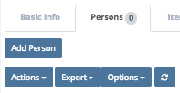

On the Case View screen, click the Persons tab, then click Add Person. This will take you to the Add Person screen. Type the Required First Name and Last Name of the Person you would like to add to the Case you were just viewing. You may also choose to enter a Business Name, in which case First and Last name will not be required. The Add to Case field will have the Case Number of the Case you were just viewing. Finally select a Required Person Type and click Save & <Choose an Option>.

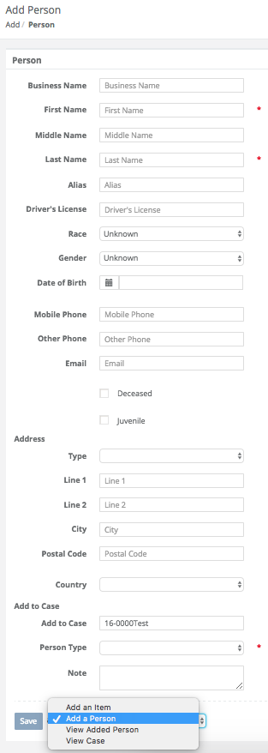
After clicking Save & <Choose an Option>, if the person you just added has a duplicate(s) in the system, the following pop-up will appear.

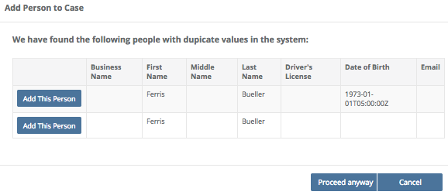
You may now click Add This Person, or Cancel. Once the Person is saved in the Case, and you are back on the Persons Tab of the Case View screen, you can continue to add Persons. You also have the option from the Actions Menu of Removing the Selected Person from the Case you’re viewing (if you have the appropriate permissions). First, select the Person you wish to Remove, then click the Actions Menu and choose Remove Selected Person.

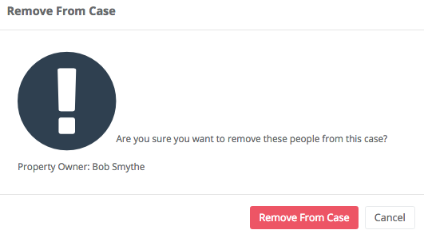

You can now Remove that person from the Case.

Creating an Item
Quick Menu » + Add \ Item

Once you have successfully created a new case/project and added the appropriate persons to it, you may begin to create and add unique items to it. You can add as many items to any case/project as you wish. Begin the process of creating and adding items to your new case by clicking the Save and add item button at the bottom of the 'Add person' or 'New case' submission pages.

From the + Add menu on the left hand side of the screen, select Item. This takes you to the Add Item screen. Enter a Required valid Case/Project Number you would like to add an item to. Also enter a Required category the item belongs to and click Next.

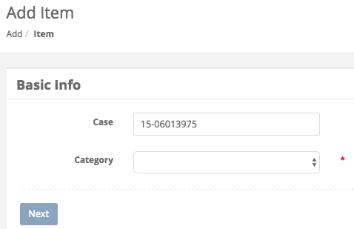

2. Once you have successfully entered a Required valid Case/Project Number and Category, and clicked Next, you must now enter a few more Required fields. The Required fields are Recovered At, Recovered By, Recovery Date, Description, Custody Reason, and Storage Location. Once you have entered these, you may add additional information to the Item you are creating, such as the Make, Model, Serial Number etc.

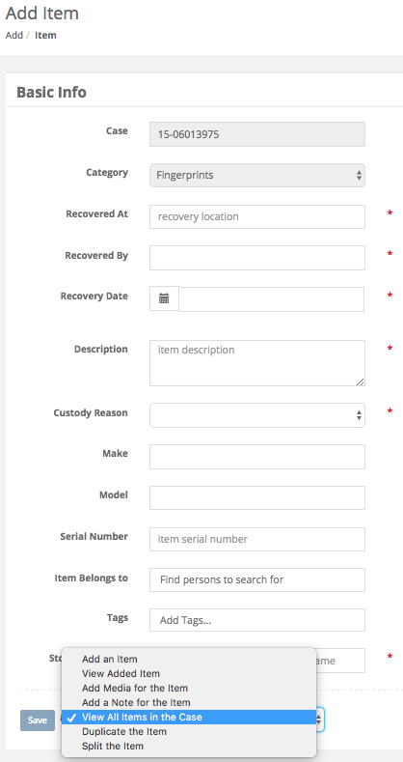
Fields on the Add Item Page
Case
Type the name of the case you want to add the item to. This is a Required field.

Category
Click anywhere in the Required Category field to bring up a list of options to choose from.

Recovered At
Type the location the item was recovered at. This is a Required field.

Recovered By
Enter who the item was Recovered By here. This is a Required field.

Recovery Date
When, and at what time was the item recovered? This is a Required field. You may wish to use the calendar icon in this field, or enter the date and time manually.

Description
Enter a brief Description of the item here. This is a Required field.

Custody Reason
What is the reason for having this item? Click anywhere in the Custody Reason field to bring up a list of options to choose from. This is a Required field.

Make
Type the Make of the item.

Model
What Model is the item? For example, Dodge is the make, Viper is the model.

Serial Number
If the item had a Serial Number, enter it here.

Item Belongs To
Who does the item belong to? Type that Person’s name here.

Tags
A searchable label any User can create that is attached to a Case or Item for the purpose of identification. Click anywhere inside the Tags field and start typing to bring up a list of available Tag options (which have already been entered) to choose from.

Storage Location
This is where the Item is currently located. For example, this may be a Temporary Locker, a box on a shelf in your evidence room, or a safe. This is a Required field.
Buttons on the Add Item Page
Save
This button saves the information you just entered about the Item. Next to it, you can make additional choices.

3. In addition to the Basic Info Add Item fields, you may be asked to fill out additional Fields if the Item entered belongs to a particular Category. For example, if you chose the Category Cellular Phone, an administrator may have attached a Cellular Phone Form to be filled out. When using a number on a Custom Form, the field does not allow multiple dots to be entered. The field will allow a single dot like “12.1” but not “12.1.” or “12.1.2.” to be entered.

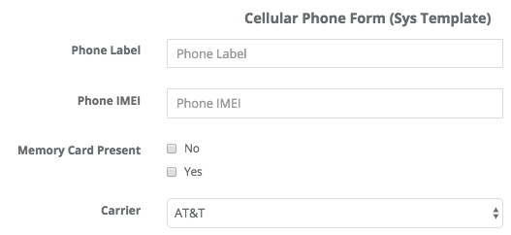

Fields on the Phone Form
Phone Label
Is there a label on the phone? If so, enter it here.

Phone IMEI
IMEI stands for International Mobile Equipment Identity and is a unique identifier for a mobile device. IMEI is a form of ESN (Electronic Serial Number). IMEI numbers are typically 15 digit numbers.

Memory Card Present
Was a memory card present when the phone was obtained? Check Yes or No.

Carrier
What carrier is associated with this phone? Choose AT&T, Verizon etc.

Searching for a Case(s)
Quick Menu » Search \ Cases

Click Search from the Quick Menu on the left hand side of the screen and select Cases. This will take you to the Advanced Search Case screen. From here, you can customize the search parameters by selecting boxes with the two small triangles (on the right side of the box). Choose from a number of variables depending on what case(s) you’re searching for. Or, if you know the Case Number, simply type it in and click Search. This will show the case you searched for.

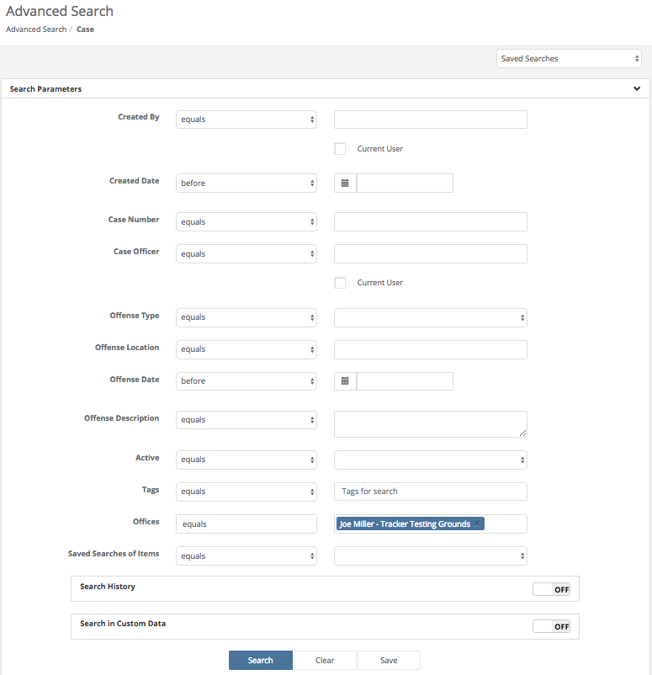

More information regarding Searches can be found by listening to our webinar:

SAFE Sessions - Advanced Searching @ https://vimeo.com/202443717/e9eb495b03
Fields on the Case Search page
Created By
Choose either ‘equals’ or ‘not equals’, then enter the name of the person who created the case. You may also choose to select ‘Use the logged in user for this search’.

Created Date
The date the Case was created. Click anywhere in the Created Date field to bring up a list of options to choose from. Next, in the box to the right of the Created Date field, there is a Calendar field where you can enter your parameters.

Case Number
Click anywhere in the Case Number field to bring up a list of options to choose from. Next, in the box to the right of the Case Number field, enter your parameters.

Case Officer
Click anywhere in the Case Officer field and choose ‘equals’ or ‘not equals’. Next, in the box to the right of the Case Officer field, you may type the name of an Officer this Case belongs to, depending on your search requirements.

Offense Type
What type of offense is this? Click anywhere in the Offense Type field and choose ‘equals’ or ‘not equals’. Next, click anywhere in the box to the right of the Offense Type field and choose an offense.

Offense Location
Where the offense was committed. Click anywhere in the Offense Location field to bring up a list of options to choose from. Next, in the box to the right of the Offense Location field, enter your parameters.

Offense Date
When the offense was committed. Click anywhere in the Offense Date field to bring up a list of options to choose from. Next, in the box to the right of the Offense Date field, there is a Calendar field where you can enter your parameters.

Offense Description
Click anywhere in the Offense Description field to bring up a list of options to choose from. Next, in the box to the right of the Offense Description field, enter your parameters.

Active
Is this case still active or not? Click anywhere in the Active field and choose ‘equals’ or ‘not equals’. Next, click anywhere in the box to the right of the Active field and select ‘true’ or ‘false’.

Tags
A searchable label any User can create that is attached to a Case or Item for the purpose of identification. Click anywhere in the Tags field and choose ‘equals’ or ‘not equals’. Next, click anywhere in the box to the right of the Tags field and select the Tags you would like to search.

Offices
Which Office location(s) does this Case pertain to? Click anywhere in the Offices field and choose ‘equals’ or ‘not equals’. Next, click anywhere in the box to the right of the Offices field and select your option(s) from the scrollable menu.

Saved Searches of Items
The first field is set to equals. In the second field, you may choose a previously Saved Search of Items you would like to couple with the search parameters you have currently chosen.

Search History \ Update Made By
When the Search History field is turned ‘on’, you may click anywhere in the Update Made By field and choose ‘equals’ or ‘not equals’. Next, in the box to the right of the Update Made By field you can enter your parameters.

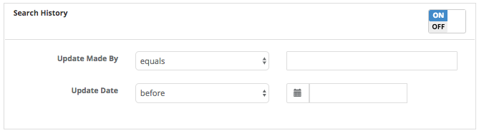

Search History \ Update Date
When the Search History field is turned ‘on’, you may click anywhere in the Update Date field to bring up a list of options to choose from. Next, in the box to the right of the Update Date field, there is a Calendar field where you can enter your parameters.

Search in Custom Data \ Form
When the Search in Custom Data field is turned ‘on’, after clicking the Plus sign at the bottom of the Search in Custom Data box, you may click anywhere in the Form field to bring up a list of options to choose from. You may also Preview the form by clicking the green Preview button.

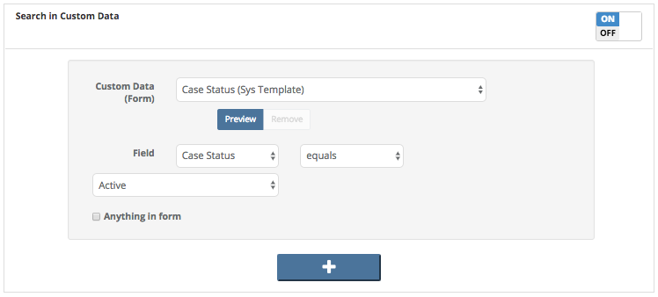

Search in Custom Data \ Field
When the Search in Custom Data field is turned ‘on’, after clicking the Plus sign at the bottom of the Search in Custom Data box, you may click anywhere in Field to bring up a list of options to choose from. Next, to the right of the first Field box, you may choose ‘equals’ or ‘not equals’.

Search in Custom Data \ Anything in form (check box)
When the Search in Custom Data field is turned ‘on’, after clicking the Plus sign at the bottom of the Search in Custom Data box, you may click the Anything in form (check box) to select a search pertaining to anything in the form you have selected.

Buttons on the Search in Custom Data field
+
Choose the blue ‘plus’ button on the Search in Custom Data field to add additional forms you can select parameters for.

Buttons on the Case Search Page
Search
Once you have entered all of your parameters, click the Search button to search cases.

Clear
Click this button to reset all parameters.

Save
Click here to save a copy of the Search containing the parameters you’ve chosen.

Cases found from a Search
After you’ve run a Search on a Case, a list of Cases will appear. Click on any box at the top of the list you would like to sort by. Simply click Case Officer for example and the list will be sorted by that. Click Case Officer again, and the list will be sorted in reverse order. You may also now switch the header options. For example, you want the Active column to be last. Simply drag Active to the last column spot and release the mouse. Active will now be the last column.

To view an individual Case, click the View box next to the Case you’re interested in looking at to bring up that particular Case Number and information, otherwise, highlight the Case(s) you’re interested in by clicking anywhere in their horizontal Case row and you may then choose from the Actions, Reports, Export or Options menus.

In the Actions menu, you can Export the list of items associated with the case you just highlighted by clicking Export All Results. The exports get deleted after 7 days. If you choose, you may also cancel the export from the Actions box on the next screen.

If you would like to run a Report, or Print a Label on the Case you just brought up, click the Reports box to bring up a list of Reports or Labels you can choose from.

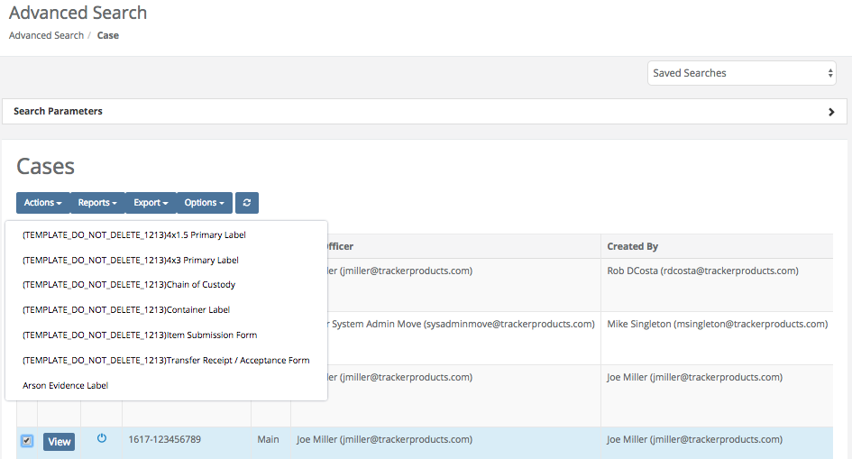

You can also click the Export box to export the information on any Case(s) you’ve selected to a comma separated value (.csv) file.

Click the Options box to display the drop down Options menu. From here, you can turn on/off which columns of information you wish to see displayed on your screen (or not displayed if there is an “X” beside them). If you don’t want a column displayed, click on it’s name and it will be removed (not permanently) from the list.

Search \ Case \ Basic Info Tab
After clicking view, the Case View screen will appear, showing the Basic Info tab.

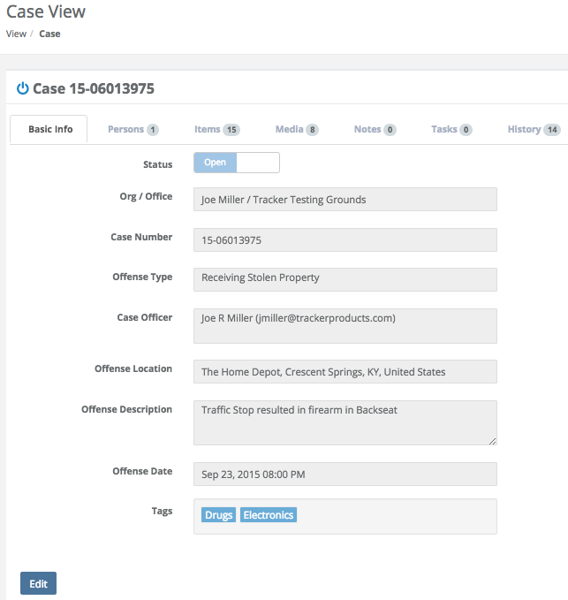

The Basic Info tab immediately under the Case number will show you basic information regarding the case. Persons, Items, Media, Notes and History (tabs) associated with the case will also be shown here.

The fields immediately under the tabs (such as Case Number and Offense Type etc.) have been filled in by the person who submitted the case.

Clicking the Edit box will allow you to edit and change any information shown on the Case View screen, depending on your permission level (except the Org / Office). For example, if a user inadvertently enters an incorrect Case Number or Offense Type, you may be allowed to change it by clicking Edit, making those changes, then clicking Save.

Search \ Case \ Persons Tab
In the Case View Section, under the Persons tab, you will see Persons associated with the particular case you have brought up if there are any. From here you can Add (another) Person to this Case by clicking Add Person (the Add Person screen will then come up and be populated with the Case Number). Or, from the Actions menu, you can Remove Selected Person(s) from this case.

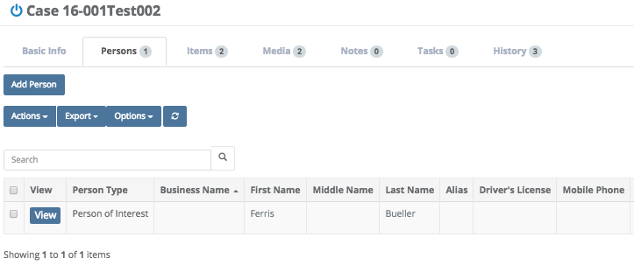

Search \ Case \ Items Tab
In the Case View Section, under the Items tab, you will see Items (with their information) associated with the particular case you have brought up. You may Add/Create Items for the case you brought up by clicking on the Add Item box then filling in any Required information (as was discussed in the previous Creating an Item section).

All item lists now show color depending on the status of the item.
Black = Checked In / Dark Yellow = Checked Out / Red = Disposed

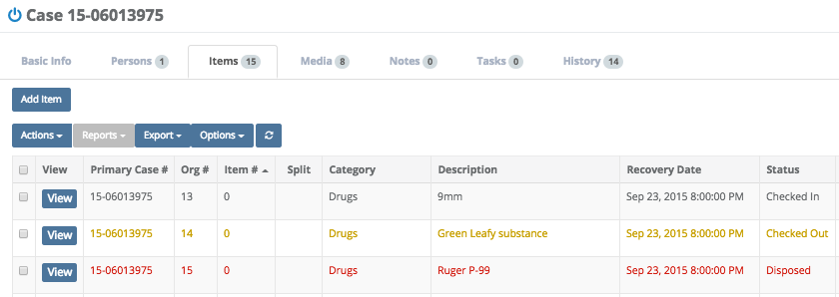

Search \ Case \ Items Tab \ Actions Box
You may immediately view an Item by clicking the View box. You may also check the box to the left of View, then click the Actions box, which will bring up a list of options to choose from.

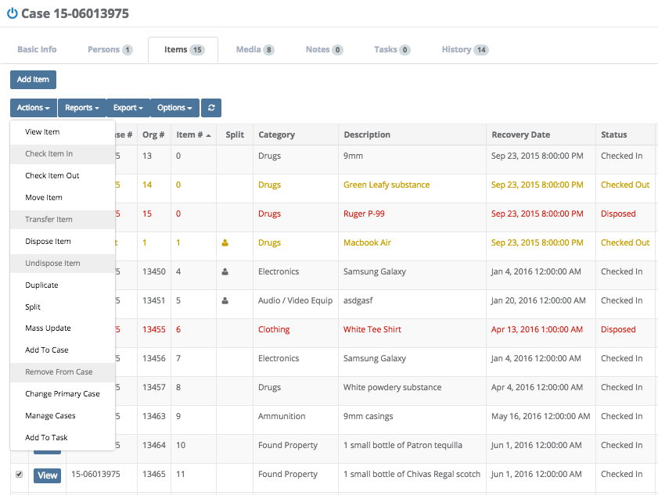

Viewing an Item
1. Click any one item and choose View Item from the Actions menu to view the item you’ve chosen. From here, you may Edit the item by clicking the Edit box. You may also click the Actions box and choose a selection (we will go into further detail on these selections in an upcoming section). You can also Print a Label, or run a report on the Item by clicking the Reports box and making a selection.

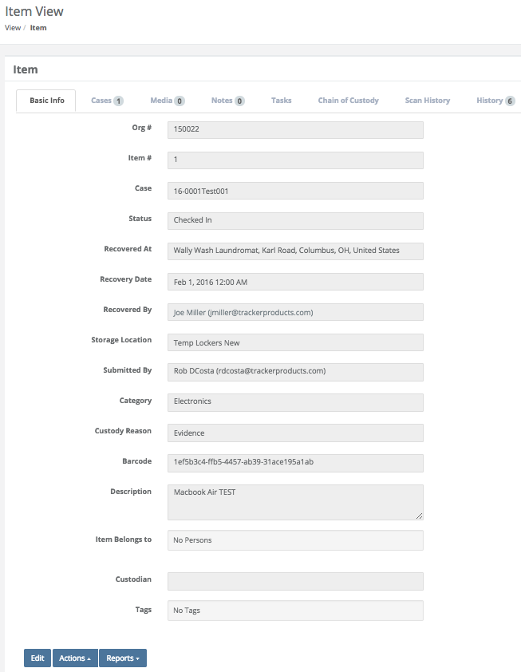

Clicking the Edit box will allow you to edit ONLY certain fields relating to the Item, depending on your permission level. For example, you may be allowed to edit Recovered At, Recovery Date, Recovered By, Category, Custody Reason, Serial Number, Model, Make, Description, Item Belongs to, and Tags.

Checking an Item In
2. Choose any item(s) you wish to Check In by selecting your item(s), and choosing Check Item(s) In from the Actions menu (make sure the item isn’t currently checked in by looking under Status). This will bring up the Check In Items screen. Perhaps this item is being returned from a court case, for example. To Check Items in from another Office or Org, see the Scan section.

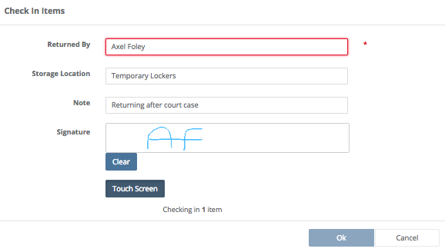

Fields on the Check In Items Screen
Returned By
Type the name of the Person who returned the Item. This field will remain red unless the person returning the item has a valid email address in the system. This is a Required field.

Location
This is where the Item will be placed. This may be a Temporary Locker, a box on a shelf in your evidence room, or a safe, for example. This is a Required field.

Note
You can type a note in this field.

Signature
Anyone checking in an item should provide a signature via Touch Screen, Topaz Signature Pad (if either of those options are enabled by your administrator), or simply signing via mouse to maintain the Chain of Custody. This is a Required field.

Checking an Item Out
3. Choose any item(s) you wish to Check Out by selecting your item(s), and choosing Check Item(s) Out from the Actions menu (make sure the item isn’t currently checked out by looking under Status). The Check Out Items screen will then appear.

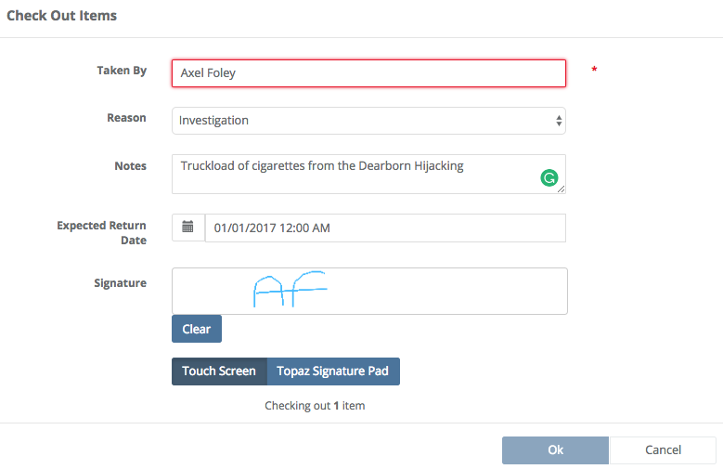
Fields on the Check Out Items Screen
Taken By
Type the name of the Person who is taking the Item. This field will remain red unless the person returning the item has a valid email address in the system. This is a Required field.

Reason
What is the reason for taking the Item? This is a Required field.

Notes
You can type notes in this field.

Expected Return Date
Enter a date and time you expect the Item to be returned by.

Signature
When checking out an item, you must sign your name in this field via Touch Screen, Topaz Signature Pad (if either of those options are enabled by your administrator), or simply signing via mouse to maintain the Chain of Custody. This is a Required field.

Moving an Item
4. You may also choose from the Actions menu, Move Item(s). This will bring up the Move Item screen. You can now move items that are ‘Checked In’ from one Location to another such as from a temporary locker to a safe, for example. Simply type a Required Location the Item will be moving to, sign your name (also Required) and click Ok.

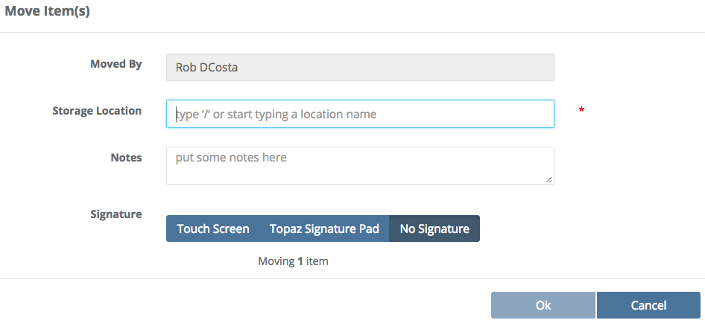

Fields on the Move Item(s) Screen
Moved By
Shows the name of the person currently logged into the software who is moving the Item.

Location
This is where the Item will be moved to. This may be a Temporary Locker, a box on a shelf in your evidence room, or a safe, for example. This is a Required field.

Notes
You can type notes in this field.

Signature
When moving an item, you must sign your name in this field (via Touch Screen, Topaz Signature Pad (if either of those options are enabled by your administrator), or simply signing via mouse to maintain the Chain of Custody. This is a Required field.

Moving an Item from one Office or Org. to another
If you are moving evidence to another Office or Org within SAFE, simply follow these steps to complete the transaction.

- Check out all items that are being transferred from the Office they currently reside in
- Switch the current Office to the Office you would like the Items transferred to
- Go to the Scan page
- Scan all items that are being checked in (Choose Office for Inter-Org moves, or System if Checking the Item in from a different Org.)
- Complete the check in. This action will now move these items from the originating Office / Org into your current Office / Org.

Transferring Items
5. The purpose of Transferring Items (to a Person OR User) is to Check Out an Item that is ALREADY Checked Out. For example, you can Check Out an Item to an Officer who then Transfers that Item to a lab for testing. When going through the Transfer process, the Officer can document notes regarding the Transfer, and obtain a signature from the lab via a cell phone or tablet with internet connectivity. To Transfer an Item(s) to another Organization that uses SAFE (for example), first make sure that Item has been ‘Checked Out’, next highlight the Item(s) you would like to Transfer and choose Transfer Item(s) from the Actions menu. The Transfer screen will then appear.

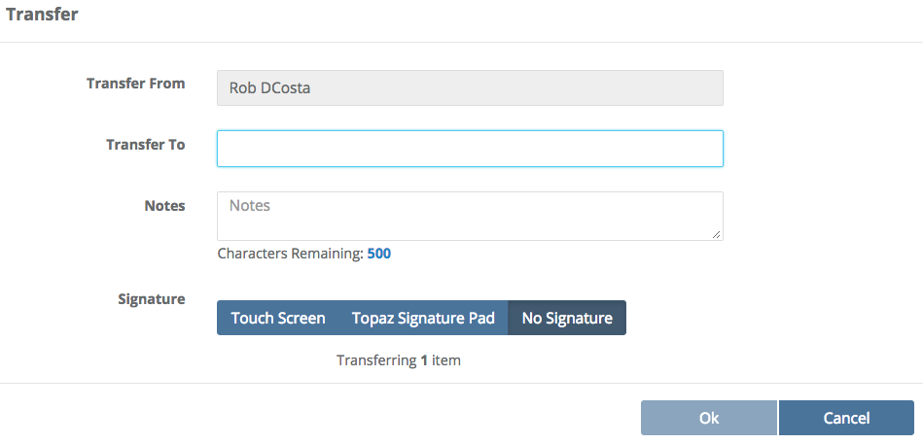

Fields on the Transfer Screen
Transfer From
This is the person currently logged into the software who is transferring the Item.
Transfer To
Type the name of the Organization you are transferring the Item to. This is a Required field.

Notes
You can type notes in this field.

Signature
Anyone transferring an item must provide a signature (via Touch Screen, Topaz Signature Pad (if either of those options are enabled by your administrator), or simply signing via mouse to maintain the Chain of Custody. This is a Required field.

Disposition of Items
6. If you wish to Dispose of an Item(s), highlight the Item(s), then choose Dispose Item(s) from the Actions menu. This will take you to the Item Disposal screen.

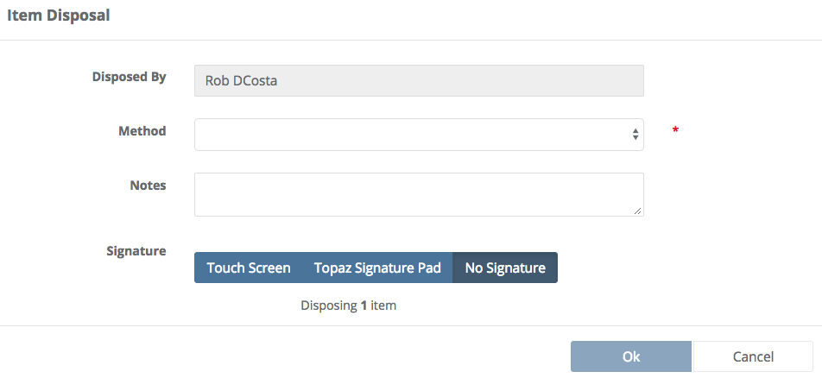

Fields on the Item Disposal Screen
Disposed By
This is the person currently logged into the software who is disposing the Item.

Method
This will state how the Item was disposed of. Click anywhere in the Method field to bring up a list of choices. This is a Required field.

Notes
You can type notes in this field.
Signature
Anyone disposing an item must provide a signature (via Touch Screen, Topaz Signature Pad
(if either of those options are enabled by your administrator), or simply signing via mouse to maintain the Chain of Custody. This is a Required field.

Undispose an Item
7. As an Org Admin, why Undispose? Because when you Undispose an Item, you are checking the Item back in, and a Chain of Custody entry will be added to that Item.

For example, if you accidentally disposed a credit card that had fingerprints on it, when it was actually on a shelf in the furthest reaches of your evidence room. Or, you accidentally disposed a hard drive that (unbeknownst to you) someone had sent to the lab for analysis. These are just a few of the possible reasons to use the Undispose function.

If you wish to Undispose an Item(s), highlight the Item(s), then choose Undispose Item(s) from the Actions menu. This will take you to the Check In Items screen.

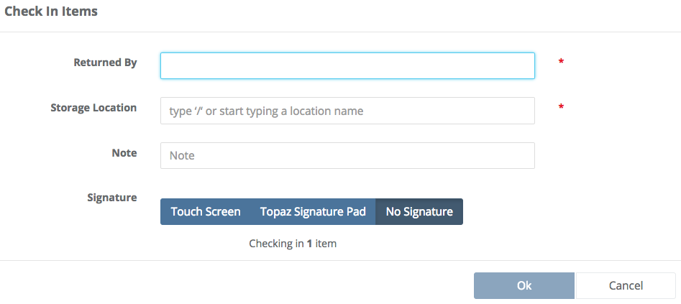

Duplicating Items
8. The Duplicate feature found in the Actions menu, can streamline the Item entry process. Users can duplicate previously created items to make new items. You can also edit newly created duplicated items before submitting them. This option removes the need to retype the same information over and over into the system.

To Duplicate an Item, highlight one item you wish to copy, then choose Duplicate from the Actions menu. This will take you to the Add Item screen where the software has made a duplicate of the information from this Item, but provided the duplicate with a unique GUID (Globally Unique Identifier which is a unique 128-bit integer number). The GUID is/corresponds to the barcode ID for an Item.

(Note: A common mistake in the software is creating too many items when duplicating existing items. Emphasize to your users they need to pay close attention when duplicating items to avoid creating too many new items.)

Splitting Items
9. Why Split Items? Say you have a backpack full of various items, some of which need to be sent to the lab for analysis. Or, you’ve taken an image of a computer hard drive and would like to maintain the Chain of Custody relating to the Original Item. To show, maintain, and preserve the Chain of Custody relating to the Original Item, you can Split the Item (multiple times if needed). Splitting an Item will show that “parent/child” relationship. The Split creates a new Item and indicates that it came from the parent.

If you wish to Split an Item(s), highlight the Item(s), then choose Split from the Actions menu. This will take you to the Add Item page where the case number and category have been selected. Clicking Next will take you to the Add Item \ Basic Info page. Fill in as much information as you can, then click Save & <Choose an Option>.

If you clicked Save & View Item, you will now be on the Item View page. Click the Cases Tab, then click View (to View the Case with the Item you just Split). Next, on the Case View screen, click the Items Tab. You will now see the Item you just Split.

In the Split Column, the single/parent icon denotes the Original Item, while the multiple/child icon denotes the Split Item. If you have one Split, only 1 parent and 1 child icon will appear. In the example below, a Split Item (Fingerprints lifted from the Huffy bike) was Split from the the ‘1 Huffy bike’ and is shown by the multiple/child icon . Another indicator that an Item was Split is shown in the Item # column, as the Split Item now shows Item # 2.1

When splitting items, it can be useful to include (in the description field) what the item was split from.

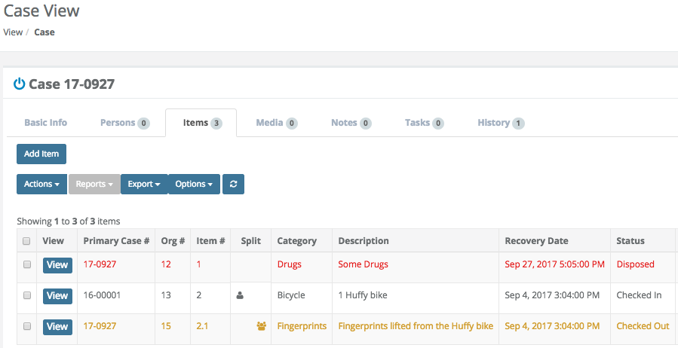

Clicking either the parent or the child item Icon will reveal the Org # and a partial description of either the child or parent Items.

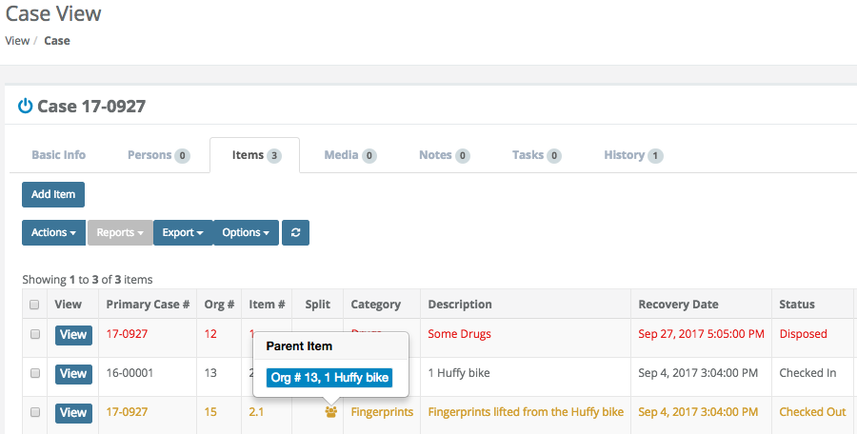

Mass Update on Multiple Items
10. To do a Mass Update on multiple items from the Same Case, choose more than 1 item and select Mass Update from the Actions menu. This will bring up the Mass Update Items screen. After you finish choosing your options from the Mass Update Items selections, click Ok.

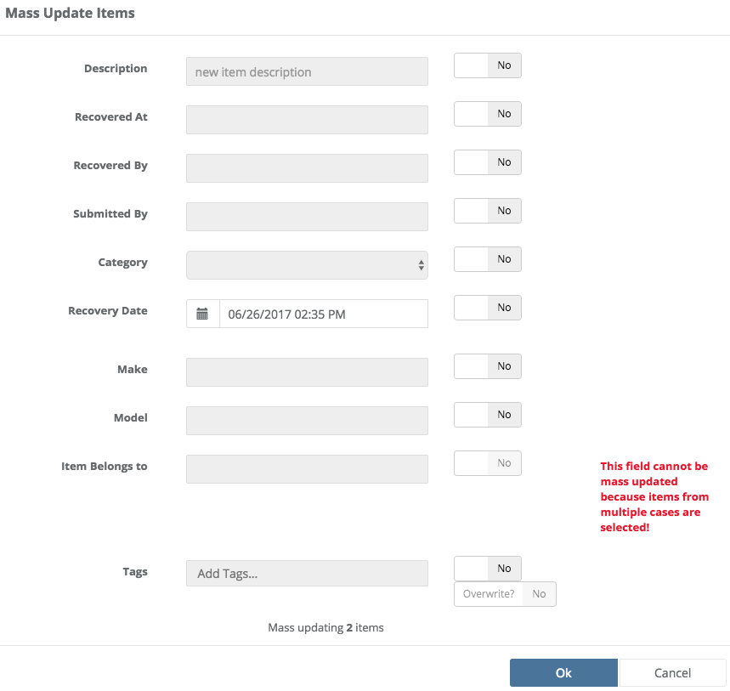

Fields on the Mass Update Items Screen
Description
If you’d like a new item description for the items you’ve selected, type one here and select Yes.

Recovered At
To update the location the items were recovered at, type one here and select Yes.

Recovered By
To update who the item was Recovered By, type one here and select Yes.

Submitted By
To update who Submitted the items, type one here and select Yes.
Category
To update the category these items belong to, Select Yes first. Next, click in the category box and a selectable menu will appear.

Recovery Date
To update the date and time these items were recovered on, click the calendar icon to choose a date and time, or enter one manually and select Yes.

Make
To update the Make of these items, type one here and select Yes.

Model
To update the Model of these items, type one here and select Yes.

Item Belongs To
To update who this Item Belongs To, type one here and select Yes.

Tags
The item mass update option allows you to mass apply or overwrite Tags to selected items.
The default value is to apply the new tags to selected items. You must select Overwrite to
replace all tags.

Adding an Item to a Case
11. Click any number of item(s) and Choose Add to Case from the Actions menu to add the item(s) you’ve chosen to a particular case.
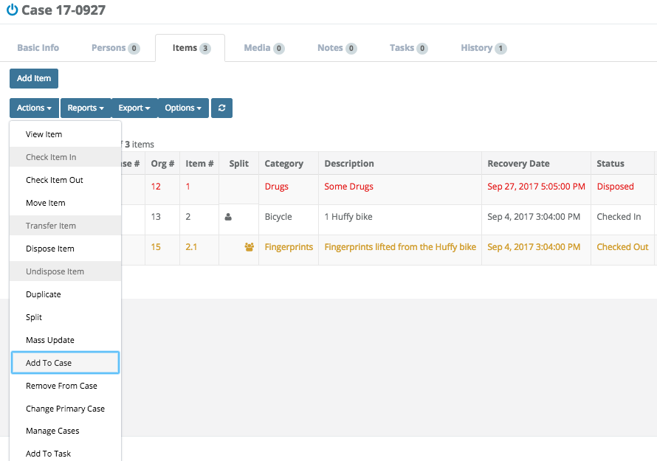
When the Add Items to Case screen is shown, enter a Required Case Number and click Ok.

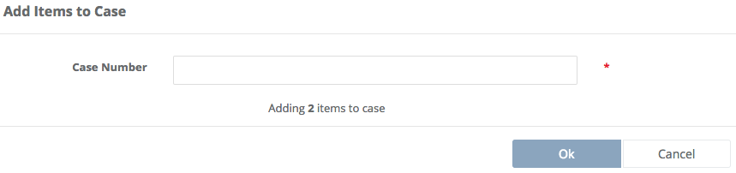

Removing an Item From a Case
12. Select an Item which has been ‘Checked Out’, and Choose Remove from Case from the Actions menu to remove the item you’ve chosen from a particular case. When the Remove from Case screen is shown, select a case (Required) by clicking in the ‘Please select a case’ field, then click Remove.

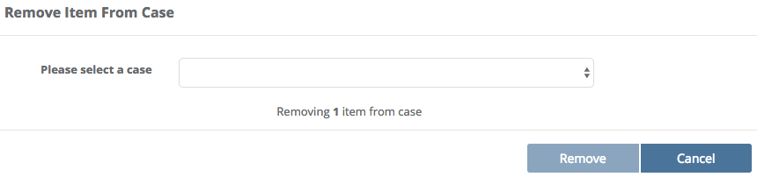

Changing the Primary Case
13. The Change Primary Case feature found in the Actions menu, will allow you to select a new Primary Case related to the Item(s) you have selected.

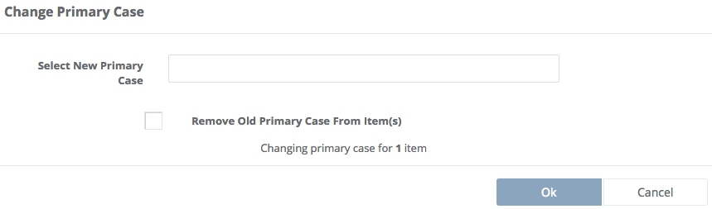

Note: When changing an Item’s Primary Case # (moving the Item from one Case to another), or if an Item is in more than one Case, to preserve the Chain of Custody, DUPLICATE Item #s may be created!
For these reasons alone, we suggest using the Org # (on labels for example), because the Org # will never have a duplicate!

Search \ Case \ Items Tab \ Reports Box
In the Case View Section, under the Items tab, you can also click the Reports box to run a report on any item(s) you’ve selected.

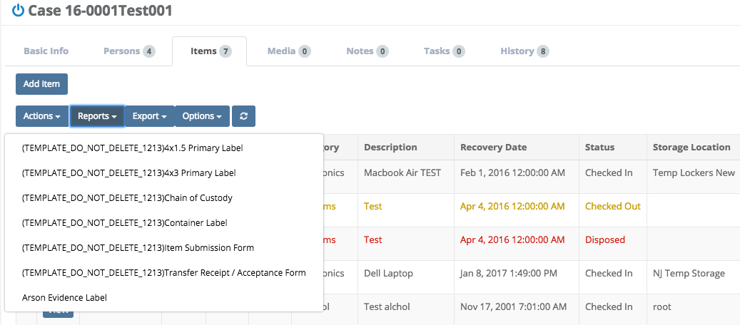

Search \ Case \ Items Tab \ Reports Box \ Persons
If you would like to run a Report showing specific Persons, first select the Items you’re interested in. Next, check the Include Custom People Selection and finally choose the Report you would like to run.

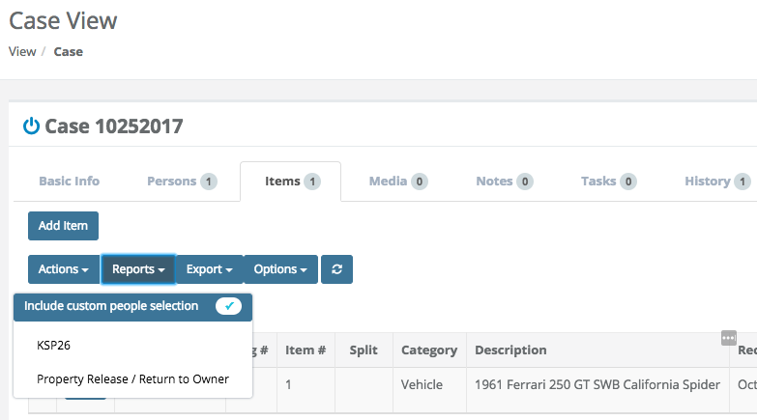
You may now select People for the Report and then run the Report.

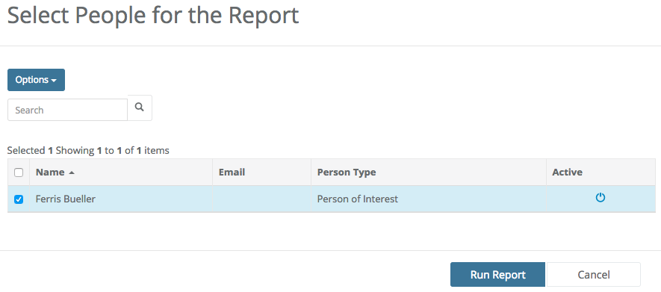

Depending on how your Administrator has set up your report, you may see the Person you’ve selected, their Address, Person Type etc.

Search \ Case \ Items Tab \ Export Box
In the Case View Section, under the Items tab, you can also click the Export box to export the information on any item(s) you’ve selected by selecting Selected, All, or a Subset of the Search Results to a .csv file.

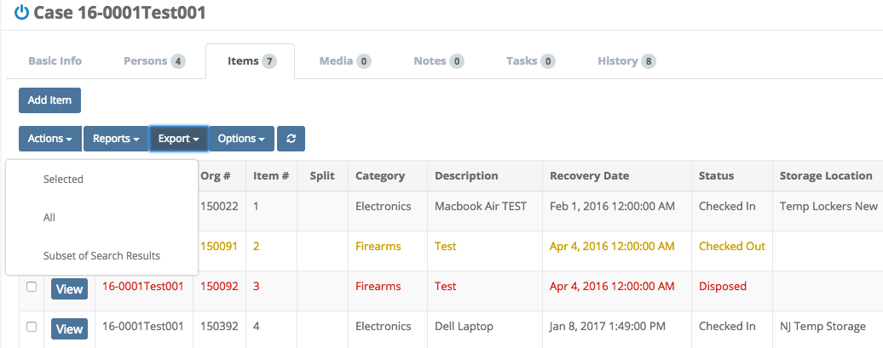

Search \ Case \ Items Tab \ Options Box
Click the Options box to display the drop down Options menu. From here, you can turn on/off which columns of information you wish to see displayed on your screen (or not displayed if there is an “X” beside them). If you don’t want a column displayed, click on it’s name and it will be removed (not permanently) from the list.

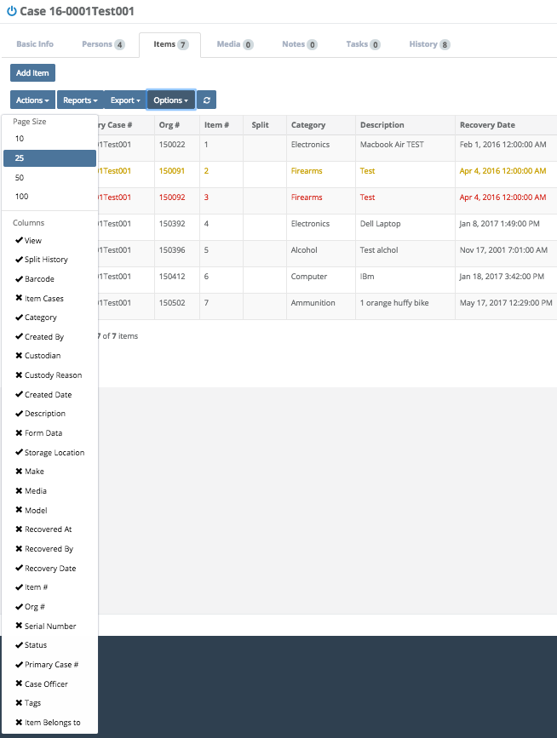

Search \ Case \ Media Tab
In the Case View Section, under the Media tab, you will see Media associated with the particular Case you have brought up, if there is any. If there is no Media associated with the Case, you have the option of Uploading Media to the Case by clicking the Add box. Next, click the Upload Files box, and choose or Drag and Drop your files into the marked box.

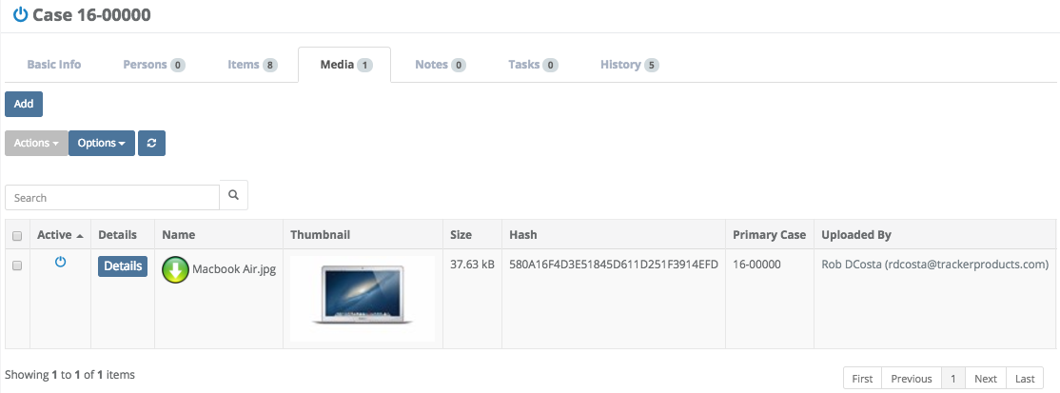

Clicking the Thumbnail of the Media allows you to see the image associated with it.
If you click the checkbox to the far left of any Media, and you have the appropriate level of permissions, you may then click on the Actions box, where you will be given the option to Delete the Media associated with this particular case.

Rarely do you ever want to 'delete' anything from the system. However, deleting an actual media payload file may eventually become necessary as you don't want to continue to take up server hard drive space especially with larger files. You may want to do this if you reach your storage limit and no longer need Media associated with closed Cases.

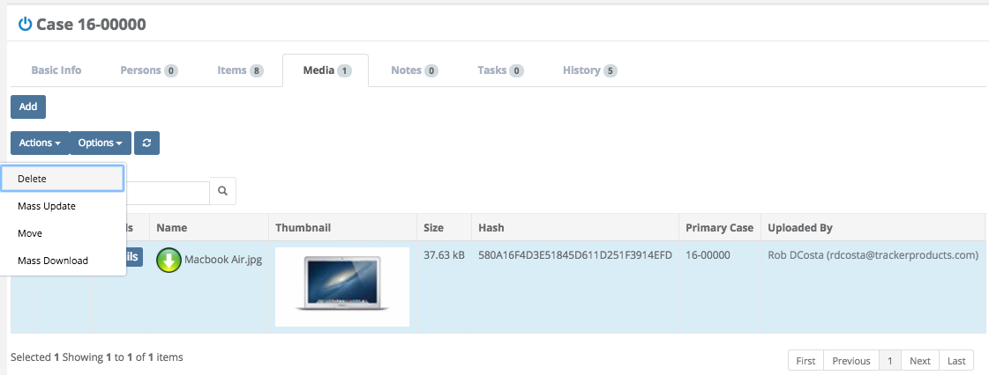

All files listed in the Case or Item 'Media' section are now able to be deleted. With the proper permissions you can select the files that you want to delete and click Actions > Delete Media. This action will only delete the actual media payload file and thumbnail file. All other meta data information including records of who deleted the file will be preserved.

Note: Deleting files will prompt a confirm message which notifies the User that file deletes cannot be recovered! This is for real, the actual payload file is not recoverable if deleted!
Anyone with the ability to Update Media (Settings > Security) is able to delete the media payload and thumbnail file.

After clicking Delete, the following message will appear.
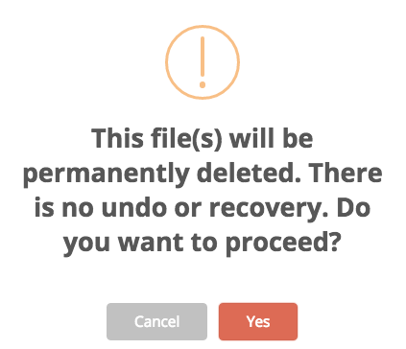

Once you Delete any Media, the files will be Permanently Deleted, and Completely Unrecoverable! Deleted Media will then be designated by a white “X” with a red background.

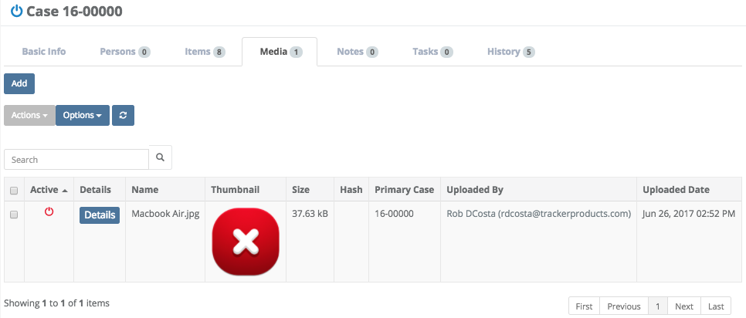

A useful feature from the Cases View is being able to Mass Update Media. Simply check the check box for the Media you’re interested in. Next, click the Actions Box, and finally click Mass Update.

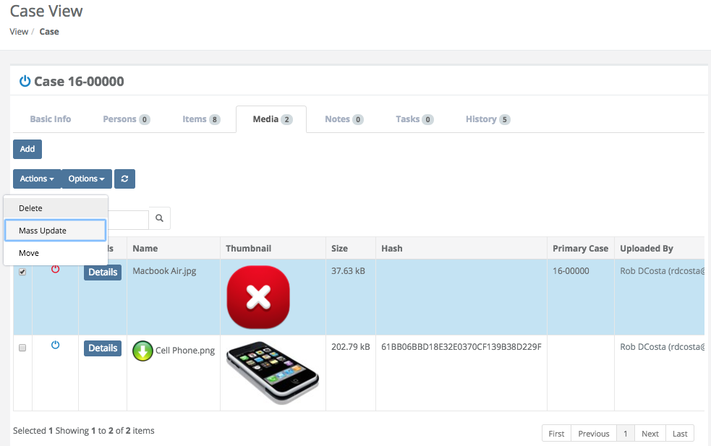

A Mass Update Medium pop up window will then appear. You may now Mass Update the Category and/or Description(s) or Item(s).

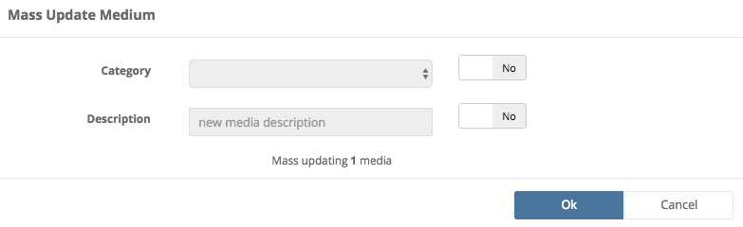

Another useful feature from the Case View is being able to Move Media to another Case or Item. Simply check the check box for the Media you’re interested in. Next, click the Actions Box, and finally click Move. A Move Media pop up window will then appear. You may now Move the Media to another Case or Item.
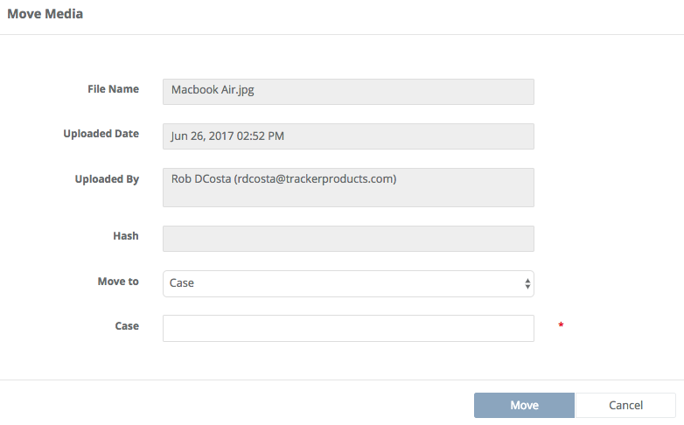
More information regarding Media can be found by listening to our webinar:
SAFE Sessions 3 - Media and On Premise File Server @ https://vimeo.com/213138970/45faf15f72

Search \ Case \ Notes Tab
In the Items Section, under the Notes tab, you will see Notes associated with the particular case you have brought up if there are any. You also have the option of Adding Notes by typing a Note you’d like to Add (which is Required), then clicking Add.

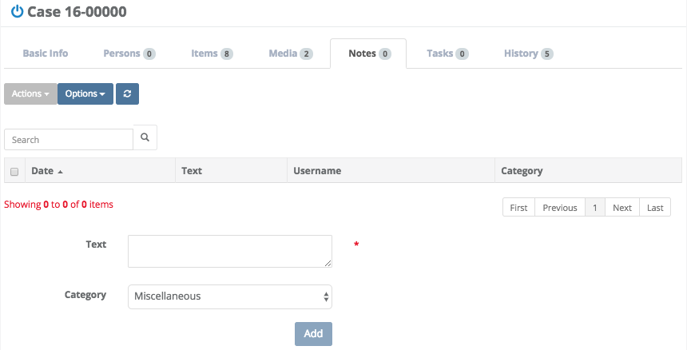

Search \ Case \ History Tab
From the Case (or Item) View, under the History tab, you will see History associated with the particular Case (or Item) you have brought up if there is any. You may choose to Export the History associated with this Case (or Item) by clicking the checkbox next to the History you’re interested in Exporting, then clicking the Export box and choosing Selected.

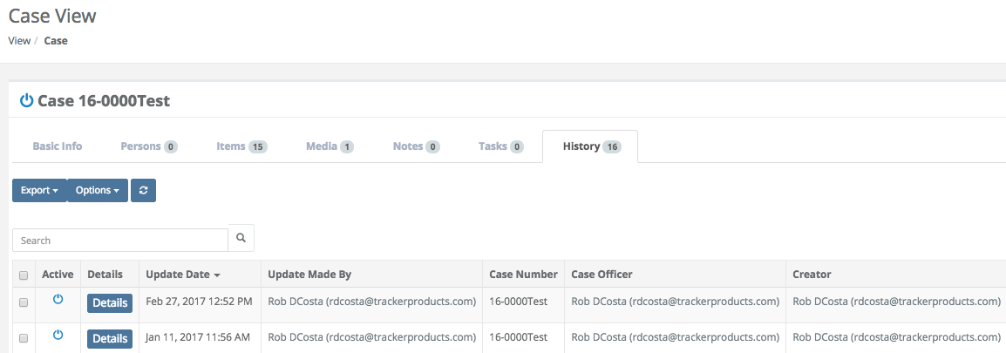

On the History tab for Cases and Items, next to each History entry is a 'Details' button which will show more Details on an item. If you click the Details button, you will see two columns of information. The column on the left is the most current information on that Case (or Item), and the column one the right was the previous update. In addition to that, red values reflect changes that were made in the most recent update.

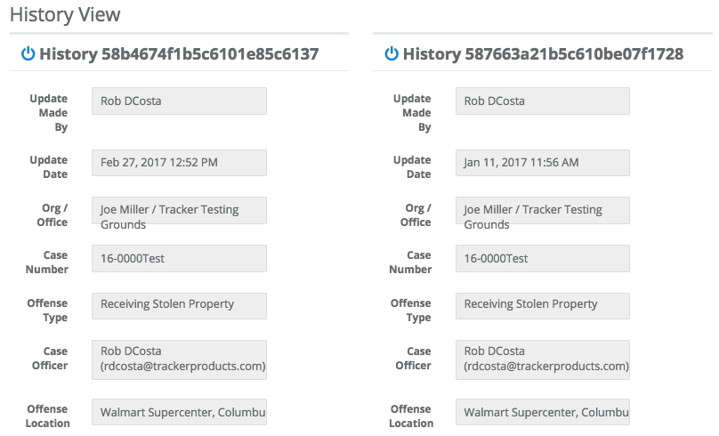

Viewing Recent Cases
Quick Menu » Recent Cases

A very fast way to view cases you’ve recently brought up is by clicking Recent Cases from the Quick Menu on the left hand side of the screen. This will let you view your last 15 cases.

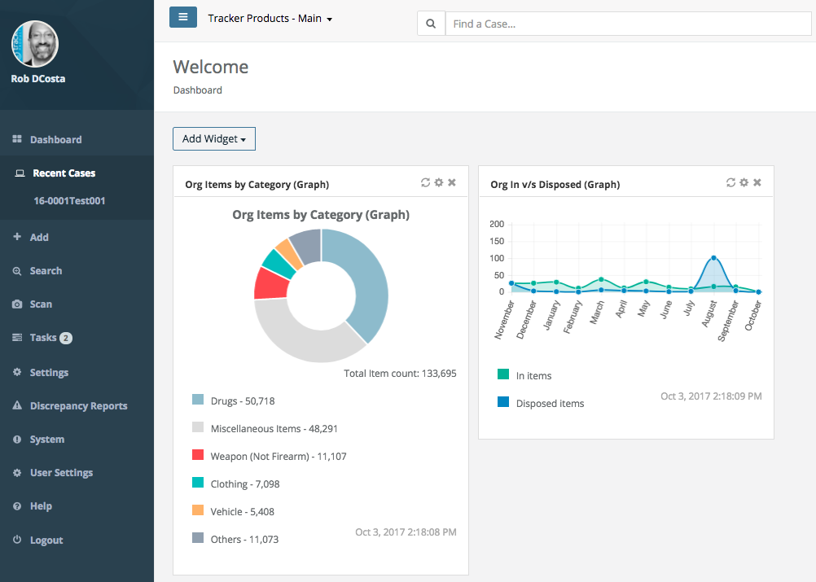

Searching for Items
Quick Menu » Search \ Items

Click Search from the Quick Menu on the left hand side of the screen and select Items. This will take you to the Advanced Search Items screen where you can customize your search. Choose from a number of variables depending on what Item(s) you’re searching for.

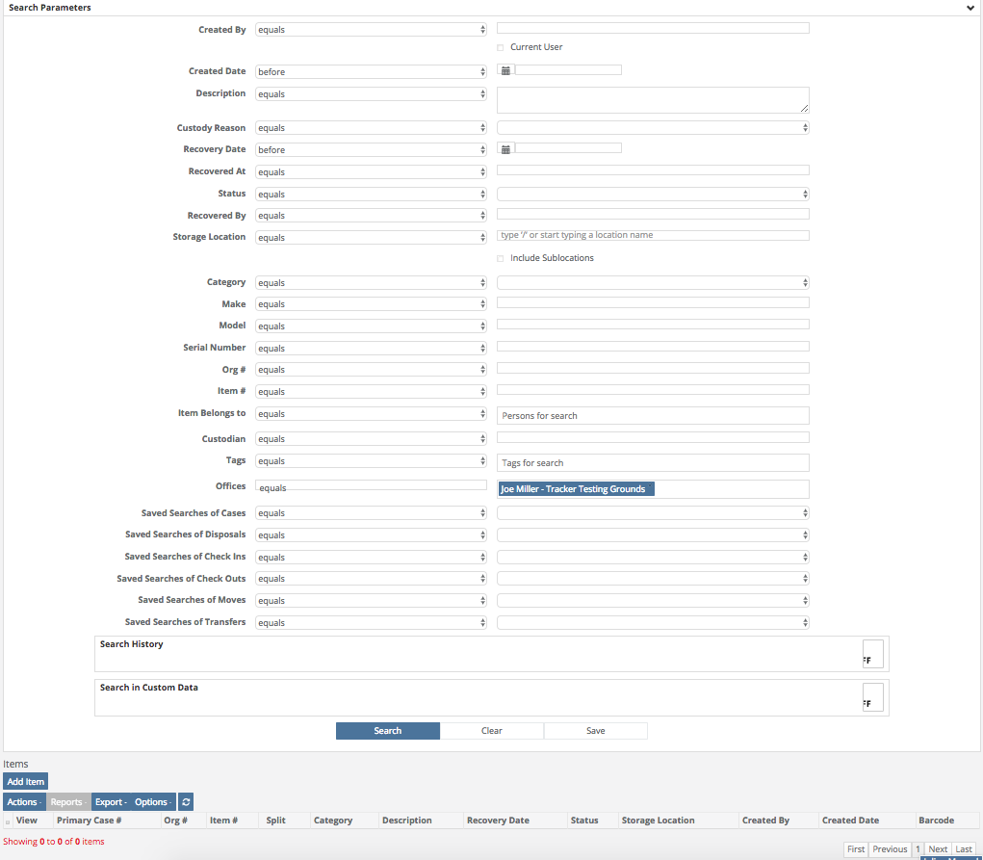
More information regarding Searches can be found by listening to our webinar:

SAFE Sessions 1 - Advanced Searching @ https://vimeo.com/202443717/e9eb495b03

Fields on the Items Search page
Created By
Choose either ‘equals’ or ‘not equals’, then enter the name of the person who created the case. You may also choose to select ‘Use the logged in user for this search’.

Created Date
The date the Case was created. Click anywhere in the Created Date field to bring up a list of options to choose from. Next, in the box to the right of the Created Date field, there is a Calendar field where you can enter your parameters.

Description
Click anywhere in the Description field to bring up a list of options to choose from. Next, in the box to the right of the Description field, type in your search parameters.

Custody Reason
Choose equals or not equals, then click the box to the right and make a selection.

Recovery Date
Click anywhere in the Recovery Date field to bring up a list of options to choose from. Next, in the box to the right of the Recovery Date field, there is a Calendar field where you can enter your parameters.

Recovered At
Click anywhere in the Recovered At field to bring up a list of options to choose from. Next, in the box to the right of the Recovered At field, type in your search parameters.

Status
Click anywhere in the Status field and choose ‘equals’ or ‘not equals’. Next, in the box to the right of the Status field, you may choose from the menu of options as to whether the Item has been ‘checked in’ or ‘disposed of’ etc.

Recovered By
Click anywhere in the Recovered By field and choose ‘equals’ or ‘not equals’. Next, in the box to the right of the Recovered By field, type in your search parameters.

Storage Location
This is where the Item is currently located. This may be a Temporary Locker, a box on a shelf in your evidence room, or a safe, for example. Click anywhere in the Storage Location field and choose ‘equals’ or ‘not equals’. Next, in the box to the right of the Storage Location field, type in your search parameters. You may also check the Include Sublocations box to include any sublocations in the root Storage Location you selected, in your search.

Category
Click anywhere in the Category field and choose ‘equals’ or ‘not equals’. Next, in the box to the right of the Category field, you may choose from the menu of available options.

Make
Click anywhere in the Make field to bring up a list of options to choose from. Next, in the box to the right of the Make field, type in your search parameters.

Model
Click anywhere in the Model field to bring up a list of options to choose from. Next, in the box to the right of the Model field, type in your search parameters.

Serial Number
Click anywhere in the Serial Number field to bring up a list of options to choose from. Next, in the box to the right of the Serial Number field, type in your search parameters.

Org #
Click anywhere in the Org # field to bring up a list of options to choose from. Next, in the box to the right of the Org # field, type in your search parameters. The Org # is a system assigned number given to all entries. It is the most current ascending, unique number any Item is assigned in the Organization when entered.

Item #
Click anywhere in the Item # field to bring up a list of options to choose from. Next, in the box to the right of the Item # field, type in your search parameters. The Item # (Agency Item Number) is a sequential, ascending number any Item(s) are assigned by the system when they are entered into a particular Case.

Item Belongs To
To update who this Item Belongs To, type a Person’s name for the search.

Custodian
Can be equals or not equals to the person responsible for this Item. For example, when an Item has been Checked Out.

Tags
A searchable label any User can create that is attached to a Case or Item for the purpose of identification. Click anywhere inside the Tags field and start typing to bring up a list of available Tag options (which have already been entered) to choose from.

Offices
Which Office location(s) does this Item pertain to? Click anywhere in the Offices field and choose ‘equals’ or ‘not equals’. Next, click anywhere in the box to the right of the Offices field and select your option(s) from the scrollable menu.

Saved Searches of Cases, Disposals, Check Ins, Check Outs, Moves, and Transfers
Which Saved Search does the Item pertain to? Click anywhere in the Saved Searches (equals) field and choose ‘equals’ or ‘not equals’. Next, click anywhere in the box to the right of that, and select your Saved Search(s) from the scrollable menu.

Search History \ Update Made By
When the Search History field is turned ‘on’, you may click anywhere in the Update Made By field and choose ‘equals’ or ‘not equals’. Next, in the box to the right of the Update Made By field you can enter your parameters.

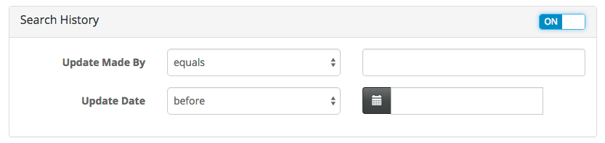

Search History \ Update Date
When the Search History field is turned ‘on’, you may click anywhere in the Update Date field to bring up a list of options to choose from. Next, in the box to the right of the Update Date field, there is a Calendar field where you can enter your parameters.

Search in Custom Data \ Form
When the Search in Custom Data field is turned ‘on’, you may click anywhere in the Form field to bring up a list of Forms to choose from.

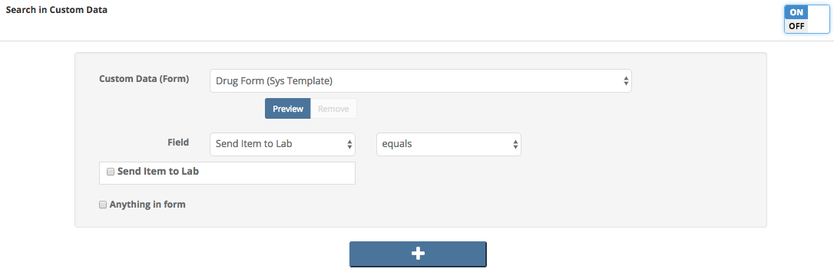

Search in Custom Data \ Field
When the Search in Custom Data field is turned ‘on’, you may click anywhere in the Field box to bring up a list of options to choose from. To the right of the Field box, you may choose ‘equals’ or ‘not equals’.

Search in Custom Data \ Send Item to Lab (check box)
When the Search in Custom Data field is turned ‘on’, if you are sending this item to the lab, make sure the Send Item to Lab box is checked.

Search in Custom Data \ Anything in form (check box)
When the Search in Custom Data field is turned ‘on’, you may click the Anything in form (check box) to select a search pertaining to anything in the form you have selected.

Buttons on the Search in Custom Data field
+
Choose the ‘plus’ button on the Search in Custom Data field to add additional forms you can Search and select parameters for.

Buttons on the Items Search Page
Search
Once you have entered all of your parameters, click the Search button to search cases.

Clear
Click this button to reset all parameters.

Save
Click here to save a copy of the Search containing the parameters you’ve chosen.

Items Found from a Search - All Items
After you have run a Search for an Item, a list of Items will appear. You can an Add Item(s) to this list by clicking the Add Item box (explained in the Creating an Item section), or highlight the Item(s) you’re interested in by clicking the small box next to the View box. You may also click on the Actions, Reports, Export, or Options boxes for more choices (explained in the previous Search \ Case \ Items Tab section).

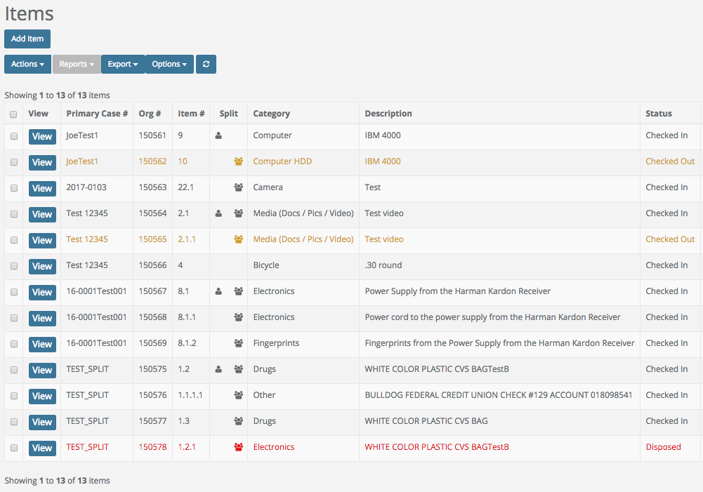

Items Found from a Search - Individual Items
After running a Search for an Item, a list of Items will appear. Highlight the Item you’re interested in by clicking the small box next to View and/or clicking View to examine the individual item’s attributes. You will be taken to the Item View screen Basic Info Tab.

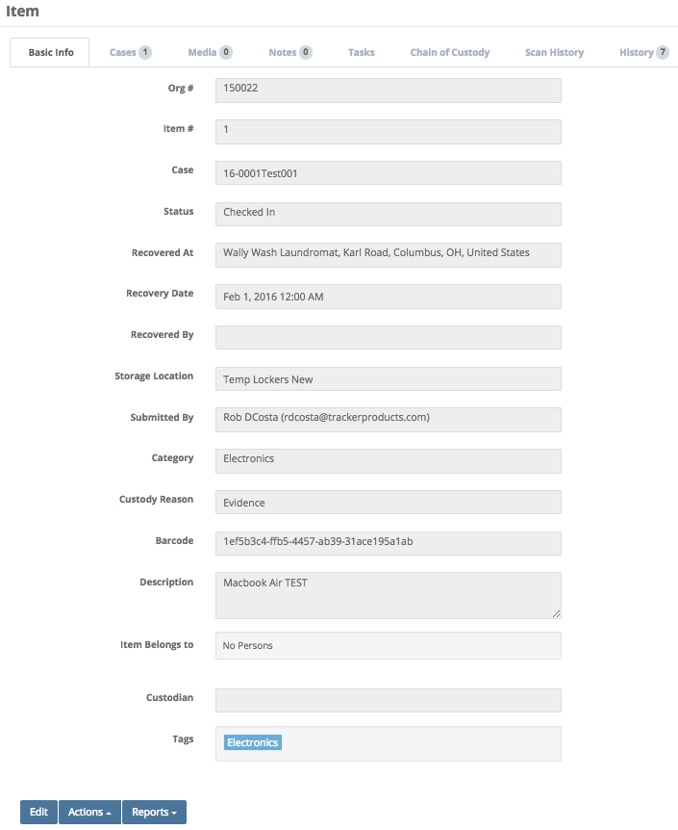
Fields on the Items Found from a Search - Individual Items Screen
Org #
The Org # is a system assigned ascending Item # for every Item in the system. It gives you an idea of how many Items you have entered. Since the system allows you to Move Items from one Case to another, it is advisable to use the Org # since it will be a unique number no matter what Case the Item is in (see Editing an Item and Managing Cases for more information).

Item #
The Item # (Agency Item Number) is a sequential, ascending number any Item(s) are assigned by the system when they are entered into a particular Case.

Case
This is the Case this Item belongs to.

Status
This field will show if the Item is checked in or out etc.

Recovered At
This is the location the Item was Recovered At.

Recovery Date
This is the Date the Item was recovered.

Recovered By
This field shows who recovered the Item.

Storage Location
This is where the Item is currently located. This could be a safe or temporary locker for example.

Submitted By
The person who submitted the Item.

Category
The category this Item belongs to.

Custody Reason
The reason for having this Item.

Serial Number
The serial number of the Item, if it has one.

Model
What model the Item is.
Barcode
The Barcode field consists of a unique GUID (Globally Unique Identifier which is a unique 128-bit integer number). This number uniquely identifies the Item it relates to.

Make
What make the Item is.

Description
A brief description of the item.

Item Belongs To
To update who this Item Belongs To, type one here and select Yes.

Custodian
Who is the custodian of this evidence?

Child Items
Child Items associated with this Parent Item will be shown here.

Tags
A searchable label any User can create that is attached to a Case or Item for the purpose of identification. Click anywhere inside the Tags field and start typing to bring up a list of available Tag options (which have already been entered) to choose from.

Buttons on the Item View \ Item Page
Edit
Allows you to edit the item.

Actions Box
From here, you are able to perform many functions such Check Out or Move an item.

Reports Box
From here, select a report or label you would like to run on the selected item.

Editing an Item and Manage Cases
1. You may Edit the Item by clicking the Edit box, or click the Actions box and choose a selection (like checking an Item in or out).

After clicking View (the Item), the choices in the Actions menu are exactly the same as explained in the previous Search \ Case \ Items Tab section). The only different selection in the Actions menu is Manage Cases.

2. The Manage Cases feature found in the Actions menu, will allow you to “Set this as the Item’s primary case” by clicking the star icon. You may also “Remove item from this case” by clicking the “x”, or you may Add the Item to a case by supplying a valid Case Number and clicking Add To Case. When you are finished, click the Finish Editing box.

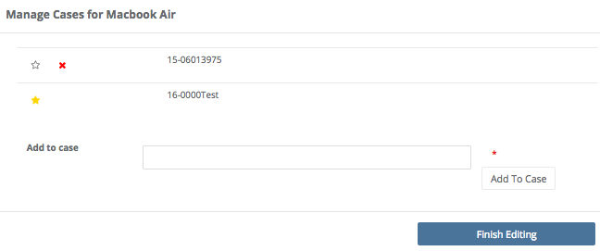

Note: When changing an Item’s Primary Case (moving the Item from one case to another), duplicate Item #s may be created! For this reason alone, we suggest using the Org # (on labels for example). The Org # will never have a duplicate!

Running a Report and Printing an Item Label
You may also run a Report or Print a Label for the Item by clicking the Reports box and making a selection.

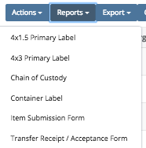

If you decide to Print a Label or Report for the Item, the software will automatically create an Adobe Acrobat file (.pdf) and the Label or Report will appear.

Label 1 example Label 2 example
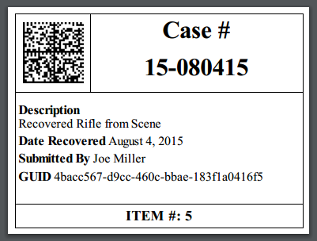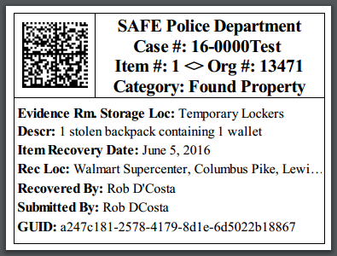

Once the Adobe Acrobat (.pdf) file is generated, you will have some options to choose from in the top right hand corner of the screen. The first two options let you rotate the document. The third option (which looks like a disk) will let you save the document. Finally, the fourth option (which looks like a printer) will let you print the document.

Search \ Item View \ Item \ Cases Tab
On the Item View page, under the Cases tab, you will see Cases associated with the particular Item you have brought up. You may view a Case by clicking the View box. You also have the option to export your results to a comma separated value (.csv) file from the Actions box. Finally, you can choose to export All Cases to a .csv file from the Export box.

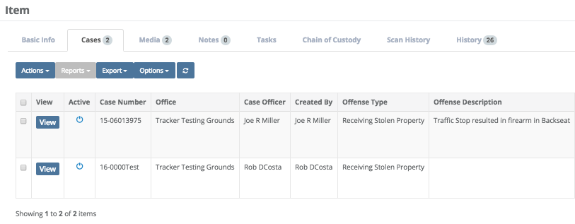

Search \ Item View \ Item \ Media Tab
On the Item View page, under the Media tab, you will see Media associated with the particular Item you have brought up, if there is any. If there is no Media associated with the item, you have the option of Uploading Media to the Item by clicking the Add box, then Dragging and Dropping your files into the marked box or clicking the Upload Files box and making selections.

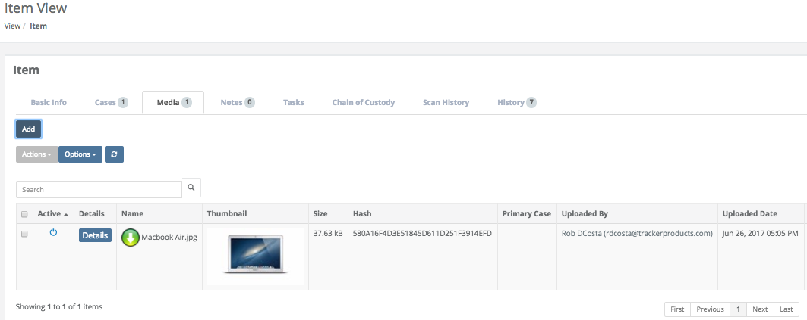

You may also view the Media CoC by clicking the Details box. This will take you to the Media Chain of Custody page where you can view the Case Number the Media is associated with, the File Name of the Media, when the Media was uploaded etc. You are also able to view meta data associated with the Media.

There is an option at the top of the page to generate an Adobe Acrobat (.pdf) file should you need it. Simply click the Save as PDF button, and the file will be downloaded to your local machine.

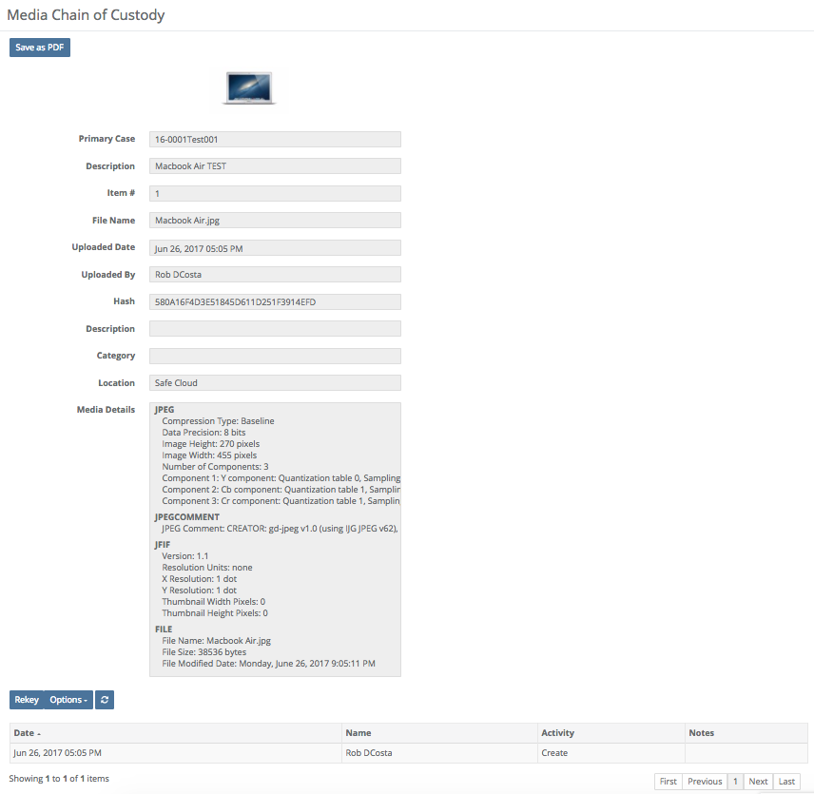

More information regarding Media can be found by listening to our webinar:
SAFE Sessions 3 - Media and On Premise File Server @ https://vimeo.com/213138970/45faf15f72

Search \ Item View \ Item \ Notes Tab
On the Item View page, under the Notes tab, you will see Notes associated with the particular case you have brought up if there are any. You also have the option of Adding Notes by typing a Note you’d like to Add (which is Required), then clicking Add.
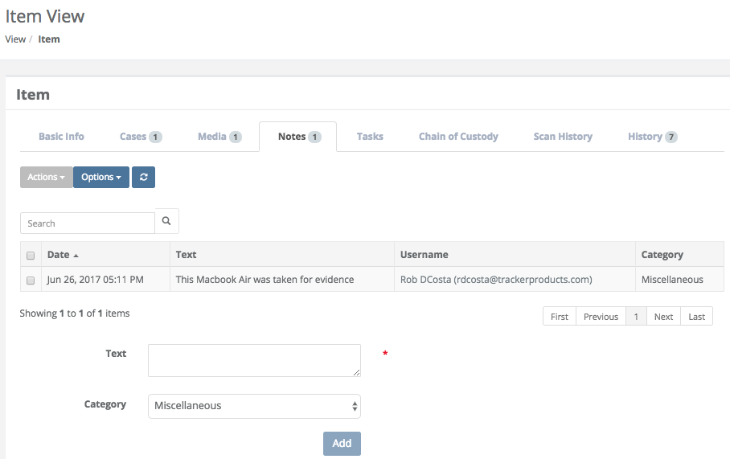

Search \ Item View \ Item \ Tasks Tab
On the Item View page, under the Tasks tab, you will see Tasks associated with the particular Item you have brought up if there are any. You also have the option of searching by Open or Closed Tasks as well as Adding Tasks to the Item etc.

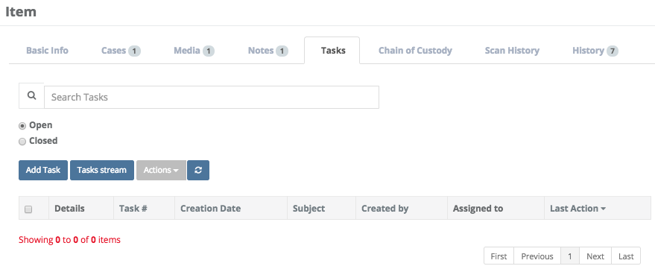

Search \ Item View \ Item \ Chain of Custody Tab
On the Item View page, the Chain of Custody tab shows when an item has been checked in or out, or has been disposed of, and who has performed this action.

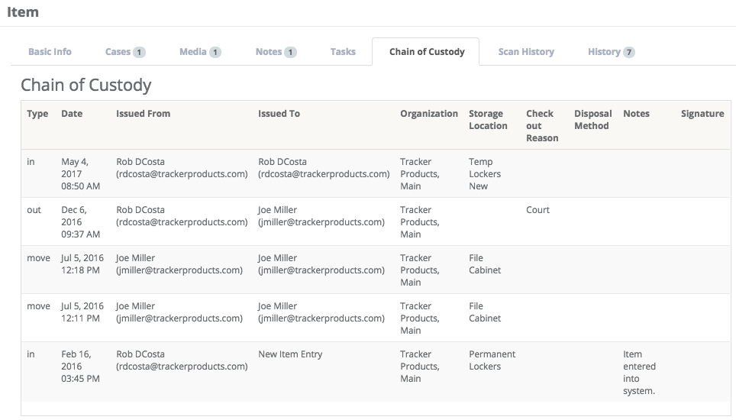

Search \ Item View \ Item \ Scan History Tab
On the Item View page, under the Scan History tab, you will see the Scan History associated with the particular Item you have brought up if there is any.

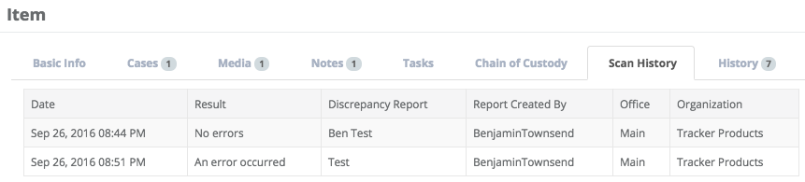

Search \ Item View \ Item \ History Tab
From the Item (or Case) View, under the History tab, you will see History associated with the particular Item (or Case) you have brought up if there is any. You may choose to Export the History associated with this Item (or Case) by clicking the checkbox next to the History you’re interested in Exporting, then clicking the Export box and choosing Selected.

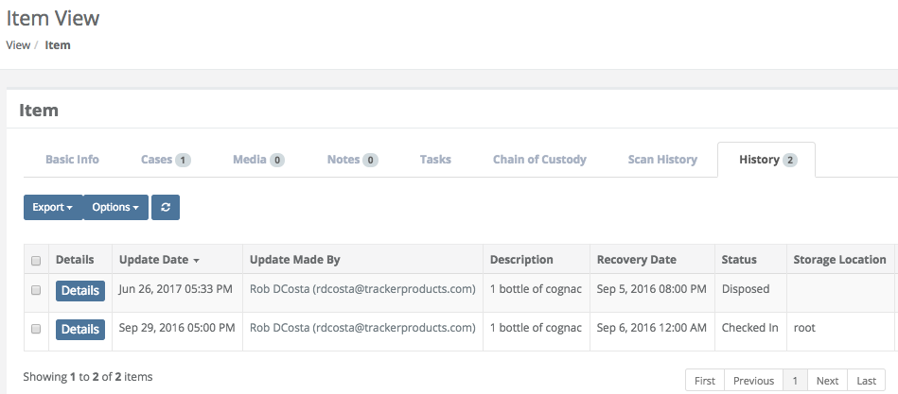

On the History tab for Cases and Items, next to each History entry is a 'Details' button which will show more Details on an item. If you click the Details button, you will see two columns of information. The column on the left is the most current information on that Case (or Item), and the column one the right was the previous update. In addition to that, red values reflect changes that were made in the most recent update.

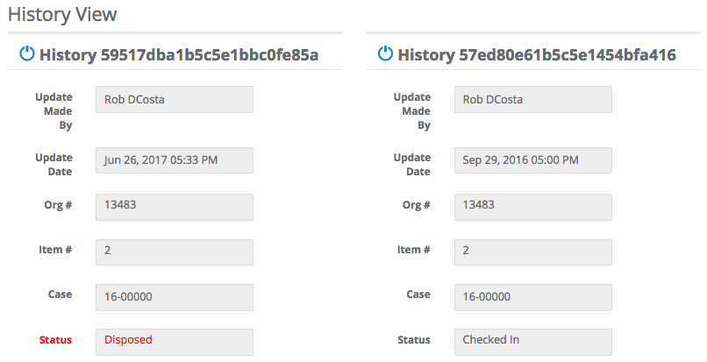

Searching for People
Quick Menu » Search \ People

Click Search from the Quick Menu on the left hand side of the screen and select People. This takes you to the Advanced Search People screen. From here, you can customize the search parameters by selecting boxes with the two small triangles (on the right side of the box). Choose from a number of variables depending on what People(s) you’re searching for. Or, if you know the People(s), simply type it in and click Search. This will show the People you searched for.

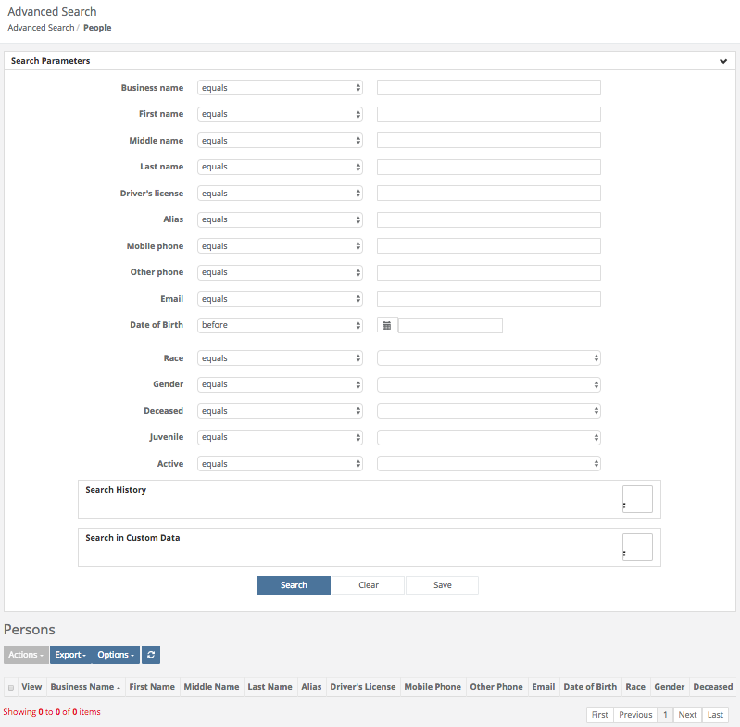

Fields on the People Search page
Business Name
Click anywhere in the Business Name field to bring up a list of options to choose from. Next, in the box to the right of the Business Name field, type in your search parameters.

First Name
Click anywhere in the First Name field to bring up a list of options to choose from. Next, in the box to the right of the First Name field, type in your search parameters.

Middle Name
Click anywhere in the Middle Name field to bring up a list of options to choose from. Next, in the box to the right of the Middle Name field, type in your search parameters.

Last Name
Click anywhere in the Last Name field to bring up a list of options to choose from. Next, in the box to the right of the Last Name field, type in your search parameters.

Driver’s License
Click anywhere in the Driver’s License field to bring up a list of options to choose from. Next, in the box to the right of the Driver’s License field, type in your search parameters.

Alias
Click anywhere in the Alias field to bring up a list of options to choose from. Next, in the box to the right of the Alias field, type in your search parameters.

Mobile Phone
Click anywhere in the Mobile Phone field to bring up a list of options to choose from. Next, in the box to the right of the Mobile Phone field, type in your search parameters.

Other Phone
Click anywhere in the Other Phone field to bring up a list of options to choose from. Next, in the box to the right of the Other Phone field, type in your search parameters.

Email
Click anywhere in the Email field to bring up a list of options to choose from. Next, in the box to the right of the Email field, type in your search parameters.

Date of Birth
Click in the Date of Birth field to bring up a list of options to choose from. Next, in the box to the right of the Date of Birth field, there is a Calendar field where you can enter your parameters.

Race
Click anywhere in the Race field and choose ‘equals’ or ‘not equals’. Next, in the box to the right of the Race field, select an option from the menu.
Gender
Click anywhere in the Gender field and choose ‘equals’ or ‘not equals’. Next, in the box to the right of the Gender field, select an option from the menu.

Deceased
Click anywhere in the Deceased field and choose ‘equals’ or ‘not equals’. Next, in the box to the right of the Deceased field, select ‘true’ or ‘false’.

Juvenile
Click anywhere in the Juvenile field and choose ‘equals’ or ‘not equals’. Next, in the box to the right of the Juvenile field, select ‘true’ or ‘false’.

Active
Click anywhere in the Active field and choose ‘equals’ or ‘not equals’. Next, in the box to the right of the Active field, select ‘true’ or ‘false’.

Search History \ Update Made By
When the Search History field is turned ‘on’, you may click anywhere in the Update Made By field and choose ‘equals’ or ‘not equals’. Next, in the box to the right of the Update Made By field you can enter your parameters.

Search History \ Update Date
When the Search History field is turned ‘on’, you may click anywhere in the Update Date field to bring up a list of options to choose from. Next, in the box to the right of the Update Date field, there is a Calendar field where you can enter your parameters.

Buttons on the People Search Page
Search
Once you have entered all of your parameters, click the Search button to search cases.

Clear
Click this button to reset all parameters.

Save
Click here to save a copy of the Search containing the parameters you’ve chosen.

People found from a Search
After running a Search on People, a list of Persons will appear. You can export your entire search to a comma separated value (.csv) file by clicking the Actions box and choosing Export All Results.

If you’d like to export your results by filtering them, choose that option from the Export box.

If you’d like to choose the results you want to export that you found from your search, highlight them by clicking anywhere in their row, then click the Export box and choose Selected.

Click the Options box to display the drop down Options menu. From here, select which columns of information you wish to see displayed. If you don’t want a column displayed click on it’s name and it will be removed (not permanently) from the list. For example, Alias, Middle Name, Deceased, Juvenile, and Race have been removed from the Search results below.

Click on any box at the top of the list you would like to sort by. Simply click DOB for example and the list will be sorted by that. Click DOB again, and the list will be sorted in reverse order.
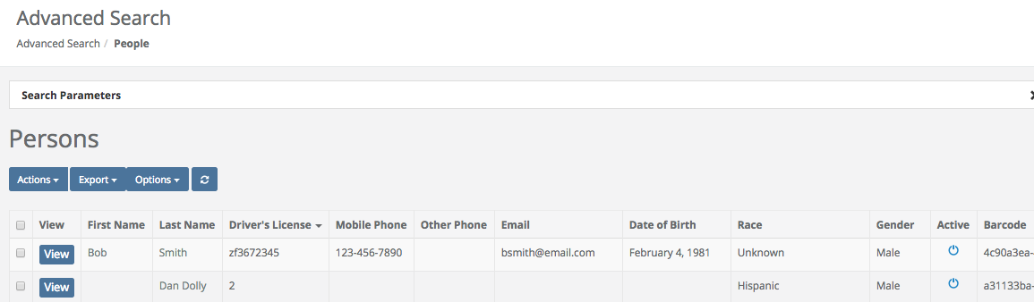

From the list of Persons you just obtained, you may now click the View box next to their name which will take you to the Person View screen. From here, you will see information relating to that person such as their first, middle and last name.

If you scroll down to the bottom of the Person View screen, you can Add an Address for this person by clicking the Add Address button. If there are multiple addresses, you can Set one as the Default. You may also click the Notes Tab to add Notes relating to this person. Or you may click the Cases Involved Tab to see which Cases this person is associated with etc.

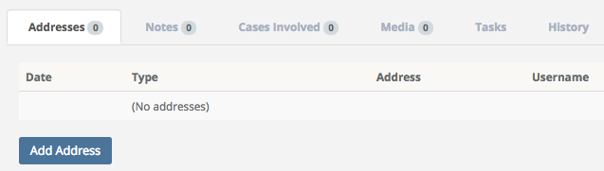

Searching for Disposals
Quick Menu » Search \ Disposals

Depending on your level of permissions, you may or may not be able to Search for Disposals. Click Search from the Quick Menu on the left hand side of the screen and select Disposals. This takes you to the Advanced Search Disposal screen. From here, you can customize the search parameters by selecting boxes with the two small triangles (on the right side of the box). Choose from a number of variables depending on what Disposal(s) you’re searching for. When you are finished customizing your search criteria, click Search. This will show the Disposals you searched for.

You may now click the Export Box and make selections you would like to export to a comma separated value (.csv) file.

More information regarding Searches can be found by listening to our webinar:

SAFE Sessions 1 - Advanced Searching @ https://vimeo.com/202443717/e9eb495b03

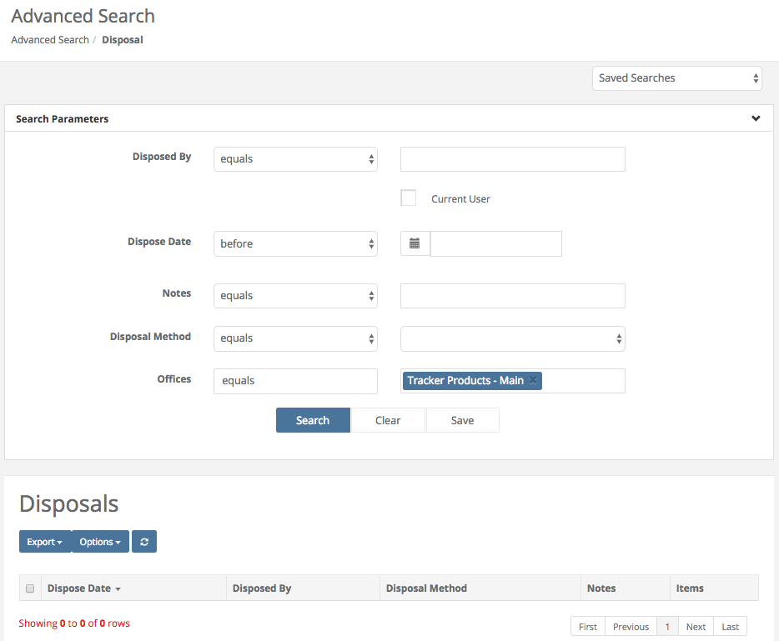
Fields on the Advanced Search Disposal page
Disposed By
Click anywhere in the Disposed By field to bring up a list of options to choose from. Next, in the box to the right of the Disposed By field, type in a User for your search parameter.

Dispose Date
Click anywhere in the Dispose Date field to bring up a list of options to choose from. Next, in the calendar box to the right of the Disposed Date field, type in a date, or click the calendar icon and choose the Dispose Date you’d like.

Notes
Click anywhere in the Notes field to bring up a list of options to choose from. Next, in the box to the right of the Notes field, type in Notes for your search parameters.

Disposal Method
Click anywhere in the Disposal Method field to bring up a list of options to choose from. Next, in the box to the right of the Disposal Method field, click anywhere in the box to bring up a list of options to choose from such as Auctioned, or Released to Owner.

Offices
Click anywhere in the Offices field to bring up a list of options to choose from. Next, in the box to the right of the Offices field, type in an Office for your search parameter (your default office should already be listed).

Buttons on the Advanced Search Disposal page
Search
Once you have entered all of your parameters, click the Search button to search cases.

Clear
Click this button to reset all parameters.

Save
Click here to save a copy of the Search containing the parameters you’ve chosen.

Searching for Check Ins
Quick Menu » Search \ Check Ins

Depending on your level of permissions, you may or may not be able to Search for Check Ins. Click Search from the Quick Menu on the left hand side of the screen and select Check Ins. This takes you to the Advanced Search Check In screen. From here, you can customize the search parameters by selecting boxes with the two small triangles (on the right side of the box). Choose from a number of variables depending on what Check In(s) you’re searching for. When you are finished customizing your search criteria, click Search. This will show the Check Ins you searched for.

You may now click the Export Box and make selections you would like to export to a comma separated value (.csv) file.

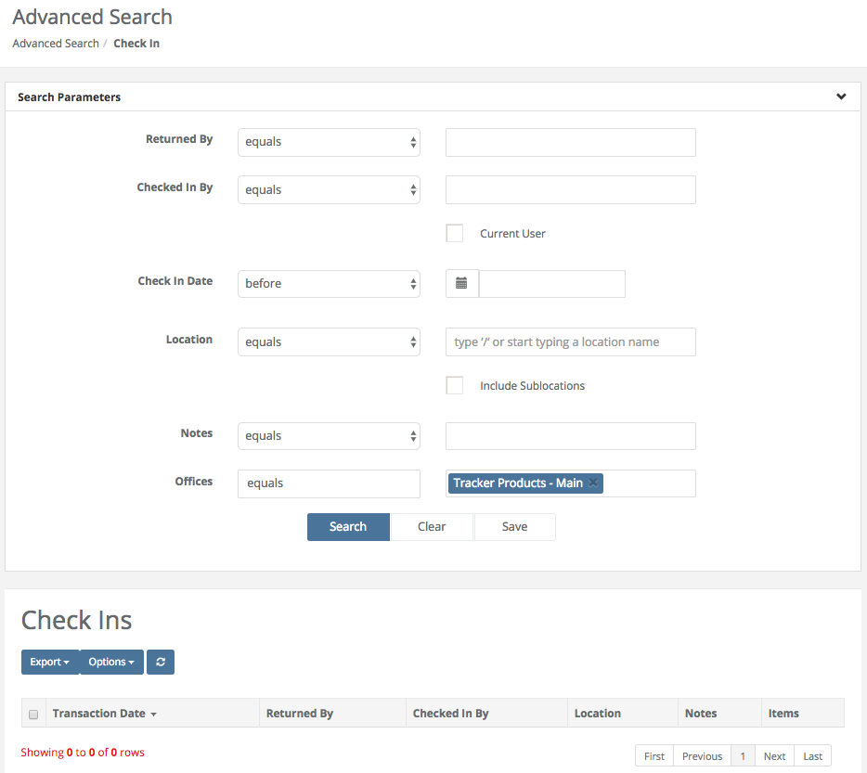
Fields on the Advanced Search Check Ins page
Returned By
Click anywhere in the Returned By field to bring up a list of options to choose from. Next, in the box to the right of the Returned By field, type in a User for your search parameter.

Checked In By
Click anywhere in the Checked In By field to bring up a list of options to choose from. Next, in the box to the right of the Checked In By field, type in a User for your search parameter.

Check In Date
Click anywhere in the Check In Date field to bring up a list of options to choose from. Next, in the calendar box to the right of the Check In Date field, type in a date, or click the calendar icon and choose the Check In Date you’d like.

Location
Click anywhere in the Location field to bring up a list of options to choose from. Next, in the box to the right of the Location field, type in the Storage Location for your search parameter. You may click the checkbox to Include Sublocations in your search.

Notes
Click anywhere in the Notes field to bring up a list of options to choose from. Next, in the box to the right of the Notes field, type in Notes for your search parameters.

Offices
Click anywhere in the Offices field to bring up a list of options to choose from. Next, in the box to the right of the Offices field, type in an Office for your search parameter (your default office should already be listed).

Buttons on the Advanced Search Check In page
Search
Once you have entered all of your parameters, click the Search button to search cases.

Clear
Click this button to reset all parameters.

Save
Click here to save a copy of the Search containing the parameters you’ve chosen.

Searching for Check Outs
Quick Menu » Search \ Check Out

Depending on your level of permissions, you may or may not be able to Search for Check Outs. Click Search from the Quick Menu on the left hand side of the screen and select Check Outs. This takes you to the Advanced Search Check Out screen. From here, you can customize the search parameters by selecting boxes with the two small triangles (on the right side of the box). Choose from a number of variables depending on what Check Out(s) you’re searching for. When you are finished customizing your search criteria, click Search. This will show the Check Outs you searched for.

You may now click the Export Box and make selections you would like to export to a comma separated value (.csv) file.

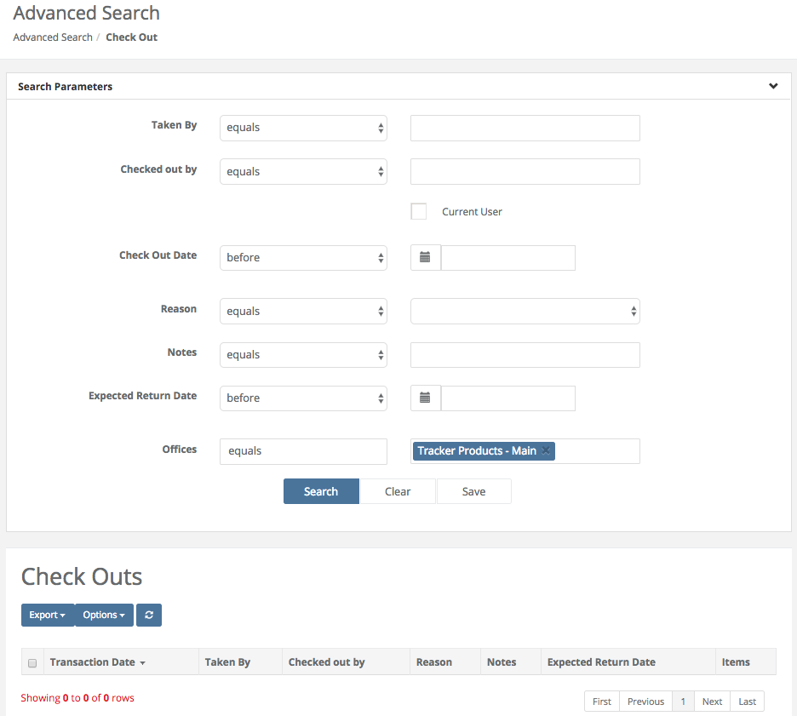
Fields on the Advanced Search Check Out page
Taken By
Click anywhere in the Taken By field to bring up a list of options to choose from. Next, in the box to the right of the Taken By field, type in a User for your search parameter.

Checked Out By
Click anywhere in the Checked Out By field to bring up a list of options to choose from. Next, in the box to the right of the Checked Out By field, type in a User for your search parameter.

Check Out Date
Click anywhere in the Check Out Date field to bring up a list of options to choose from. Next, in the calendar box to the right of the Check Out Date field, type in a date, or click the calendar icon and choose the Check Out Date you’d like.

Reason
Click anywhere in the Reason field to bring up a list of options to choose from. Next, click anywhere in the box to the right of the Reason field, to bring up a list of options to choose from, such as Court or Lab etc.

Notes
Click anywhere in the Notes field to bring up a list of options to choose from. Next, in the box to the right of the Notes field, type in Notes for your search parameters.

Expected Return Date
Click anywhere in the Expected Return Date field to bring up a list of options to choose from. Next, in the calendar box to the right of the Expected Return Date field, type in a date, or click the calendar icon and choose the Expected Return Date you’d like.

Offices
Click anywhere in the Offices field to bring up a list of options to choose from. Next, in the box to the right of the Offices field, type in an Office for your search parameter (your default office should already be listed).

Buttons on the Advanced Search Check Out page
Search
Once you have entered all of your parameters, click the Search button to search cases.

Clear
Click this button to reset all parameters.

Save
Click here to save a copy of the Search containing the parameters you’ve chosen.

Searching for Moves
Quick Menu » Search \ Moves

Depending on your level of permissions, you may or may not be able to Search for Moves. Click Search from the Quick Menu on the left hand side of the screen and select Moves. This takes you to the Advanced Search Move screen. From here, you can customize the search parameters by selecting boxes with the two small triangles (on the right side of the box). Choose from a number of variables depending on what Move(s) you’re searching for. When you are finished customizing your search criteria, click Search. This will show the Moves you searched for.

You may now click the Export Box and make selections you would like to export to a comma separated value (.csv) file.

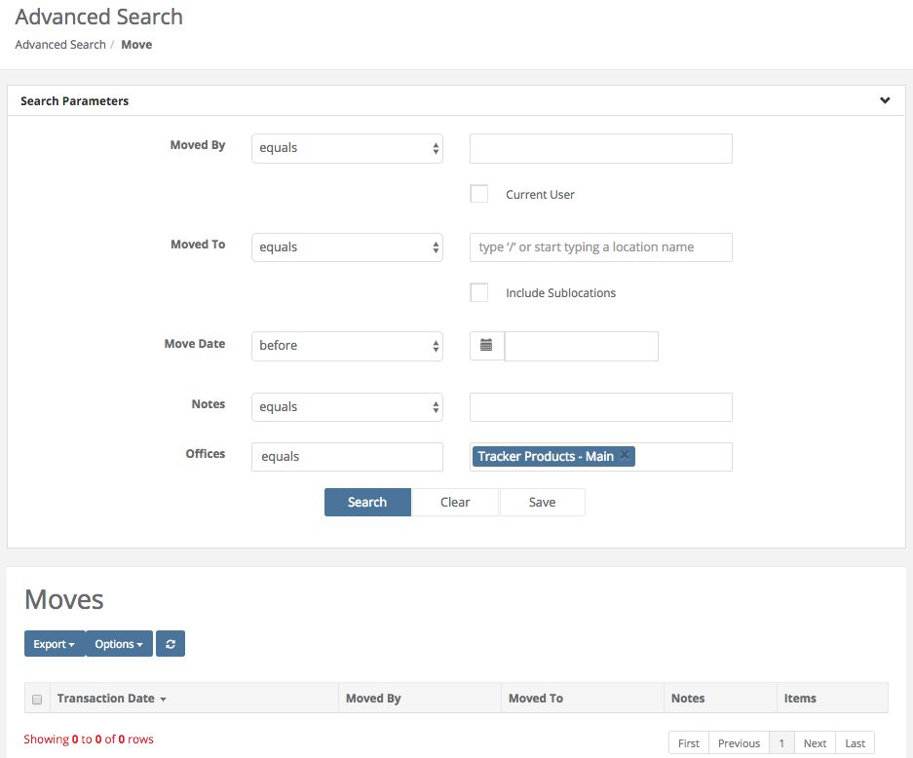

Fields on the Advanced Search Move page
Moved By
Click anywhere in the Moved By field to bring up a list of options to choose from. Next, in the box to the right of the Moved By field, type in a User for your search parameter.

Moved To
Click anywhere in the Moved To field to bring up a list of options to choose from. Next, in the box to the right of the Moved To field, type in the Storage Location for your search parameter. You may click the checkbox to Include Sub-locations in your search.

Move Date
Click anywhere in the Move Date field to bring up a list of options to choose from. Next, in the calendar box to the right of the Move Date field, type in a date, or click the calendar icon and choose the Move Date you’d like.

Notes
Click anywhere in the Notes field to bring up a list of options to choose from. Next, in the box to the right of the Notes field, type in Notes for your search parameters.

Offices
Click anywhere in the Offices field to bring up a list of options to choose from. Next, in the box to the right of the Offices field, type in an Office for your search parameter (your default office should already be listed).

Buttons on the Advanced Search Move page
Search
Once you have entered all of your parameters, click the Search button to search cases.

Clear
Click this button to reset all parameters.

Save
Click here to save a copy of the Search containing the parameters you’ve chosen.

Searching for Transfers
Quick Menu » Search \ Transfers

Depending on your level of permissions, you may or may not be able to Search for Transfers. Click Search from the Quick Menu on the left hand side of the screen and select Transfers. This takes you to the Advanced Search Transfer screen. From here, you can customize the search parameters by selecting boxes with the two small triangles (on the right side of the box). Choose from a number of variables depending on what Transfer(s) you’re searching for. When you are finished customizing your search criteria, click Search. This will show the Transfers you searched for.

You may now click the Export Box and make selections you would like to export to a comma separated value (.csv) file.

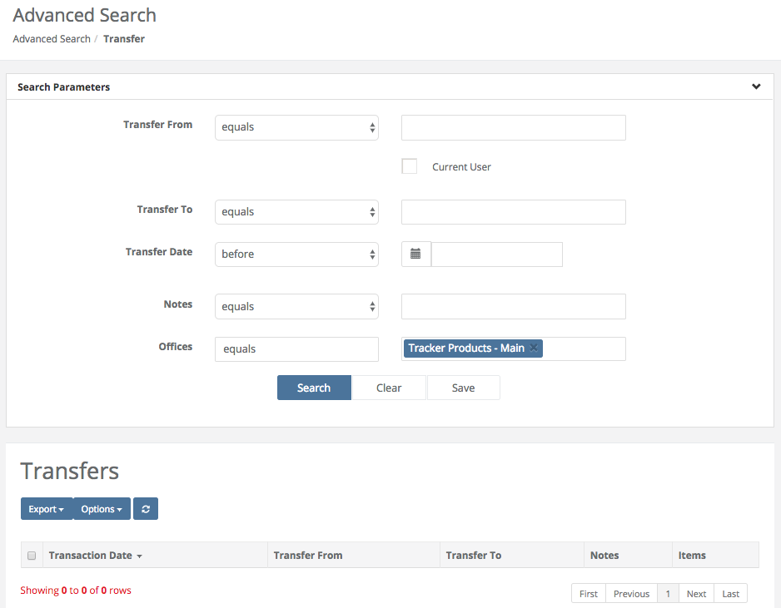

Fields on the Advanced Search Transfer page
Transfer From
Click anywhere in the Transfer From field to bring up a list of options to choose from. Next, in the box to the right of the Transfer From field, type in a User for your search parameter.

Transfer To
Click anywhere in the Transfer To field to bring up a list of options to choose from. Next, in the box to the right of the Transfer To field, type in a User for your search parameter.

Transfer Date
Click anywhere in the Transfer Date field to bring up a list of options to choose from. Next, in the calendar box to the right of the Transfer Date field, type in a date, or click the calendar icon and choose the Transfer Date you’d like.

Notes
Click anywhere in the Notes field to bring up a list of options to choose from. Next, in the box to the right of the Notes field, type in Notes for your search parameters.

Offices
Click anywhere in the Offices field to bring up a list of options to choose from. Next, in the box to the right of the Offices field, type in an Office for your search parameter (your default office should already be listed).

Buttons on the Advanced Search Transfer page
Search
Once you have entered all of your parameters, click the Search button to search cases.

Clear
Click this button to reset all parameters.

Save
Click here to save a copy of the Search containing the parameters you’ve chosen.

Searching for Notes
Quick Menu » Search \ Notes

Depending on your level of permissions, you may or may not be able to Search for Notes. Click Search from the Quick Menu on the left hand side of the screen and select Notes. This takes you to the Advanced Search Note screen. From here, you can customize the search parameters by selecting boxes with the two small triangles (on the right side of the box). Choose from a number of variables depending on what Note(s) you’re searching for. When you are finished customizing your search criteria, click Search. This will show the Notes you searched for.

You may now click the Export Box and make selections you would like to export to a comma separated value (.csv) file.

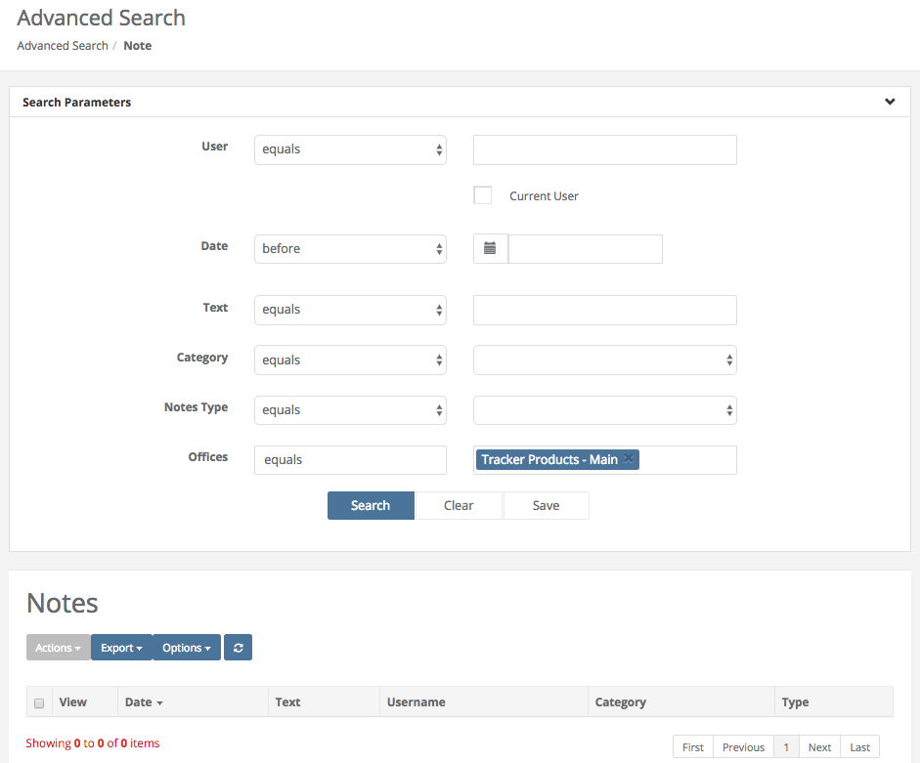

Fields on the Advanced Search Note page
User
Click anywhere in the User field to bring up a list of options to choose from. Next, in the box to the right of the User field, type in a User for your search parameter.

Date
Click anywhere in the Date field to bring up a list of options to choose from. Next, in the calendar box to the right of the Date field, type in a date, or click the calendar icon and choose the Date you’d like.

Text
Click anywhere in the Text field to bring up a list of options to choose from. Next, in the box to the right of the Text field, type in the text you would like to search for.

Category
Click anywhere in the Category field to bring up a list of options to choose from. Next, in the box to the right of the Category field, select the Category you would like to search for.

Notes Type
Click anywhere in the Notes Type field to bring up a list of options to choose from. Next, in the box to the right of the Notes Type field, choose a selection from the list of available choices for your search parameters.

Offices
Click anywhere in the Offices field to bring up a list of options to choose from. Next, in the box to the right of the Offices field, type in an Office for your search parameter (your default office should already be listed).

Buttons on the Advanced Search Note page
Search
Once you have entered all of your parameters, click the Search button to search cases.

Clear
Click this button to reset all parameters.

Save
Click here to save a copy of the Search containing the parameters you’ve chosen.

Searching for Media
Quick Menu » Search \ Media

Depending on your level of permissions, you may or may not be able to Search for Media. Click Search from the Quick Menu on the left hand side of the screen and select Media. This takes you to the Advanced Search Media screen. Here you can customize the search parameters by selecting boxes with the two small triangles (on the right side of the box). Choose from a number of variables depending on what Media(s) you’re searching for. When you are finished customizing your search criteria, click Search. This will show the Media you searched for.

You may now click the Export Box and make selections you would like to export to a comma separated value (.csv) file.

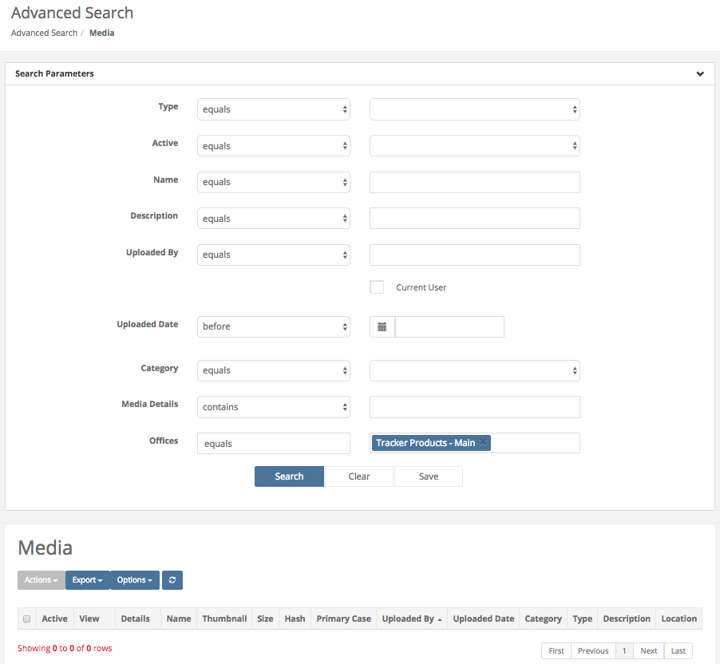

Fields on the Advanced Search Media page
Type
Click anywhere in the Type field to bring up a list of options to choose from. Next, in the box to the right of the Type field, select the Category the Media belongs to that you would like to search for (for example, does the Media relate to an Item or a Person etc.).

Active
Click anywhere in the Active field to bring up a list of options to choose from. Next, in the box to the right of the Active field, choose a selection from the list of available choices for your search parameters.

Name
Click anywhere in the Name field to bring up a list of options to choose from. Next, in the box to the right of the Name field, type in the Name of the Media you would like to search for.

Description
Click anywhere in the Description field to bring up a list of options to choose from. Next, in the box to the right of the Description field, type in a Description of the Media you would like to search for.

Uploaded By
Click anywhere in the Uploaded By field to bring up a list of options to choose from. Next, in the box to the right of the Uploaded By field, type in a User for your search parameter.

Uploaded Date
Click anywhere in the Uploaded Date field to bring up a list of options to choose from. Next, in the calendar box to the right of the Uploaded Date field, type in a date, or click the calendar icon and choose the Uploaded Date (of the Media) you’d like.

Category
Click anywhere in the Category field to bring up a list of options to choose from. Next, in the box to the right of the Category field, select the Category you would like to search for.

Media Details
Click anywhere in the Media Details field to bring up a list of options to choose from. Next, in the box to the right of the Media Details field, type Media Details you would like to search for.

Offices
Click anywhere in the Offices field to bring up a list of options to choose from. Next, in the box to the right of the Offices field, type in an Office for your search parameter (your default office should already be listed).

Buttons on the Advanced Search Media page
Search
Once you have entered all of your parameters, click the Search button to search cases.

Clear
Click this button to reset all parameters.

Save
Click here to save a copy of the Search containing the parameters you’ve chosen.

Searching for Tasks
Quick Menu » Search \ Tasks

Depending on your level of permissions, you may or may not be able to Search for Tasks. Click Search from the Quick Menu on the left hand side of the screen and select Tasks. This takes you to the Advanced Search Task screen. Here you can customize the search parameters by selecting boxes with the two small triangles (on the right side of the box). Choose from a number of variables depending on what Task(s) you’re searching for. When you are finished customizing your search criteria, click Search. This will show the Task(s) you searched for.

You may now click the Export Box and make selections you would like to export to a comma separated value (.csv) file.

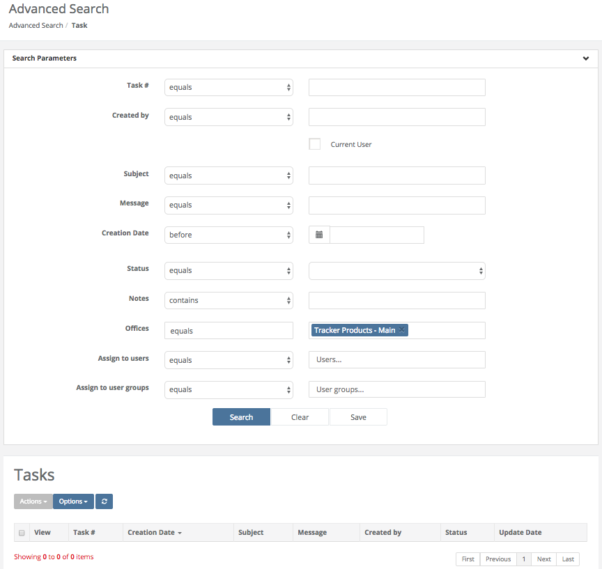
Fields on the Advanced Search Task page
Task #
Click anywhere in the Created by field to bring up a list of options to choose from. Next, in the box to the right of the Task # field, type in a Task #.

Created by
Click anywhere in the Created by field to bring up a list of options to choose from. Next, in the box to the right of the Created by field, type in a User for your search parameter.

Subject
Click anywhere in the Subject field to bring up a list of options to choose from. Next, in the box to the right of the Subject field, type in the Subject of the Task you would like to search for.

Message
Click anywhere in the Message field to bring up a list of options to choose from. Next, in the box to the right of the Message field, type the Message from the Task you would like to search for.

Creation Date
Click anywhere in the Creation Date field to bring up a list of options to choose from. Next, in the calendar box to the right of the Creation Date field, type in a date, or click the calendar icon and choose the Creation Date you’d like.

Status
Click anywhere in the Status field to bring up a list of options to choose from. Next, in the box to the right of the Status field, select the Status of the Task you would like to search for.

Notes
Click anywhere in the Notes field to bring up a list of options to choose from. Next, in the box to the right of the Notes field, type a Note from the Task you would like to search for.

Offices
Click anywhere in the Offices field to bring up a list of options to choose from. Next, in the box to the right of the Offices field, type in an Office for your search parameter (your default office should already be listed).

Assign to Users
Click anywhere in the Assign to Users field to bring up a list of options to choose from. Next, in the box to the right of the Assign to Users field, type Users the Task was assigned to.

Assign to User Groups
Click anywhere in the Assign to User Groups field to bring up a list of options to choose from. Next, in the box to the right of the Assign to User Groups field, type the User Group the Task was assigned to.

Searching for Exported Searches
Quick Menu » Search \ Exported Searches

Click Search from the Quick Menu on the left hand side of the screen and select Exported Searches. This will take you to the Export Jobs screen. From here, you can export a search to a comma separated value (.csv) file by first highlighting the item you want, and then clicking the Download link. 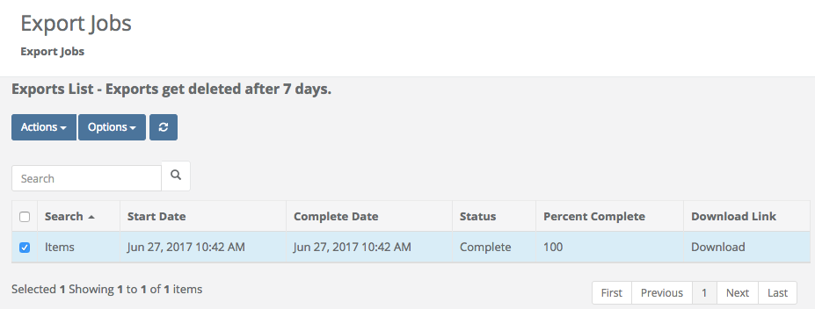

Using Quick Search
Once you’ve created all of your information in the system you may wish to use the Quick Search option to search for Cases. From the magnifying glass icon in the upper right hand corner of the screen, as soon as you start typing in the Find a [Case] field, a list of available options will appear for you to choose from.

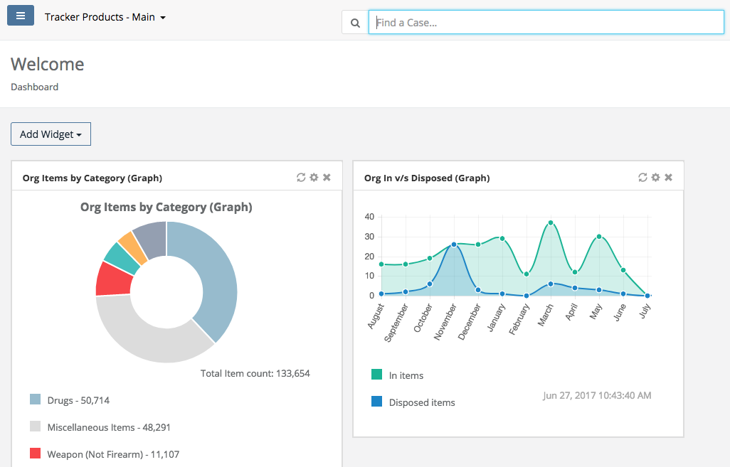

Dashboard Icon and Creating Widgets
Quick Menu » Dashboard

1. Click Dashboard from the Quick Menu on the left hand side of the screen. This will take you to the Dashboard screen you can personalize by creating Widgets (shortcuts relating to saved searches), or by copying Widgets that have already been created by other Users.

2. You can customize/personalize this screen with multiple Widgets (shortcuts relating to saved searches) that will save you time by minimizing the need to perform repeated searches. Click the Add Widget box, then select from the drop down menu of pre-made Widgets you want to add. You now have a personalized screen of Widgets (shortcuts/saved searches) to choose from. To ‘refresh’ a Widget, click the two arrows forming a circle in the Widget box. To rename a Widget, click the icon that looks like a star. Finally, to close a Widget, click the ‘x’ in the box of that particular Widget.

3. If none of the pre-made Widgets are what you require, you may create your own. From the Dashboard screen, do a Search on Cases, Items, or People. Enter your parameters and then click the Save box to Save that Search. Next, from your Dashboard, click the Add Widget box.

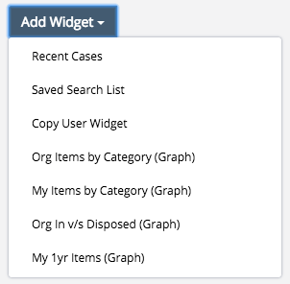

Then scroll down the list and click Statistics.

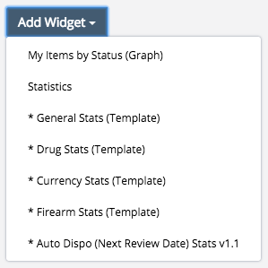

The Widget 1 box will then appear. Rename the Widget 1 box by clicking the icon that looks like a star, then give it a name of your choosing.

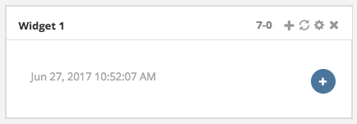
Next, click the blue circle with the plus symbol in it, and the Add Statistic page will appear.

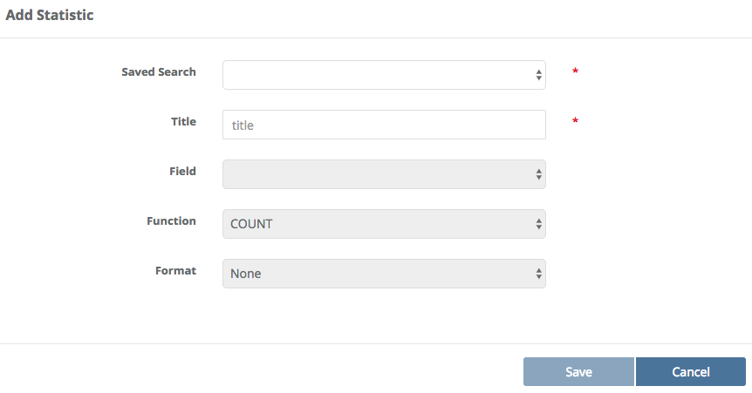

Give your Statistic Widget a Title. Next click the Saved Search box and choose from one of your saved searches. Then select a Field, Function and possibly Format and click Save (these will be auto-populated for you, so all you really need to do is click save). Your newly created Widget will then appear on your dashboard. A Green checkmark denotes you’re seeing All Offices in your Organization. A Red checkmark denotes you’re not seeing all Offices in your Organization.

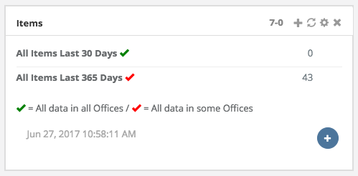

4. Any User can copy another User’s Widgets by clicking the Add Widget box on their Dashboard, then selecting Copy User Widget.

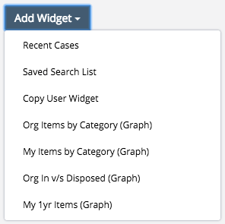

Next, enter the Widget ID located in the top right-hand corner of your Widget box, and click OK.

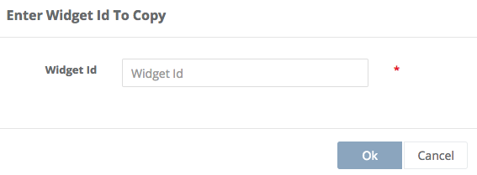

A copy of that User’s Widget will then be on the Dashboard.

5. Initially, a Widget is rather wide. To ‘scrunch’ your Widget, put your mouse cursor over the right edge of the Widget (until you see the double arrow <->), then click and drag to the left.
Your widget will then be smaller, allowing you to place more of them in the same space.

Deleting Saved Searches
Quick Menu » Dashboard

1. Click Dashboard from the Quick Menu on the left hand side of the screen. This will take you to the Dashboard screen. Next, click the Add Widget box and select Saved Search List.

A widget will then be created on your Dashboard screen which contains all of your Saved Searches.

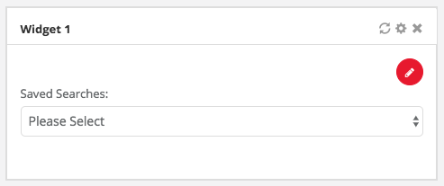

Click the red circle (with a pencil in it) on the Saved Searches widget you just created. Doing this will bring up your entire list of Saved Searches, which you may now manage. To delete a Saved Search you are no longer using, simply click the garbage can next to it.

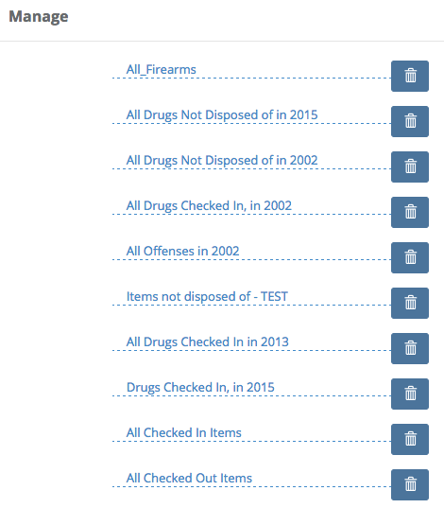

The system will then ask if you’re sure you want to delete the search. If you are, click Yes and the search will be deleted.

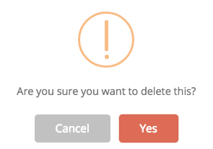

Scan Icon
Quick Menu » Scan

Click Scan from the Quick Menu on the left hand side of the screen. This will take you to the Scan Items screen. You may Scan Item(s) or manually enter a barcode(s). The software will let you know how many items you have scanned so far. From the Scan screen, once you have scanned your Items, you can do a Mass Disposal of Items – Drugs for example, or you could Check Out numerous Items at once. Simply click the Actions box and make a selection.

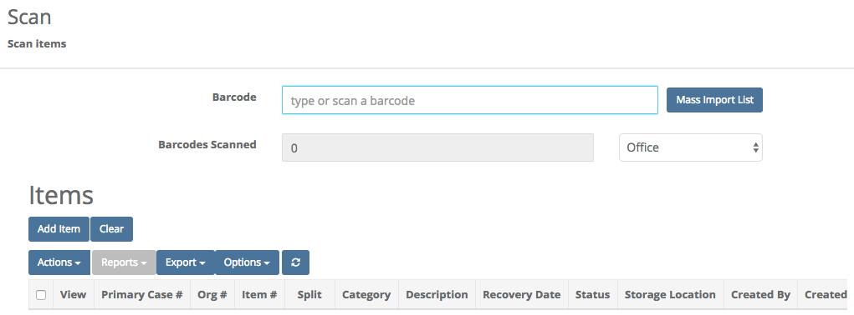

Note: If all columns aren’t visible, you may either remove some via the Options Box or scroll to the right with your mouse to view them.

Click Mass Import List to bring up a text area box you can now paste a large quantity of barcodes into for mass population of the Scan screen.

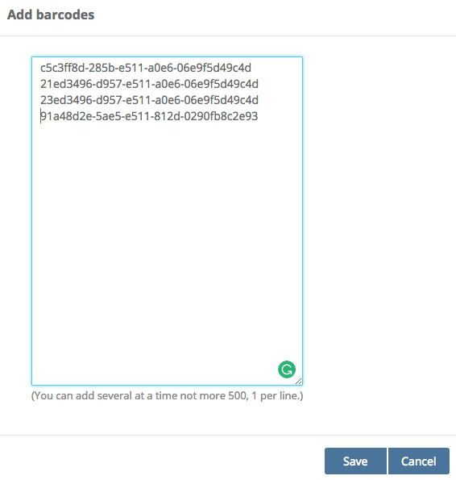

Save this list to have the barcodes populated.

Scanning Items from another Office or Organization
In the Scan area, you may also Check an Item Out from one Office or Org and Check that Item into another Office or Org. To do that, first Check out an Item. Next switch Offices or Orgs then go to the Scan area. If that Item is from another Office or Org, to the right of Barcodes Scanned, select System from the selectable list. You may then type or Scan the Barcode(s) of the Item(s).

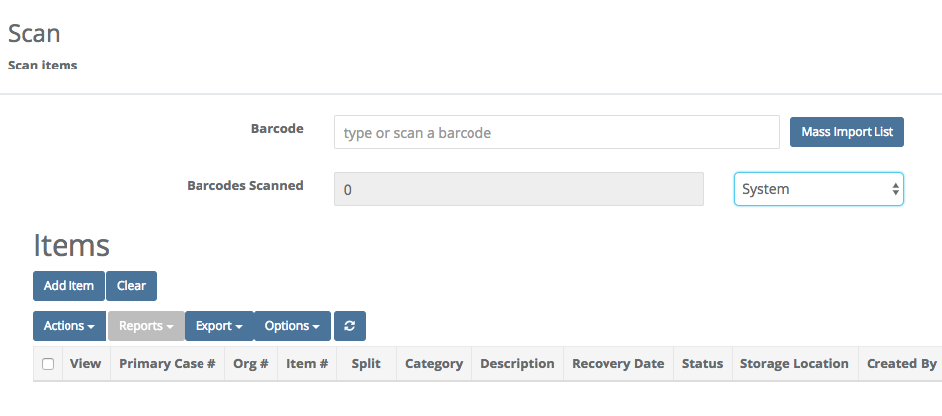

Tasks
Quick Menu » Tasks

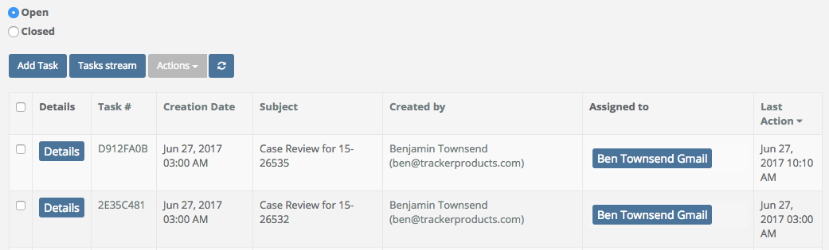

The SAFE Task system allows users within the software to communicate with other system users. The key feature being that all communication takes place within the software, where it can be tracked to a Case or Item, instead of outside of the system where communication is not documented for further review.

Typical Scenario:
- User A needs information from User B.
- User A initiates a system Task.
- User A fills in the task screen with information such as who the task is for (User B) along with a subject line and description.
- Upon submission User B will receive an email indicating that they have received a task from User A with a link back to the system.
- User B will login to the system and supply the requested information about the task.
- User A will receive a return email indicating that a response has been posted. User A can then respond to the task or close the task.

Tasks Menu Option
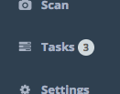

The menu bar (on the left) will have a link to the Tasks page along with a (#) that shows how many open tasks are assigned to you or in a group that you are a part of. Click on either of these options and you will be directed to the Tasks page.

Creating a Task
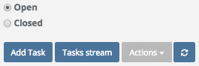

Click the ‘Add Task’ button to begin to generate a Task.

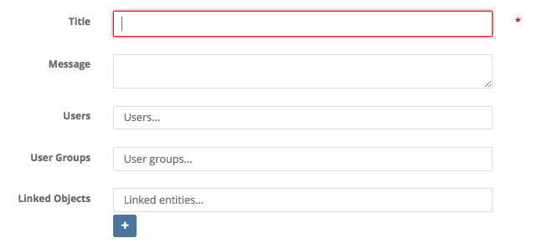

Title & Message – This is sort of like a Subject and Message for an email message. Fill in a Title (Subject) and message for the user or group you are going to assign the Task.

User – Begin to type the name or email of a user you want to get the Task.

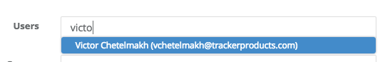
As you begin to type a name the options for that name will come up below.

User Groups – If you want to assign a Task to a group of users you will type in the name of the group here.

Note: If you are a Org Admin you can setup these groups in Settings > User Groups.

Note 2: Tasks can be generated for a user or group but must contain at least one user or group.

Linked Object – This is where you can associate a Task with a Case(s), Person(s) or Item(s).

User Groups
Quick Menu » Settings \ User Groups

User groups are for assigning tasks to Groups of users. When a task is assigned to a group, all users in the group will get the task along with a notification email.

To add users to the group, go to Settings > User Admin. Select the users for the group and go to Actions > Add to Group.

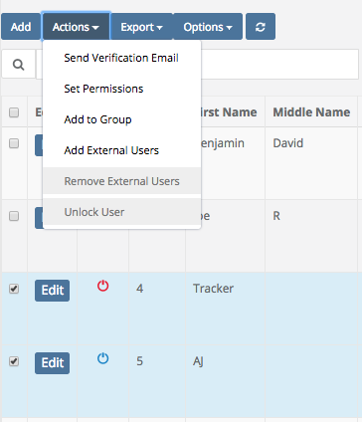

Users that are a part of a group will be shown in the User grid under the heading User Groups.

Adding a Case, Person or Item from Menu
While you can add a Case, Person or Item to a Task from within the Task creation screen, the far better option is to add these from their respective search pages.

Go to Search > Items. Search for all items entered in the last 10 days (assuming you have some items in this search). Search for the list of results.
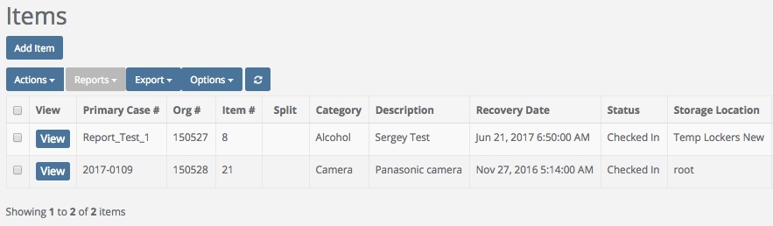

Now that I have a list of results, select all the items in this list and go to Actions > Add to Task

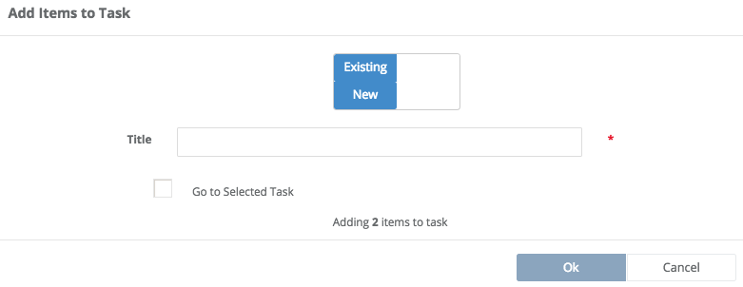

There is a slider on the top to add these items to an existing task or to create a new task. Click the slider for New.

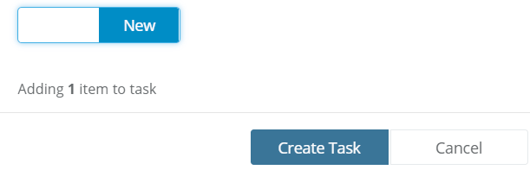

Click Create Task.

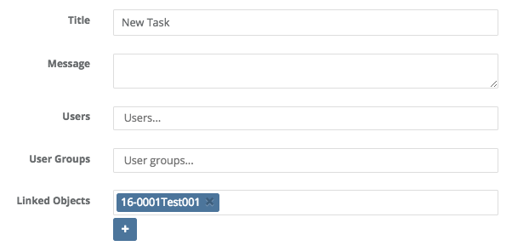

You are now redirected to the Task entry screen but all of your items are now in the list. Note: You can complete the same results by searching for Cases or Persons and adding to a Task.

Viewing a Task

Clicking on the Task menu on the left side of the screen will take you into the Tasks display area.

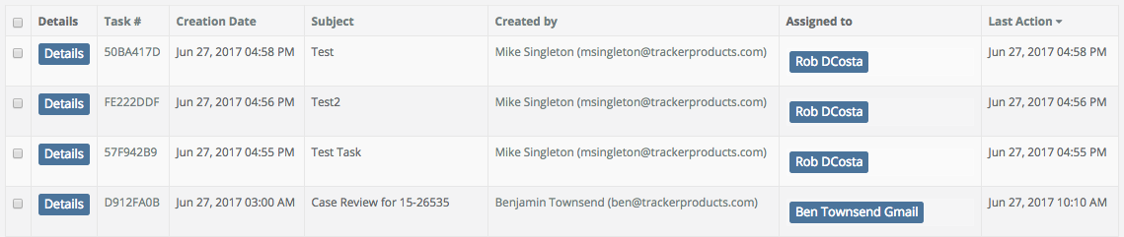

This page will show a list of all Tasks that you have created or are assigned to you. The list, by default, is sorted by the Last Action date column so you always get the most up to date task on top. You can of course resort the list by clicking on any of the headers.

The Tasks view page also has an option at the top to quick search for Tasks by Task # or Subject. Toggle the Open / Closed value to see Tasks that are open or Closed.
Each task will have a Details button that will take you into more details on the Task.

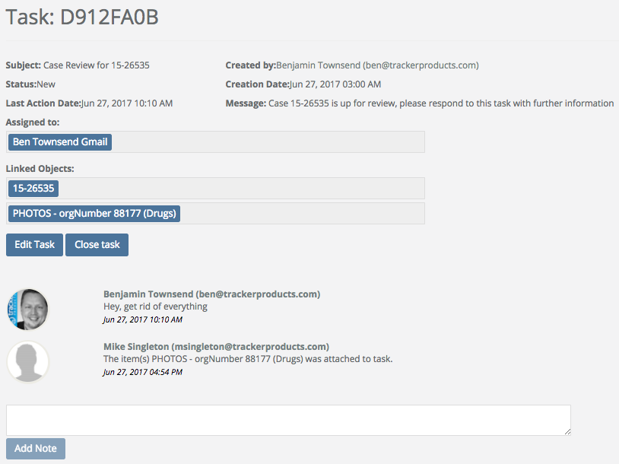

From this page you can see all of the Task details, who it is assigned to along with all notes on the task. If you created or are assigned the task you will have the option to Edit, Close or Add a Note to the task.

Task Email
All newly created or updated Tasks will generate an email to the recipient of the Task.

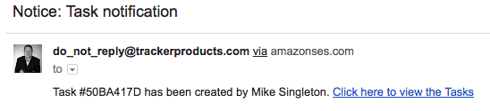

The email will contain information about the task and a short bit of info about the current status of the Task. The email will also contain a link back to the task in the system.

Task email with more details
By default, very little information about the Task is passed in the email. If you are an Administrator, you can go to Settings > Organization, and enable the option for the email to include more details. If enabled, the user will not only get a Task ID and what was updated, but they will get the actual log of the transaction.

Edit a Task
Only the creator of a task or assignee can edit the task.

To Edit a task, go to the Details button for the Task and click the Edit option.

Closing or Opening a Task
Any Open task can be closed and vise versa. From the Task menu you can open or close more than one task at a time.

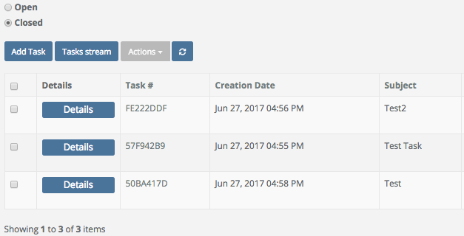

In this scenario I have my ‘Closed’ tasks screen open and I have selected three tasks. Go to Actions > Open tasks to open all the selected Tasks.

Task Security
The Org Admin can control who can create or view tasks in the system. Go to Settings > Permissions Groups. Click Permissions for the desired group.

There is now a new option at the bottom to control who can View or Create a task. By default, these are enabled for all Permission Groups in the entire system.

Task Search
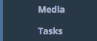

The Search menu contains a Tasks option which allows you to search across all Tasks in the system. From your Navigation Menu on the left hand side of the screen, you can click Search \ Tasks.

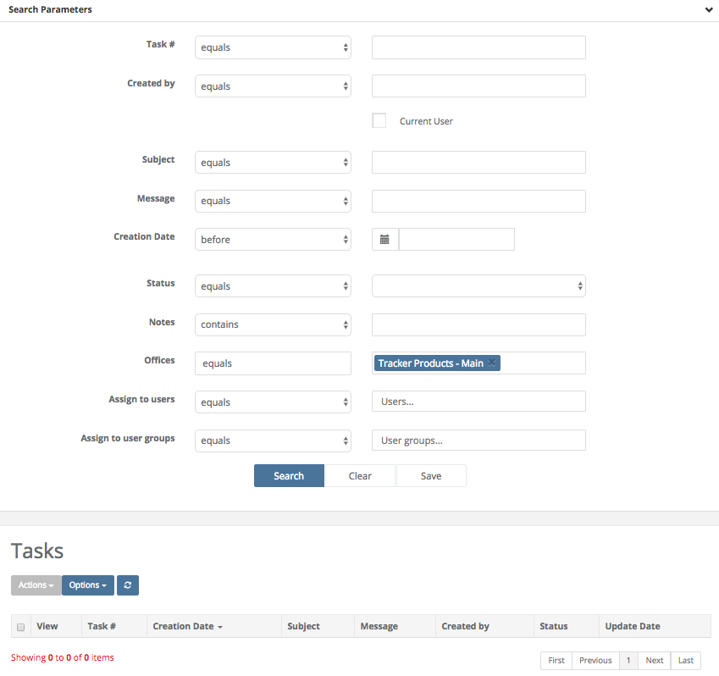

From here you search against any Task in your organization.

View a Task from with a Case, Person or Item view
The Case, Person and Item details screen will now have a new tab for ‘Tasks’.

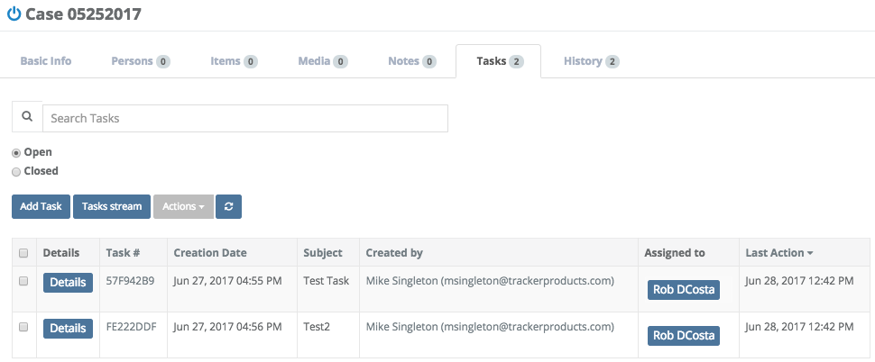

This Tab will show all Tasks that are, or have been, assigned to the object you are viewing. Like the Tasks menu you can go to details of the Task and work on it from there.

Task Stream
To view a list of all Task transactions, select ‘Tasks stream’ from the Tasks menu.
From this page, we see a list of all Task transactions in descending date order.

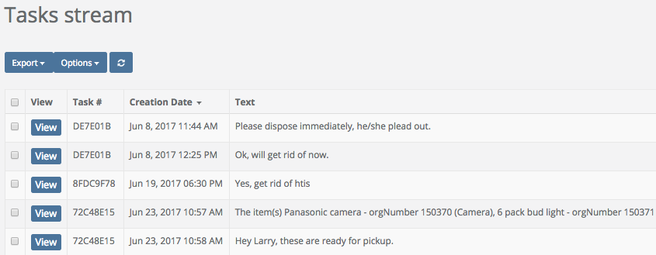

For more information regarding Tasks, please listen to our Webinar:
SAFE Sessions 2 - Tasks @ https://vimeo.com/207013802/02fd286346

Discrepancy Reports
Quick Menu » Discrepancy Reports

1. Given the appropriate Permissions from an Org Admin, you may access the Discrepancy Reports section of the software from the Quick Menu on the left hand side of the screen by selecting the Discrepancy Reports Icon (it has an exclamation point inside a triangle). You are now on the Discrepancy Reports screen. From here, you can choose which Storage Location you’re interested in running a report on.

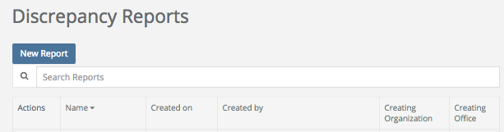

First click New Report and give your report a name and then scan or enter the barcode of the location you would like to audit.

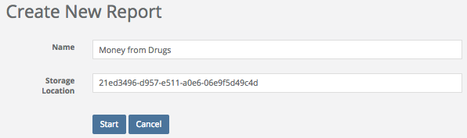

Next, Finally, click Start, or your Enter key.

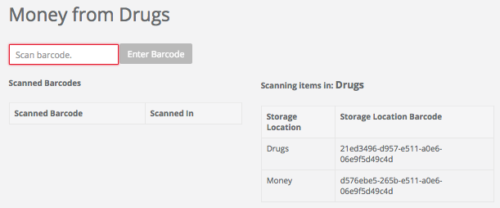

You may then begin scanning in barcodes from that particular Storage Location.

* Note where it says “Scanning Items in: __________ “. This is the current Storage Location where the Items are currently located. To change to a different (Nested) Storage Location, scan (or copy and paste) another Storage Location from the Storage Location Barcode (Nested List). In the above example, the only other Storage Location you may choose to scan is Money (since it is a Storage Location Nested under Drugs). Once the Storage Location has been changed, you may continue scanning Items, before finally running your report. *

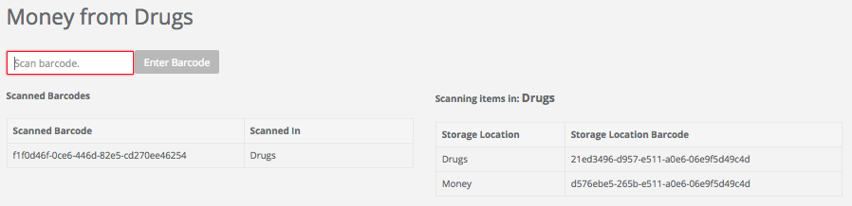

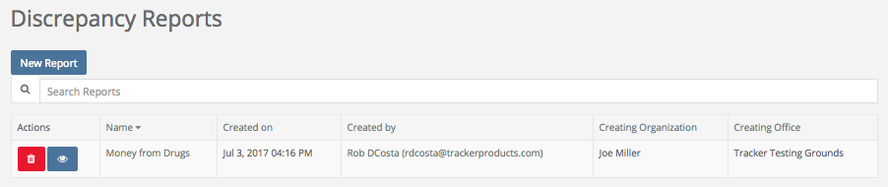

Once a report has been run, you will see a Discrepancy Report for the Storage Location(s) you specified. You may then view and print the report, go through the checklist, fix any discrepancies listed, sign and date it.

User Settings and Multi-Factor Authentication
Quick Menu » User Settings

Click User Settings from the Quick Menu on the left hand side of the screen. This will take you to the User Settings screen. Here, you can edit your First and Last Name, Phone Number etc.

For those needing an added level of site security, SAFE now supports 'Google Authenticator' multi-factor authentication (MFA). Simply download the Google Authenticator app on your phone and go to your User Settings. Edit your settings and enable Google Authenticator. This will force a screen scan and setup of MFA. Upon your next login you will be required to enter the MFA code for the site.

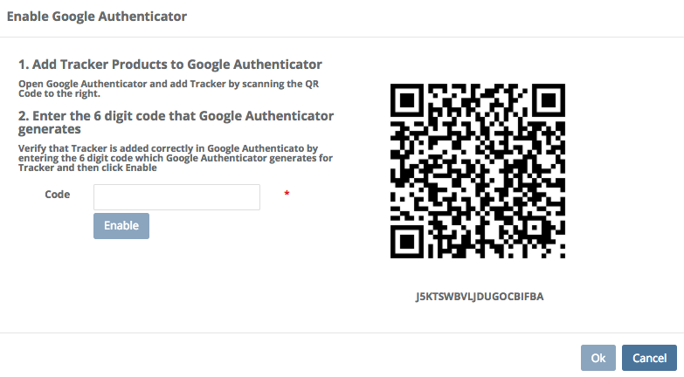

What is Multi-Factor Authentication (MFA)? MFA is a security system that requires more than one method of authentication from independent categories of credentials to verify the User’s identity for a login or other transaction. It provides an additional layer or security.

For more information regarding Multi-Factor Authentication, please listen to our Webinar:
SAFE Sessions 3 - Security Options @ https://vimeo.com/213138766/669ce2f31a

Collapsing the Quick Menu
Once you are familiar with the icons in your Quick Menu on the left hand side of your screen, if you’d like to have some extra room, you can collapse the Quick Menu by clicking the blue square box with 3 horizontal lines in it, next to the name of your office location in the upper left hand side of the screen. To re-inflate the menu, click the blue square box with 3 horizontal lines in it one more time.

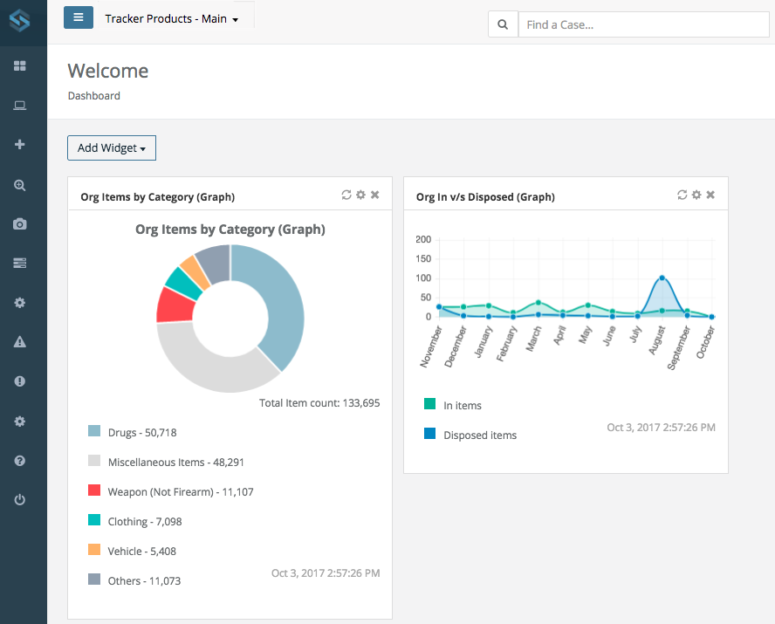

Logging Out of the software (Shared Archive For Evidence)
To Logout of the software, simply click the Logout field located in the lower left hand corner of the screen. If you do not Logout of the system, you will remain logged in until you are automatically logged out (by default) 30 minutes after your last activity. You will be given a 2 minute warning before you’re logged out.

Each User logged into the system is utilizing 1 Concurrent Access License (CAL) until you Logout. Make sure to logout of the system once you’re finished using it, or additional Users will not be able to log into the system if a CAL Limit is reached. You will then see a message stating that the Maximum Number of Concurrent Access Licenses has been reached.

