Shared Archive For Evidence

SAFE Reference Manual for Administrators
Version 10.26.2017

Table of Contents
Support: Submitting a support ticket 3
General Information: Overview 3
Before logging in for the first time 4
Logging into the software (Shared Archive For Evidence) 5
Can the software store my Password? 5
User Lockout and IP Address Blocking 6
Settings \ Organization 7
Settings \ Organization \ Auto Disposition 23
Overview 23
The Goal 23
How does auto disposition work, step by step (in very simplistic terms) 23
Enabling Auto Disposition 24
Case Entry being Disabled 27
Case Entry or Edit 28
Case Open or Close Option 28
Tasks 29
Mass Updating a Case 29
Mass Updating an Item 29
Auto Disposition Template Widget 30
Warning - Resistance ahead! 30
Settings \ Offices 31
Settings \ Storage Locations \ Sorting Imported Storage Locations 35
Settings \ Storage Locations \ Adding, Editing, Creating & Printing Labels for Storage Locations 40
Settings \ Custom Data (Forms) 44
Settings \ Permission Groups 48
Settings \ Permission Groups \ Office Based Permissions 51
Settings \ Security \ Location Based Permissions 54
Settings \ User Admin 55
Settings \ User Groups 64
Settings \ Data Import 66
Assisted Data Import Instructions 67
Overview 67
Finally, how much does data import cost? 68
Settings \ Sessions 68
Settings \ License Allocations 69
Settings \ Tags 70
Settings \ Report Builder \ Creating Reports 73
Settings \ Report Builder \ Creating Labels 79
Discrepancy Reports 83
Creating a Manual Inventory Report from an Item Search 85
Logging Out of the software (Shared Archive For Evidence) 88

Introduction
Welcome to the Reference Manual for Administrators. This document is fully accessible to our current and potential customers. Comments or suggestions can be sent to support@trackerproducts.com or by calling (866) 438-6565. You can also visit our website at http://www.trackerproducts.com for more information. We’re always here to help!

Support: Submitting a support ticket
You can submit support requests on our online ticket page. To begin, go to https://support.trackerproducts.com/ and follow the instructions.

General Information: Overview
Software administrators should consult the following list of action items before any training is conducted. Some of the items on this list may require a role assignment that needs to be made.

1. Does your agency / department have at least 1 full time technical person that handles your computers and network?
a. Please provide this person’s contact information.
(Name, Title, Email, Phone Number and Cell Phone)
2. Who needs to view system information (other than the property room controller)?
3. Explain your current evidence process from collection to disposition.
a. How is evidence collected at the crime scene?
b. Is there a document that explains packaging standards?
c. How many forms are used for processing? (Submission, Lab)
d. How is evidence submitted to property room?
e. Explain your organization’s temporary locker process.
f. How do officers and courts request access to items?
g. How do you communicate with others about item disposition?
h. Who approves disposition of items?
i. How often are inventories scheduled to be completed?
4. How many units deal with evidence?
a. Do each of these departments use the same process for identifying a piece of evidence (i.e. case number, incident numbers, etc.)? In some cases we have seen separate units assigning their own identifying number to an item and each unit tracking those numbers.
5. How do items get to the lab? Who drops them off?
6. Who is going to input items into the software system? Will it be an officer or the property/evidence custodian?
7. How many facilities do you use to store items? How many lockable rooms are in each of these facilities?
8. Who sets and approves all policies and procedures?

Before logging in for the first time
For security reasons, the software requires the use of a supported web browser, this will help minimize security vulnerabilities. It is recommended you make sure your Users are using the newest version of any web browser, and also suggested keeping it up to date by configuring it to perform automatic updates. You may also perform manual updates on a regular basis in addition to automatic updates to double check you are up to date.

If you are using an unsupported web browser (such as Microsoft’s Internet Explorer 9), and see the following screen, please update your browser before continuing!

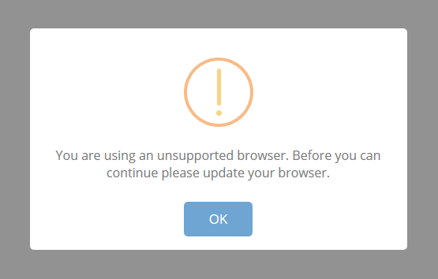

We also suggest updating whatever Operating System you are using to a supported one. For example, Microsoft Windows XP is no longer supported, while Windows 10 mainstream support will continue until October 13, 2020. Finally, it goes without saying, always keep your antivirus, firewall etc. software up to date!

Logging into the software (Shared Archive For Evidence)
Logging into the software is as simple as opening your browser of choice and typing in your site link. Our support department will provide this link. If this link is entered correctly, you will see a login page like the screen below. Enter your Email and Password to log into the system. If you see anything other than this login screen, you will need to contact Support for further assistance.

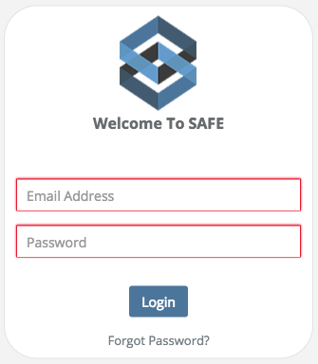

Can the software store my Password?
Saving Names and Passwords is NOT a feature of the software for obvious security reasons. Instead, this is a function of the web browser you are using. When any web browser asks if you, or your Users would like to save Name(s) and Password(s), select No. If a user has inadvertently saved their Name and Password, it is the Administrator’s job to delete those saved Names and Passwords and clear the web browser’s cache. There are a number of online articles on how to best accomplish this, depending on which web browser you are using (We have provided some useful links on our Support Help Center website for this purpose). As the Administrator, you should also routinely check all web browser settings and clean the cache to make 100% sure nothing has been, or is being saved.

User Lockout and IP Address Blocking
As a safeguard to prevent password hacking and brute force attacks, the software requires each user to have a unique username and password that must be entered each time a user logs on. Password strength parameters are enforced by the application and include: Password lengths of 10-128 characters, passwords cannot contain 2 identical characters in a row, must contain at least 3 character types out of 4 (upper case, lower case, numbers, and special characters), and passwords cannot be “reused” for one year. In addition, accounts are locked after 5 failed login attempts for a duration of 10 minutes or until unlocked by an Administrator.

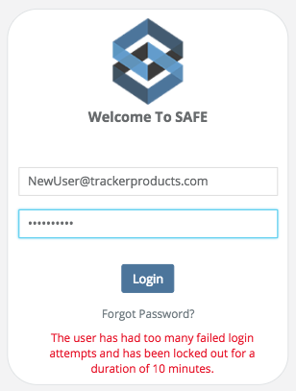

If you go into Users, the user who has been locked out will have a lock icon in the Active Column, otherwise, they are no longer locked out. Only an Org Admin can select the User and click the Actions drop down menu to Unlock the User.

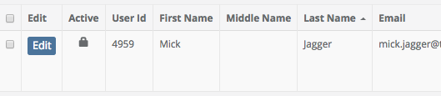

Settings \ Organization
Quick Menu » Settings \ Organizations

1. From the Quick Menu on the left hand side of the screen, select the Settings Icon (it looks like a wheel), then from the menu select Organization. You are now on the first Tab of the Organizations screen (Org Settings). From here, you can change the Time Out Settings, Default Signature Devices, Case Numbering Format, Person Formatting and Task Settings.

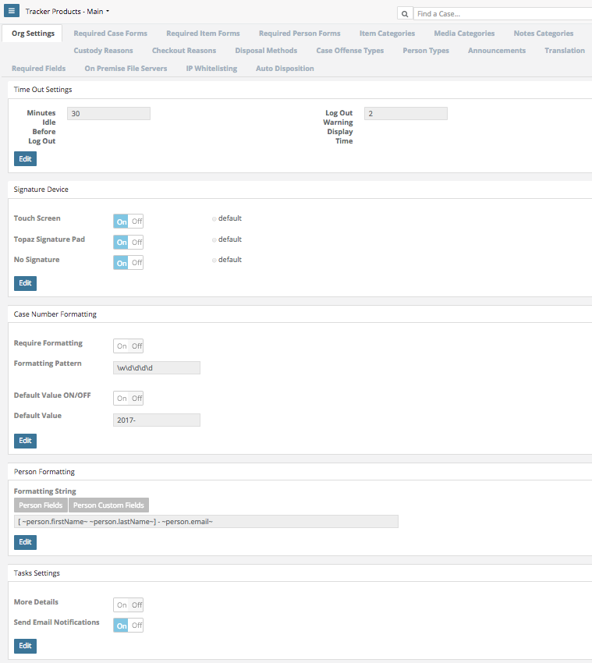
2. You may change the Time Out Settings by clicking the Edit box in that section and then selecting the Minutes a user is idle for before the system automatically logs them out. You can also change the number of minutes before a user is given a Logout Warning Display which will notify them how much time they have to remain idle before the system automatically logs them out.

3. If a Touch Screen or Topaz Signature Pad will be used, click the Edit box in the Signature Device section. Next, select which one(s) will be used by clicking the slider next to it’s name. To set it as the default option, click the radial default button and finally click the None slider from On to Off to deactivate / turn off that choice and click Save.

To Enable Signature Capture, go to Settings > Organization and enable the Topaz option.
Refer to the Topaz Systems SigWeb Installation Guide to walk you through the installation.
Go to http://www.topazsystems.com/Software/sigweb_install.pdf for instructions on installing the signature pad.

If your Topaz device is hooked up and driver installed, you will be able to enter a signature on any of the transaction screens, as shown below.

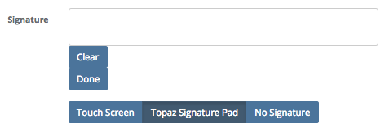

If a mouse will be used, click the Edit box in the Signature Device section. Next, select Touch Screen and click the slider next to it’s name to turn it on. To set the mouse as the default option, click the radial default button (next to Touch Screen) and finally click the None slider from On to Off to deactivate / turn off that choice and click Save.

4. To control the formatting of a case # upon case entry, if you are an Org Admin, go to Settings \ Organizations. On the Org Settings tab (the default tab), go to the Case Number Formatting section.

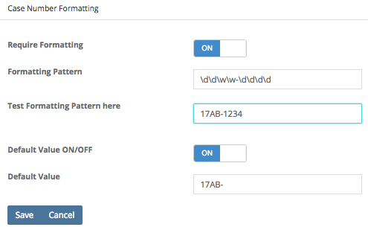

If you want to require a case # format, you need to turn On the Require Formatting Option. In the box titled Formatting Pattern, enter a valid pattern (see pattern options below).

In the Test Formatting Pattern here box, test the format you applied in Formatting Pattern. A valid pattern will leave the box glow blue and an invalid pattern will leave the box glow red.

You can also enable preset (by the administrator) default values for the Case # field by turning on the Default value on / off option.

NOTE: This formatting option is only applied for the new Case entry page. We did not apply this formatting to the Case update page so that you could add old cases or cases that do not apply to this format. So if you need to enter a case without these parameters, you must enter as a valid format and then update it to be anything you want.

Pattern Options: \d = A number value \w = A letter value

For example, \d\d-\d\d will require that the case number be something like 12-34. Anything other than two numbers, a hyphen, and then two more numbers will be invalid.

\w\d-\w\d will require a value like A1-B2

You can string numbers and characters in any format you like. For example, perhaps you would like your Case Numbers to be always have “17ES-” followed by 4 numbers. That would look like: Formatting Pattern: 17ES-\d\d\d\d with a Default Value of “17ES-“

5. In Person Formatting, you can change the way a Person is displayed on the Case View screen. For example, if you click the Edit box, then choose Last Name, First Name, and Email, then this is how a Person (see Case Officer) will appear (your choices will be in reverse order).

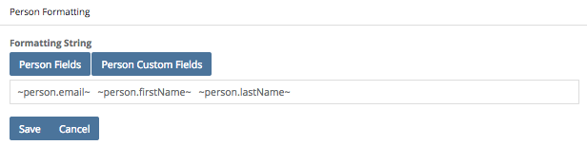

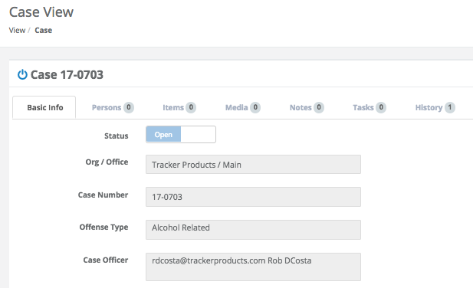

6. In Tasks Settings, click the Edit box and move the slider from Off to On to enable More Details about Tasks to be relayed via email. By default, very little information about the Task is passed along in the email. If you choose, you can go to Settings > Organization, and enable the option for the email to include more details. Once enabled, the user will not only get a Task ID and what was updated, but they will get the actual log of the transaction.

7. When a User enters a Case containing a particular Offense Type, you can attach a Form to their Case Entry screen. First, select the Required Case Forms Tab. Then, next to Select a Form, choose a Form you would like the User to fill out. You may then click the Select All box, or choose individual Offense Types from the scrollable list and click Save Changes. That particular Form will then be associated with the Offense Types you’ve chosen. Now, when you enter a Case that has an Offense Type(s) associated with the Form you selected, you will get that Form in addition to the default Case fields on the Case Entry screen.

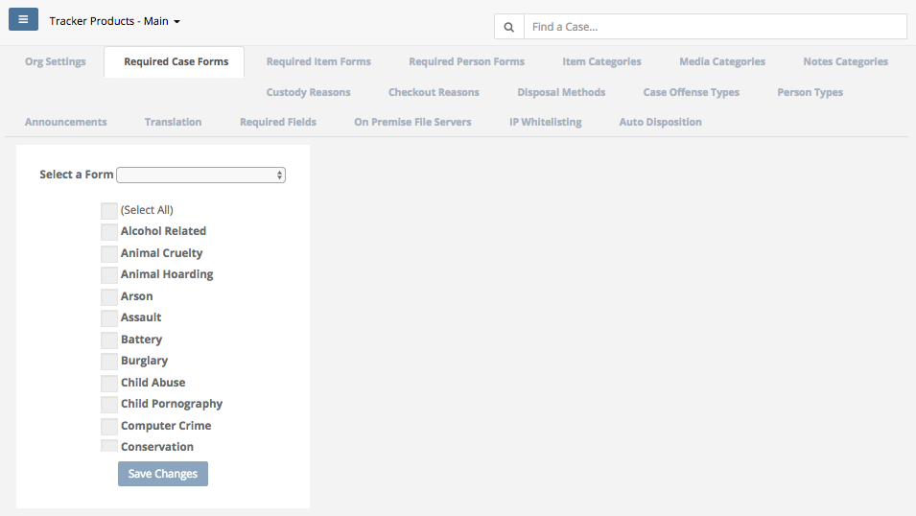

Note: If you add additional Case Offense Types after initially setting up the Required Case Forms, you will need to go back into each individual Required Case Form and add those Case Offenses to it.

8. When a User enters an Item contained in a particular Item Category, you can attach a Form to their Item Entry screen. First, select the Required Item Forms Tab. Then, next to Select a Form, choose a Form you would like the User to fill out. You may then click the Select All box, or choose individual Item Categories from the scrollable list and click Save Changes. That particular Form will then be associated with the Item Categories you’ve chosen. Now, when you enter an Item that has Item Categories associated with the Form you selected, you will get that Form in addition to the default Item fields on the Item Entry screen.

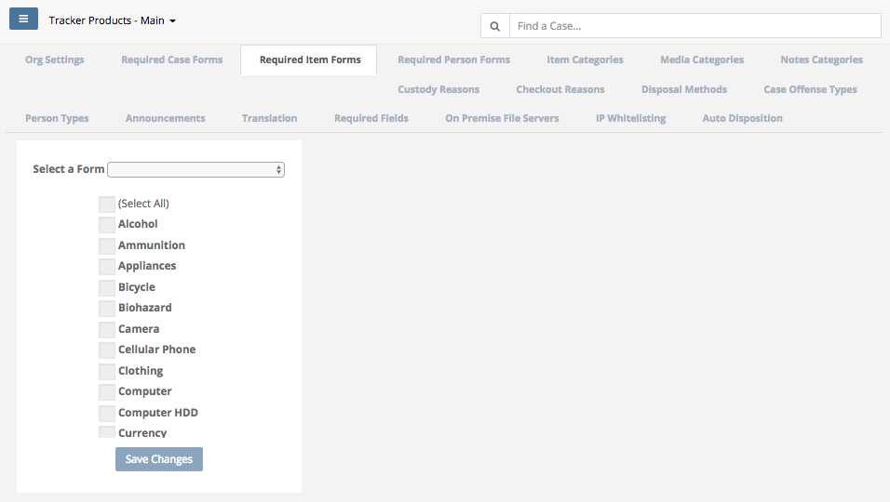

Note: If you add additional Item Categories after initially setting up the Required Item Forms, you will need to go back into each individual Required Item Form and add those Item Categories to it.

9. When a User enters a Person, you can attach a Form to that particular Person Entry screen. First, select the Required Person Forms Tab. Then, next to Select a Form, choose a Form you would like the User to fill out. You may then click the Select All box, or choose individual Person Categories from the scrollable list and click Save Changes. That particular Form will then be associated with the Person(s) Categories you’ve chosen. Now, when you enter an Person that has Person Categories associated with the Form you selected, you will get that Form in addition to the default Person fields on the Person Entry screen.

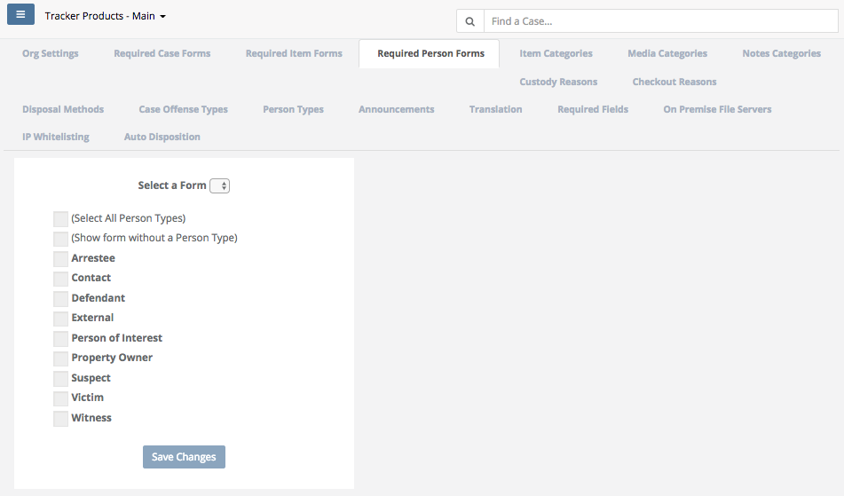

10. Select the Item Categories Tab to view and/or add items to the list of available Item Categories a user may select from when the Item Category field is displayed.

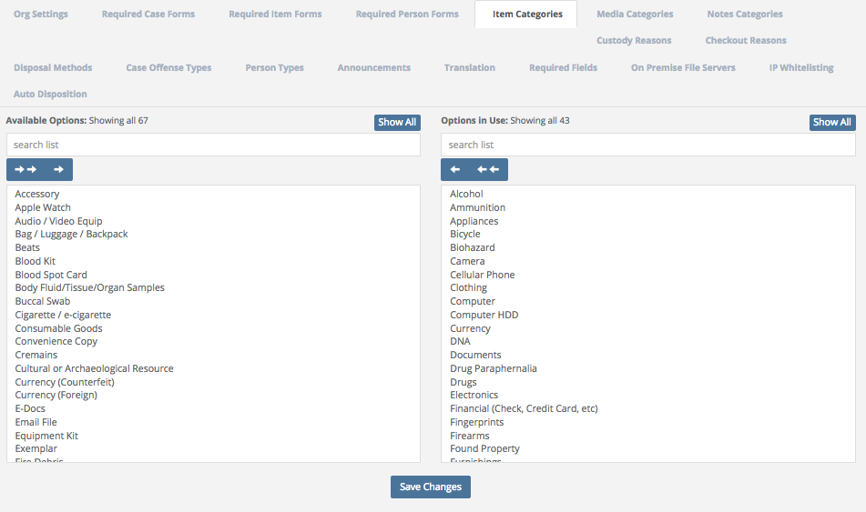

Item, Media, and Notes Categories, Custody Reasons, Checkout Reasons, Disposal Methods, and Case Offense Types are set across the system since it is designed to share data. Common fields such as those are necessary. If your agency/company has a field that you would like added to the system, please let us know. We have a group of advisors who help determine if a request is similar in nature to others, or if it warrants being added to the system. We have to keep the number of options in check otherwise the list of choices becomes unmanageable and people are less likely to take the time to scroll to the best option available.

11. Select the Media Categories Tab to view and/or add items to the list of available Media Categories a user may select from when the Media Category field is displayed.

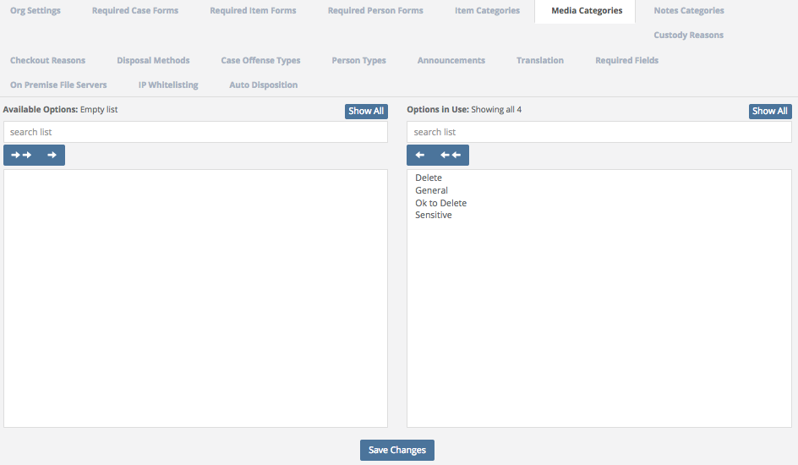

12. Select the Notes Categories Tab to view and/or add items to the list of available Notes Categories a user may select from when the Notes Category field is displayed.

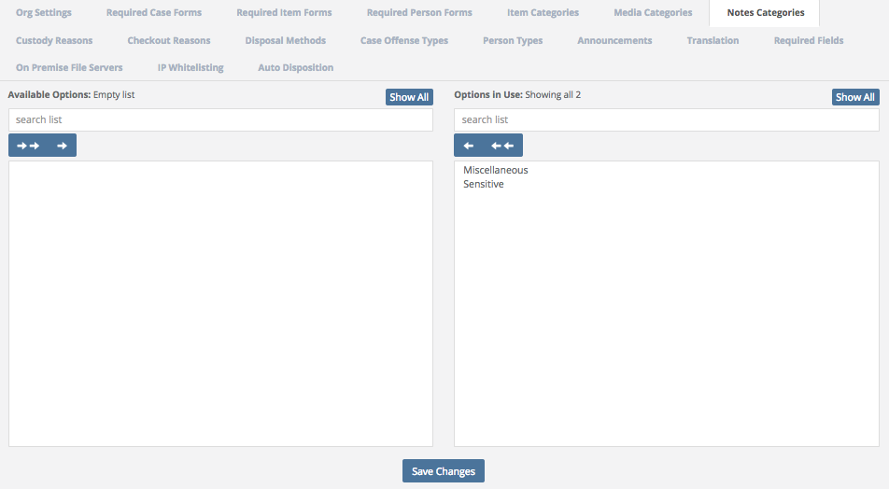

13. Select the Custody Reasons Tab to view and/or add items to the list of available Custody Reasons a user may select from when the Custody Reason field is displayed.

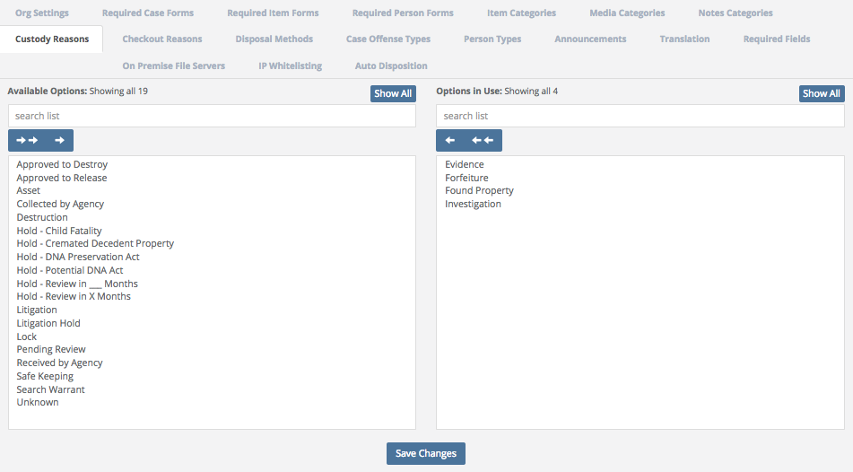

14. Select the Check Out Reason Tab to view and/or add items to the list of available Check Out Reasons a user may select from when the Check Out Reasons field is displayed.

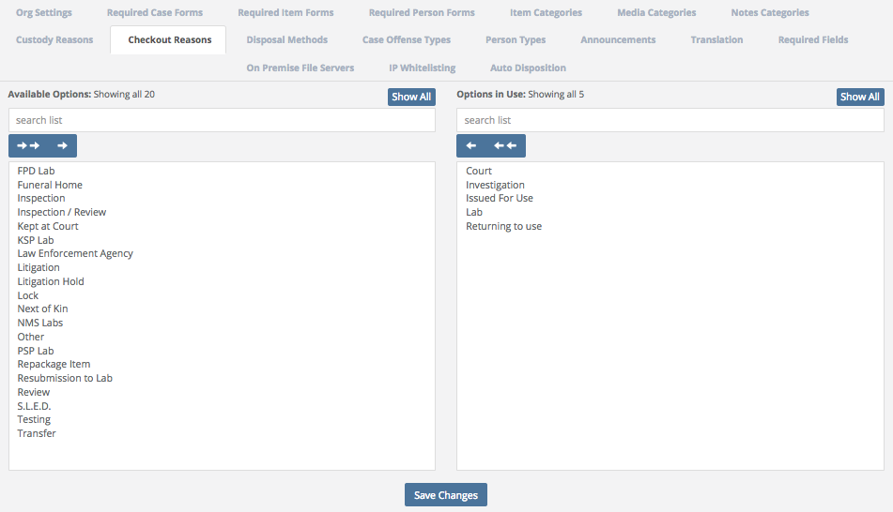

15. Select the Disposal Methods Tab to view and/or add items to the list of available Disposal Methods a user may select from when the Disposal Method field is displayed.

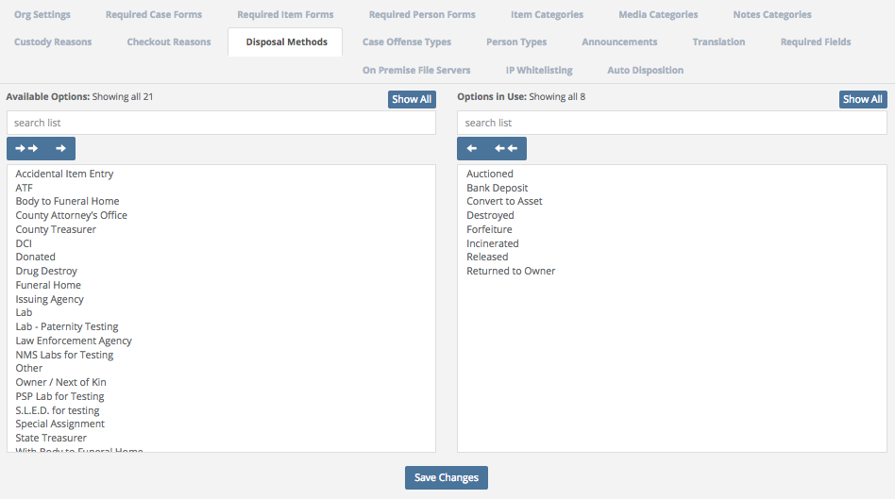

16. Select the Case Offense Types Tab to view and/or add items to the list of available Case Offenses a user may select from when the Case Offense field is displayed.

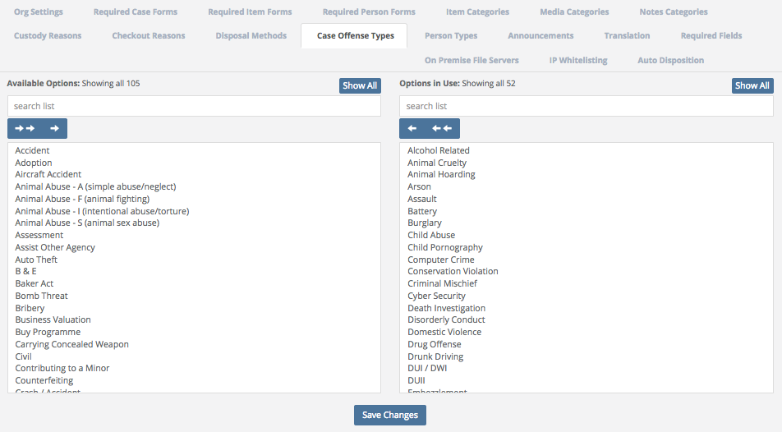

17. Select the Person Types Tab to view and/or add items to the list of available Person Types a user may select from when the Person Types field is displayed.

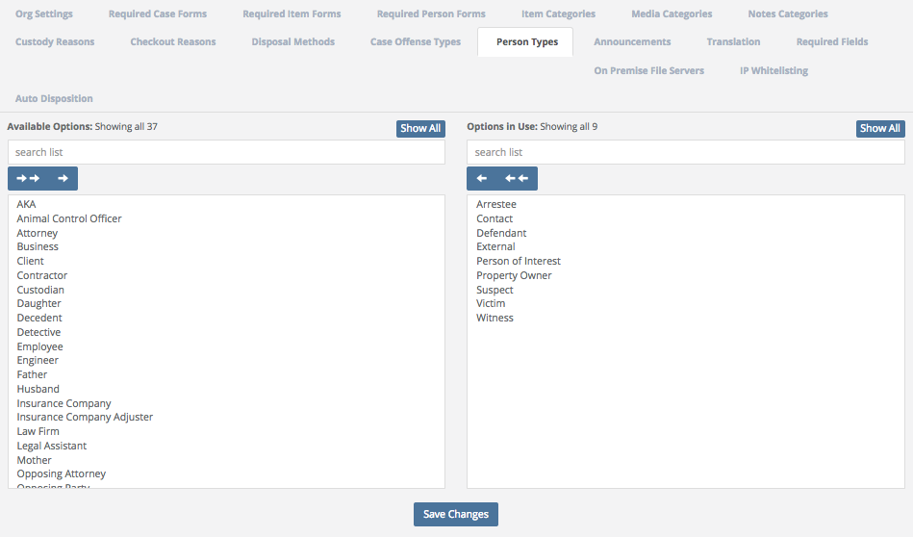

18. Select the Announcements Tab to Add, Edit or Delete Announcements.

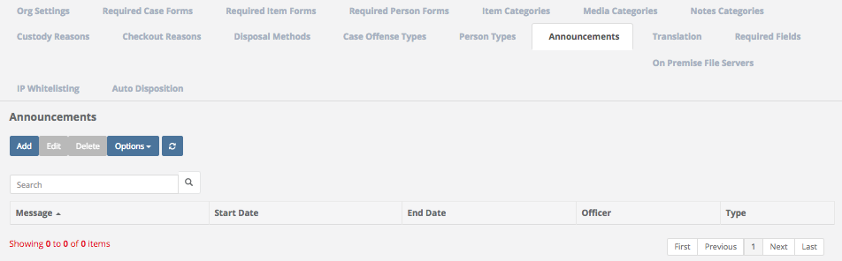

For example, you may want to have an Announcement warning Users to “Please be extra careful when entering items into the software!” when they are first learning the new software, or to let Users know of new regulations.

Click Add to bring up the Add Announcement screen. Next, type in the Required message you wish to display and give it a Required Start and End Date. Finally, select what Type of message you want to display. Will it be a Warning, Success or simply an Info message?

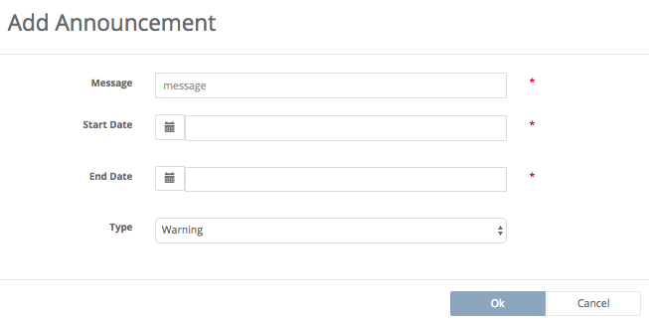

19. Select the Translation Tab to edit (most) any of the verbiage we use anywhere in the system. You can now change virtually (most) every word displayed in your site.

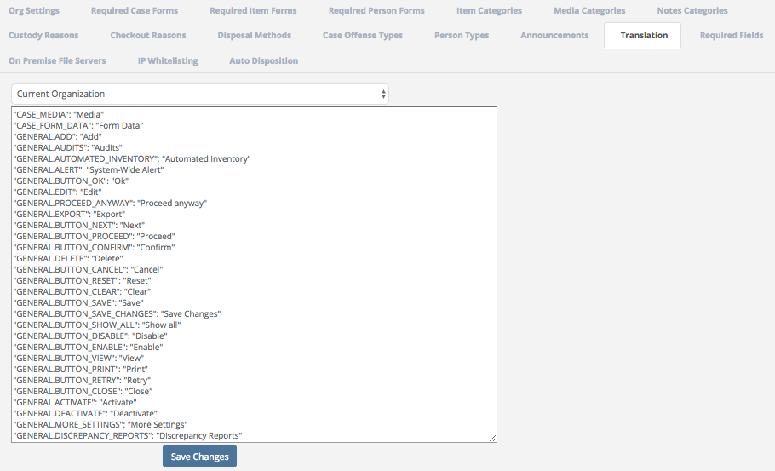

Go to Settings > Organization and click on the Translation Tab. There are hundreds of rows of translatable values.
NOTE: Only change the value in the second set of quotation marks. For example,
“Case_Media”: “Media”

Warning: Only change the Media value(s) inside the second set of question marks! Changing the first value(s) will only BREAK YOUR SITE.

NOTE: If you want to change something like Case Officer you might want to search the translation file for multiple instances of the word. Some agencies might want to change Case # to CAD #. There are most likely dozens of references to the word Case in the translation file.

20. You may also select the Required Fields Tab to turn on/off Make, Model, and/or Serial Number. Disabling these fields will prevent them from being show on any screens. More fields will be added to this screen in the future. This is a global change.

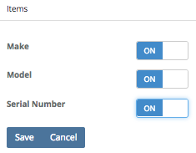

21. The On Premise File Servers Tab is used by Tracker IT and should NOT be modified in any way. The On Premise file service is a module that clients can use with our cloud based SaaS product to store and manage media files on-site. For example, video files such as body cam videos could remain on-site on a local storage disk, thereby eliminating the cloud storage fees for that particular data! More information regarding On Premise File Servers can be found by listening to our webinar:

SAFE Sessions 3 - Media and On Premise File Server @ https://vimeo.com/213138970/45faf15f72

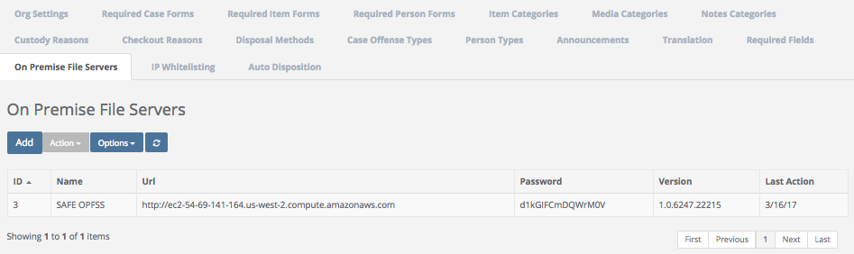

22. There is also the IP Whitelisting Tab. SAFE’s IP Whitelisting features allows the Org Admin for any Organization to lock down SAFE so that users in your Organization are only able to login from approved IP addresses. By default, there is no blocking in place. To restrict access, apply at least one valid IP Address.

Warning: If you enable an IP whitelist make sure you apply the IP address that you are using. If you apply an address that is not yours, you will block yourself out (not to worry, contact SAFE support and they will fix it).

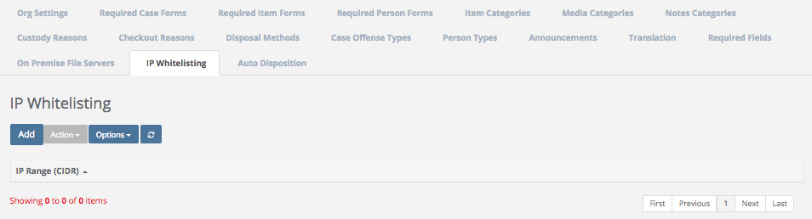

By default, the list is empty (meaning all IP addresses are allowed). Click ‘Add’ to enter your first IP Whitelist.

It is highly recommended that you first select ‘My IP’ so that you enter your own IP first.

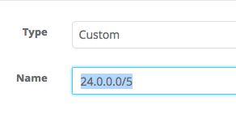
The Custom option will allow you to manually enter a IP address or range.

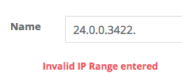
Invalid IP’s or ranges will be marked invalid and will not allow you to save them.

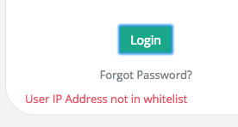

Users not within a valid IP address or range will be blocked while logging in.

For more information regarding IP Whitelisting, please go to our Webinar:
SAFE Sessions 3 - Security Options @ https://vimeo.com/213138766/669ce2f31a

Settings \ Organization \ Auto Disposition
Quick Menu » Settings \ Organization \ Auto Disposition Tab

Overview
The Auto Disposition feature of the SAFE program is an optional function that allows an Organization to automate the typically paper driven process of item disposition. Instead of relying on printed paper, you will allow the SAFE program to automatically assign a follow up date (you supply the parameters in setup) to each Case. When that review date arrives, an automated task will be assigned to the Case Officer, on behalf of the evidence custodian, advising that the case is up for review. That task will then be used, and recorded, so that all discussion back and forth will be used to help move an Item towards disposition. Through this process, far more evidence can be disposed of than normal manual or paper driven processes.

The Goal
The entire goal of the auto disposition system is to help an agency get rid of as much evidence as they bring in on an annual basis. One item goes out for every items that comes in!

How does auto disposition work, step by step (in very simplistic terms)
- Every case going into the system is automatically assigned a follow up date (legacy cases already in the system will have to be assigned a review date as part of a startup process).
- When the Review Date = today, the system will automatically generate a Task to the Case Officer (Task assignee) to review the Case and all Items.
- Task Assignee will review the Task and Case and supply a response (A and B below)
  - The Task Assignee suggests that you can’t dispose of items and you change the review date to a date further in the future (you are done with this case at this point and you can close the task).
  - The Task Assignee suggests you can dispose of items
    - If you only need permission from Task assignee to dispose of evidence, then proceed to Step 4.
    - If you need further permissions to dispose of evidence, then you edit the Task and assign to the new user. Go back to step 3 at this point.
- Item(s) that have been approved for disposition will need to be tagged.
- When it comes time to doing a disposition, you are going to Search for a list of items based on a Tag and export that list to Microsoft Excel.
- Collect all approved Items from storage locations.
- Dispose of Items and mark disposed in the system.
This list is for the general audience and not specific for every instance!

Enabling Auto Disposition
To enable the Auto Disposition feature, go to Settings > Organization > Auto Disposition (Tab)

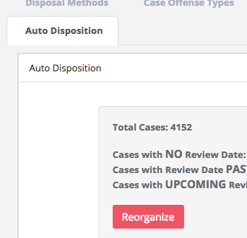

Click the Edit button (bottom of page) and turn on the Auto Disposition slider.

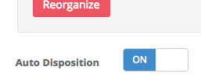

Once enabled, there are a couple of other options that must first be handled.

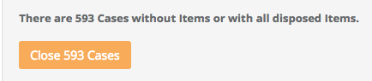

In the Case Review area (top of screen) you might see a yellow button that indicates how many Cases are open in your system that either 1. Have no items 2. Have all disposed items. These Cases should be closed as the system will send a Case Review email for any open Cases. Click the yellow button and apply a Case Closed date. Upon submittal, all of these Cases will be updated to an Inactive/Closed status and no emails will be sent.

Note: A closed Case is simply ‘closed’ in the system as denoted by the Open/Closed Status slider at the top of the Case View. If a Case has been ‘closed’, that Case has NOT been deleted from the system. The Case is still there and can be reopened at any time by an Org Admin by simply editing the Case and moving the Open/Closed Status slider at the top of the Case View to Open.
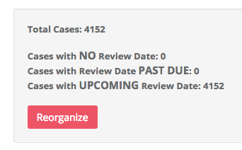

The Case Review section at the top of the page will show the current status of all Cases in your system. Most likely, if this is the first time you have enabled this feature, all of your Cases will have NO Review Date. You will want to click the Reorganize button to add a Review Date to all Cases.

Note: To get the system started, you are going to want to add a review date to all legacy Cases as the Auto Disposition feature, by default, will not send out notifications on Cases without a Follow Up Date.

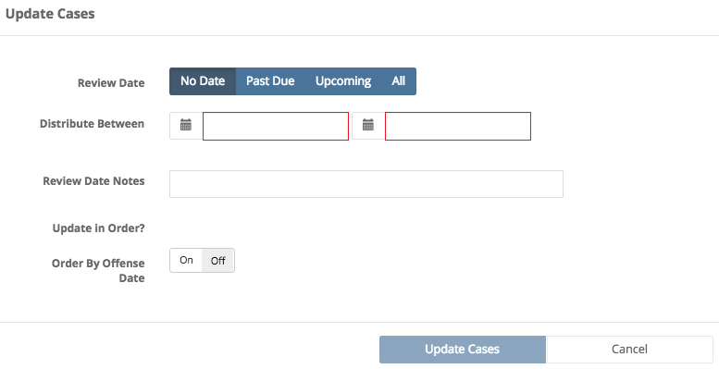

The reorganization page will allow you to choose what type of cases are going to be updated and what date range is applied.

- No Date selection means you will only update cases that do NOT have a date.
- Past Due selection means you will only update cases that have a Past Due date (used in case you decide to reorganize after you initially set all values, IE you got behind and wanted to start over).
- Upcoming selection means you will only update cases that have a Review Date that is in the future.
- All selection means that you will update all Cases in the system regardless of Review Date or not.
- Distribute Between is where you select the date range of all of your follow up dates. Select a date range that is adequate enough so that too many tasks are not being too quickly sent. If you have 5,000 cases and you select a 1-year distribution range, you will average almost 14 cases per day going out for review. It will distribute evenly over the time selected.

Note: You do NOT want tasks to go out to quickly. Users will ignore Tasks if they come to fast.

- Review Date Notes can be used to apply a note to all Cases en masse.
- Order By Offense Date will set a Review Date in order of Offense Date meaning that the oldest offenses will be sent for review first. In most cases you will allow the cases to be auto arranged over the time.

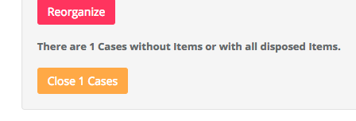
Your Auto Disposition tab in Settings might also have an option to Close any open Cases that do not contain any Items or any Items that are active. Since the Auto Disposition system will notify a Case Officer of any open cases, this is an option for Org Admins to close Cases that should be closed anyway.
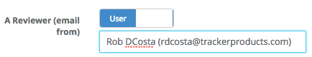
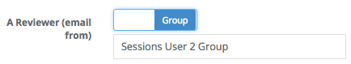

The field for ‘A Reviewer (email from)’ is used to assign who/whom the Task email is sent from. This is the User/Group that all Tasks will be assigned on behalf of. This will typically be the evidence custodian. You may prefer to allow a Group in the Auto Disposition 'A Reviewer email from' area. This allows all assigned Tasks to be sent on behalf of a Group instead of an individual User. This is particularly valuable in organizations with more than one evidence custodian.

To set up a Group, go to Settings \ User Groups, and you may Add one in that area.

Note: If a User is Deactivated, an email will still be generated and sent to that User’s email address (if they are the Case Officer). You may wish to update that email address to reflect that User’s Supervisor’s email address instead. In addition to that, if the Auto Dispo Widget has been turned on, you may see Overdue Tasks accumulating if no one is responding to them.
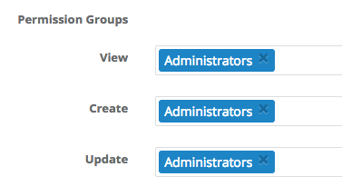
By default, only Org Admins will have access to Disposition Data. If you want to allow other groups to View, Create or Update the disposition data, you should do this in
Settings \ Permission Groups. Your choices will then be shown in Auto Disposition.
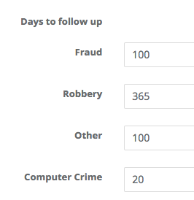
The final step in setting up Auto Disposition is to assign ‘Days to Follow Up’. Users who do not have access to setting up a Review Date, after entering a Case, these days will automatically be added to today’s date to determine the next Review Date. So in this example, if I am adding a Fraud Case, my Next Review Date will automatically be set to today's date + 100 days.

Note: Once this system in enabled, every Case will automatically be assigned a Next Follow Up Date. In fact, you will NOT be able to save the Auto Disposition Setup page until all Offense Types are given an X number of days.

Case Entry being Disabled
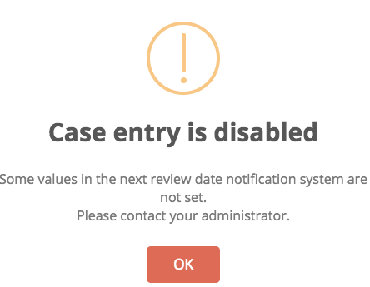

If you see the Case entry is disabled message on the Case entry screen, one of your Offense Types does not have an X days for that Offense. To clear, go back to Settings > Organization > Auto Disposition and make sure you have a value greater than 0 for all Offense types.

Case Entry or Edit
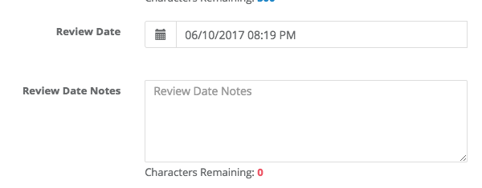
When entering a Case, there will be two new fields (Review Date & Review Date Notes). These fields will only show if you are an Org Admin or if your Permission Group has been granted access to these fields.

Note: You will want to limit these fields and who has access to them. By default, only Org Admins will have access and that should be more than enough for most. If you open access to these fields you might find that Users are kicking the Review Date too far in the future as to avoid having to deal with the review.

Case Open or Close Option
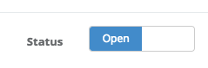
There is now a option on the Case entry or edit page to Open or Close a Case. The importance of this option is that items can’t be added to a Closed Case and you can’t Close a Case with undisposed items. This will help ensure that only open Cases are receiving new Items and valid follow up dates.

Tasks
On the day that the Case comes up for review (Review Date = today), the system will automatically create a Task for the Case Officer. The Case Officer will also receive an email that the task was assigned. The Case Officer will use this Task to communicate information about the Case. Of course, this information could be just about anything. For more information on Tasks and how to use tasks, see the Tasks area of the instruction guide.

Push a Case further down the road
If the User responds to the Task and suggests that there is nothing to do at this time, then update the Case Review date to a future date. On that future date, another Task will be sent out asking for an update. This process will continue until the Case is closed.

Tags
If the User suggests that it is ok to get rid of Item(s) in a Case, you are going to want to Tag that item for destruction. You will edit the individual Item or Mass Update many Items and apply a Tag. The Tag text can be anything you choose but this Tag will be used later for searching.

Mass Updating a Case
SAFE now allows for the Mass Updating of Case information to include the new Auto Disposition fields. To Mass Update Cases, go to Search > Cases and select one or more Cases and then go to Actions > Mass Update Case.

Mass Updating an Item
Just like a case, you can also mass update many items. Select your items from a item list and go to Actions > Mass Update Item.

Auto Disposition Template Widget
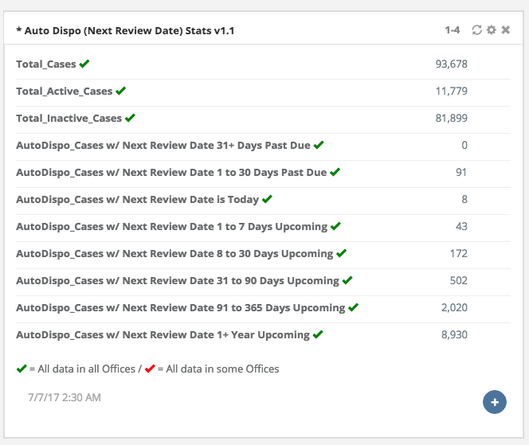

To enable the Auto Dispo widget, go to your Dashboard > Add Widget (menu) and add the Auto Dispo Template Widget. This Widget will show updated statistics for all the Cases in your system and Cases based on the Next Review Date. If you just turned on the widget, then all of your cases should have a follow up date in the future. As these review dates come and go, you will begin to see these statistics shift.

Note: You want to avoid a large backlog of Cases in the 31+ days past due or 1 to 30 days past due. If these numbers get too large you will begin to stall the process. If you get behind, go back and reorganize Cases and start over (only reorganize past due cases).

Warning - Resistance ahead!
If you are attempting to turn on Auto Disposition for your agency, be aware you may receive a certain level of resistance and complaints. This is especially true if you are going from a system where people generally are not required to do anything, to a system where people are held accountable for the evidence they submit. Make sure you have backing from command and that your Users can’t just ignore these requests for updates on Cases. If they can just ignore your request, the entire process is doomed before you get started.

Keep in mind it may take roughly 90 days to build up a habit. Don’t quit after two weeks because you get some complaints. Keep with it until you establish a discipline. After 90 days this will become ‘part of the process’ and your Users will settle down. Remember that you are changing the way you do business, it takes time.

More information regarding Auto Disposition can be found by listening to our webinar:
SAFE Sessions 4 – Auto Disposition @ https://vimeo.com/221434666

Settings \ Offices
Quick Menu » Settings \ Offices

1. From the Quick Menu on the left hand side of the screen, select the Settings Icon (it looks like a wheel), then from the menu select Offices. You are now on the Offices screen. This screen shows all the Offices in your Organization. Each Office shown has been assigned a unique GUID (Globally Unique Identifier), which is a unique 128-bit integer number, Office ID # and an Organization ID #.

From the Offices screen, you can Add, Edit, or Deactivate an Office.

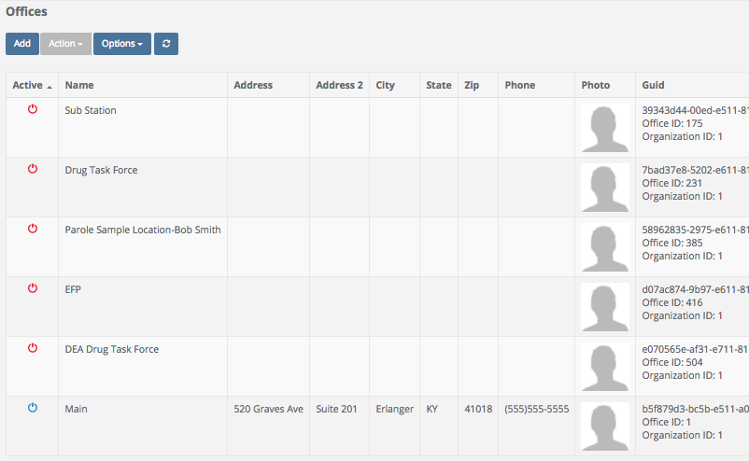

2. Click Add to add an office. Enter the Required Name and Default Location of the Office you would like to add, then fill in as much information as you can. When you are finished, click Ok. You also have the option of adding a picture of the Office by clicking the Photo Tab (next to the Properties Tab) and then browsing to the picture location. Once added, Offices are automatically given a unique GUID, Office ID # and an Organization ID.

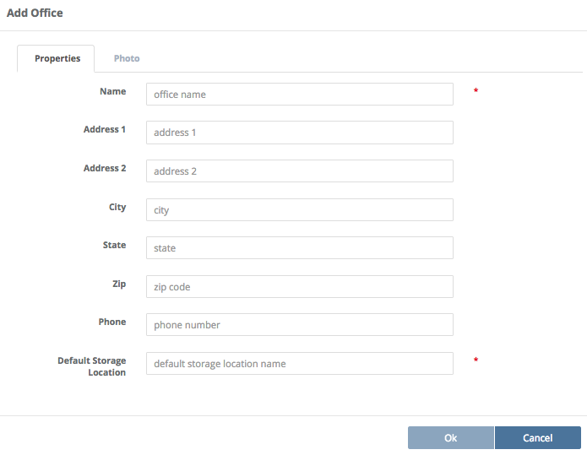

3. After you Add an Office, you may wish to edit it. To do that, click the Name of the Office you would like to edit (the fields will then be highlighted in blue), then click the Action box, and finally select Edit.

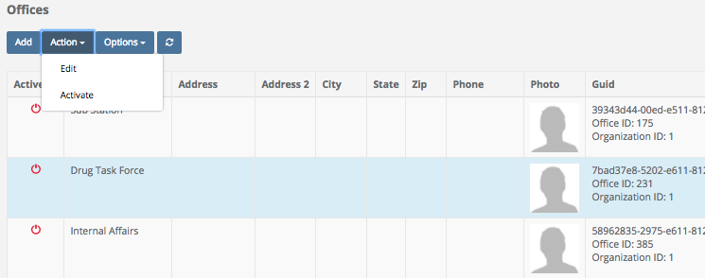

The Edit Office screen will then appear. Here, you can change the address, city, state etc. and/or attach a photo of the Office if you wish by clicking the photo Tab.

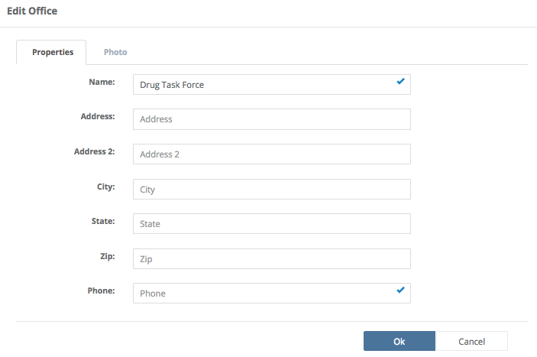

4. After you Add an Office, you may wish to Deactivate it (if it no longer used for example). To do that, click the Name of the Office you would like to Deactivate (the fields will then be highlighted in blue), then click the Action Box, and select Deactivate.

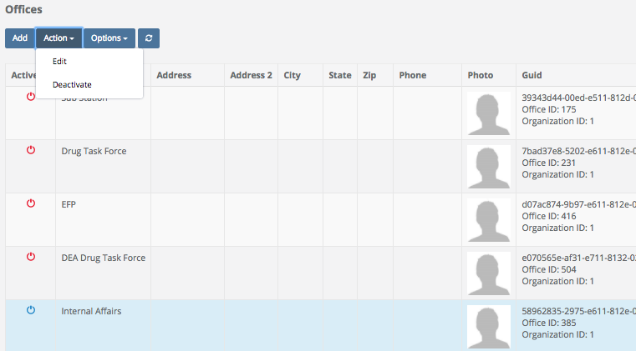

After an Office has been Deactivated, a red power icon in the Active column next to its’ name will signify that it has been deactivated.

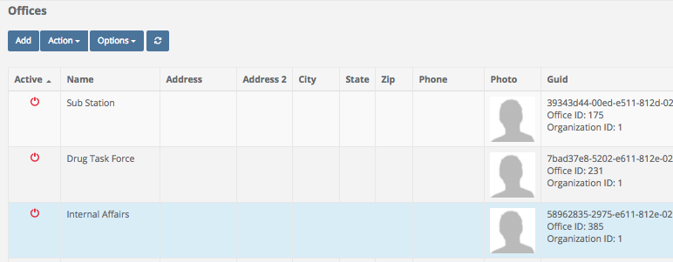

Settings \ Storage Locations \ Sorting Imported Storage Locations
Quick Menu » Settings \ Storage Locations

From the Quick Menu on the left hand side of the screen, select the Settings Icon (it looks like a wheel), then from the menu select Storage Locations. You are now on the Storage Locations screen. From here, you can Add and Edit Storage Locations as well as Create and Print Labels for them.

There are many instances where we will import Storage Locations from another system and give you some relevant information needed to move these into a proper format.

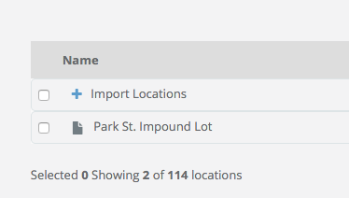

The first indicator that you have storage locations that need to be reorganized would be the ‘Import Locations’ parent location that you see here. FYI, this might be named Imported Locations for some clients.

The “+” to the left indicates that there are storage locations below this storage location name. Click the “+” button to see all of them.

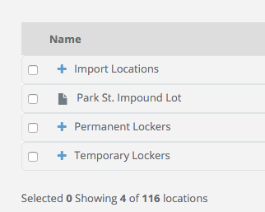
It is recommended you have two root level locations. One called Permanent (Lockers) and another called Temporary (Lockers). This will not only help better organize your Storage Locations but will also allow you to apply permissions to these root storage locations and have every child granted permissions based on the parent level access. In this case we created the following storage locations:

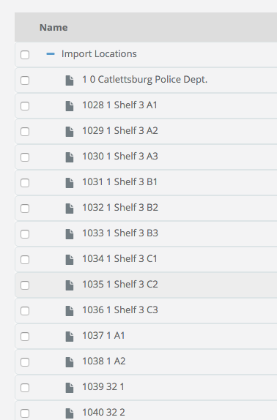

The objective is to move these storage locations into a more proper alignment in the root folder.

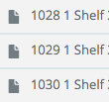

So what do the numbers to the left of each storage location name mean? These numbers are here to help you know what the parent / child ID was from the previous system. The first number in the example above is 1028 which indicates the ID of this storage storage location. The next number in the example above is 1, which indicates the parent ID for that storage location. So, it’s easy to tell all of these storage locations were children of storage location ID 1.

We need to go down the list and find every storage location with a parent ID 1 and move those storage locations to the root directory for this example:

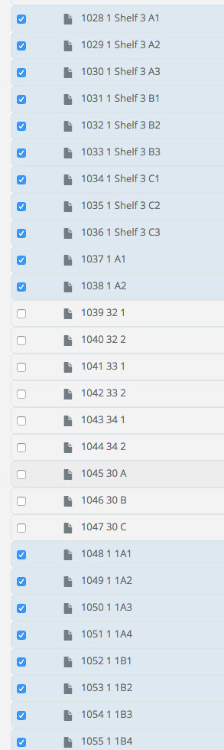

In the example above there are quite a few storage locations belonging to Parent ID 1. All of those have been selected with a check box to the left.

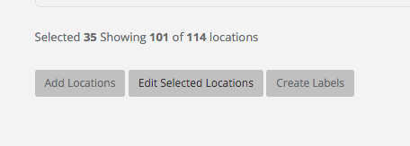

After selecting all the storage locations with ID 1, go to the bottom of the Storage Locations screen and Select Edit Selected Storage Locations. That will bring up the following screen:

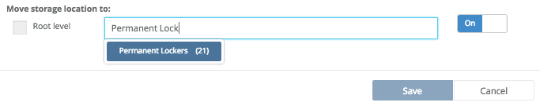

Enable the bottom option (click On over on the right) for Move storage location to and select the option ‘Permanent Lockers’ (because we want to move the selected storage locations to this storage location). When you start typing the storage location in the text box, options will automatically appear as in the example above. Next, select Save.

The following message box will appear:

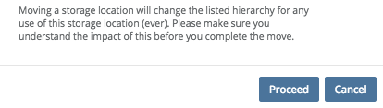

Select Proceed at this disclaimer and all of the selected storage locations will now be moved to the Permanent Locker storage location.

Now that we have moved all the storage locations where ID = 1 to the Permanent Lockers, we can focus on the sub storage locations. In this screenshot we can see that storage locations 1039 and 1040 belong to parent storage location 32.

Select both storage locations (example above).

Go to the bottom and Edit these storage locations as we performed previously.

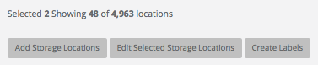
Turn on the Move storage location to option and then type the ID of “32” since this is the parent ID of these storage locations.

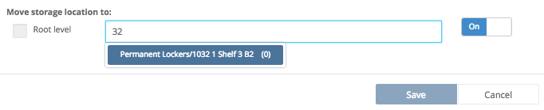

(As you start typing “32”, the option for the storage location to move to will automatically appear)

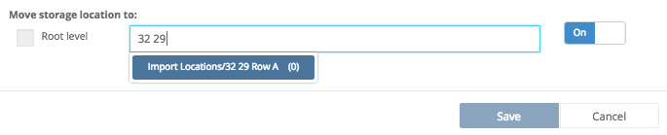

Select the correct storage locations from the drop down, then Save the selected storage locations into the parent storage location by selecting Save.

In the screenshot below, notice where the storage locations have been moved to 32 29 Row A.

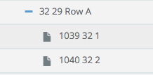

Once you perform this task correctly you will see storage location ID’s 1039 and 1040 are now children of storage location Row A (ID 32). Repeat all the steps above until every storage location is in their proper parent storage location. When you have completed all storage locations within the Import or Imported storage locations, contact us and we will remove the ID’s for all your storage locations so you only see storage location names.

Settings \ Storage Locations \ Adding, Editing, Creating & Printing Labels for Storage Locations
Quick Menu » Settings \ Storage Locations

1. From the Quick Menu on the left hand side of the screen, select the Settings Icon (it looks like a wheel), then from the menu select Storage Locations. You are now on the Storage Locations screen. From here, you can Add, Edit and Delete Storage Locations as well as Create and Print Labels for them.

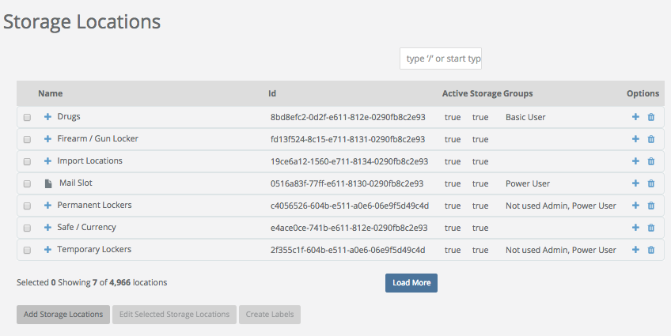

2. Click inside the Add Storage Locations box/field and type in the name of a location(s) you would like entered, then click the Add Locations box (below that) to add them. The storage location you just entered will now be located under Name.

3. You may also wish to create a storage location under a current storage location (nest). For example, you want to create the storage location Money under Drugs. To do this, select Drugs from the Storage Locations list. Next, click the Add Storage Locations box. When the Add Storage Locations screen comes up, type in Money, then click Save to add it. The sub-storage location Money has now been created under the storage location Drugs.

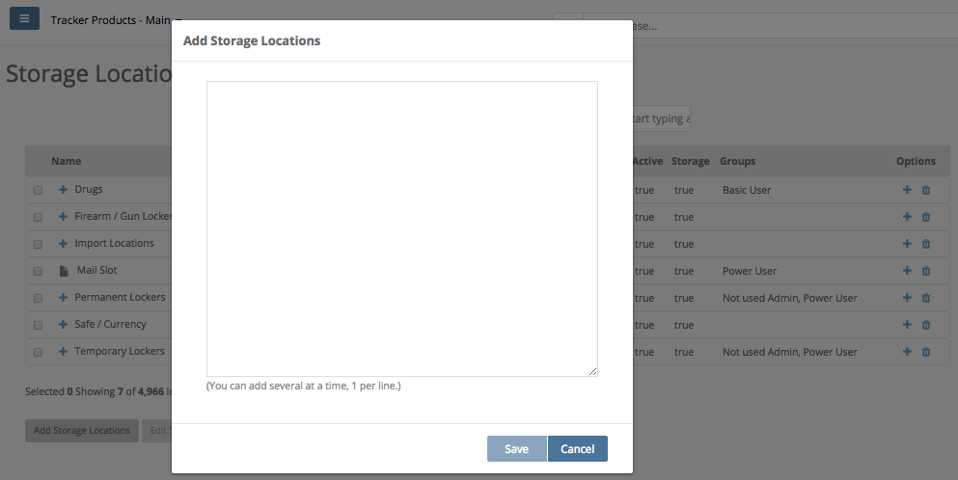

4. You can now edit, and assign a Storage Location to specific Group(s) which have specific permissions to view that storage location. To do this, click the box next to the Name of the storage location and select Edit Selected Storage Locations. The Edit Storage Location screen will now appear. From here you may select groups which have permission to view the storage location. Certain groups will have specific permissions which will allow them, or not allow them to view storage locations.

From within Storage Locations, you may allow a user to perform a transaction (such as edit, check in, check out, move, transfer, dispose, etc) if the user has access to the Storage Location where the item was stored (see Location Based Permissions).

For example, a User enters an Item into a temporary Storage Location they have access to. The User can now have Edit Item permissions and can only Edit that Item if the Item is located is in a Storage Location they have access to. If the Item is checked into a Storage Location they don't have access to, they will get an error when trying to Edit.

Another example would be if someone in the property room wants to give an Item to an officer to dispose of back to the owner. An Org admin can give access to a single Storage Location and Check the Item Out to that officer. The officer can now Dispose of that Item because they have Dispose permissions and the Item is in a Storage Location they have access to.

If permissions are assigned to a storage location which has sub-storage locations under it, the permissions of the root storage location will take precedence over the sub-storage locations.

If items are to be stored at this storage location, make sure the Can Store Here box is checked.

If the storage location is Active, make sure the Active box is checked. Then click Save.

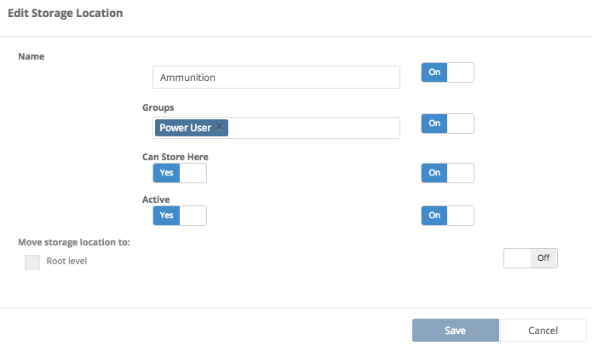

5. To delete a Storage Location, simply click the trash can symbol under the Options column for the Storage Location you would like to delete. If that storage location has not been used in some sort of system activity, it will be deleted. However, if there are items in that storage location (for example), it will not be deleted and you will receive the following message.

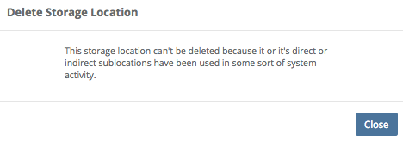

6. To Create and Print Labels for a Storage Location, click the Name(s) of the storage location(s) under Storage Locations, then click the Create Labels box. The Labels Preview screen will then appear and you can Print a copy of the label(s).

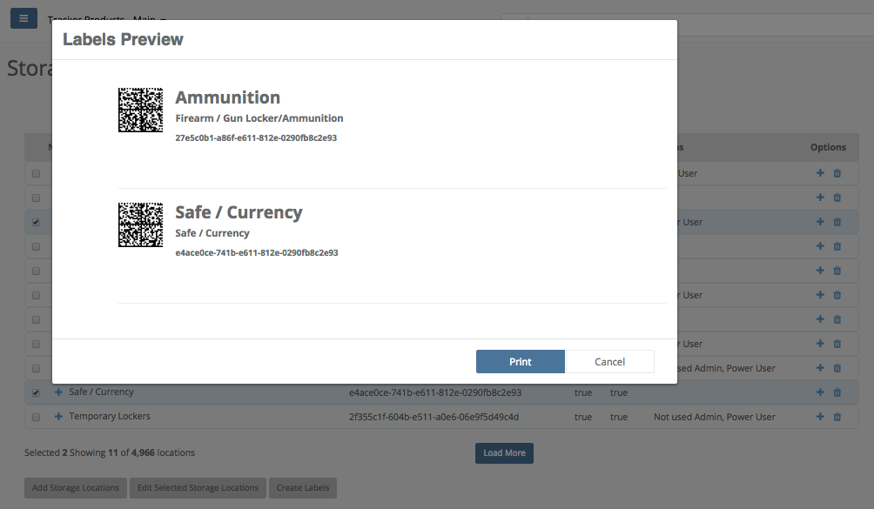

Settings \ Custom Data (Forms)
Quick Menu » Settings \ Custom Data (Forms)

1. From the Quick Menu on the left hand side of the screen, select the Settings Icon (it looks like a wheel), then from the menu select Custom Data (Forms). You are now on the Custom Data (Forms) screen. From here you can Add and Edit selected Forms, as well as Export them.

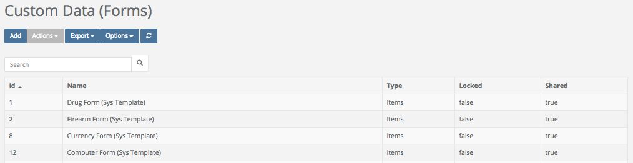

Forms are simply documents an Administrator can attach to a Case, Item, or Person that a User fills out. The attached Forms provide extra information regarding that Case, Item, or Person. For example, an Administrator may choose to attach a Phone Form to the Electronics Category. So in addition to the Basic Info Add Item fields, if the Electronics Category is selected, a Phone Form will appear and can then be filled out to provide more information.

If Cases, Items, or People are created and then a Form is created AFTER that, you can still attach that Form to those Cases, Items, or People. All you need to do is select View, then Edit, scroll down to the bottom of the screen and click Add Form. You may now retroactively go in and Add Forms to those Cases, Items, or People.

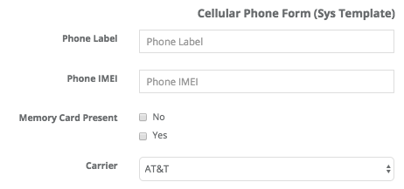

The software has some widely used Forms for your use. If the provided Forms aren’t exactly what you need, you can create a Custom Form.
2. To create a Custom Form, click Add. The Add Form screen will then appear. Enter the name of the Form you would like to create. In the Type field, assign it to either Cases, Items, or Persons. Next, you can select and add Fields from the available list and then Preview the canvas you have created. If you are satisfied with your choices, click Ok.

If creating a Custom Form is out of your ‘comfort zone’, let our Support Staff know. Depending on the time required to complete, and the complexity of your request, we will provide you with a quote to do the job for you.

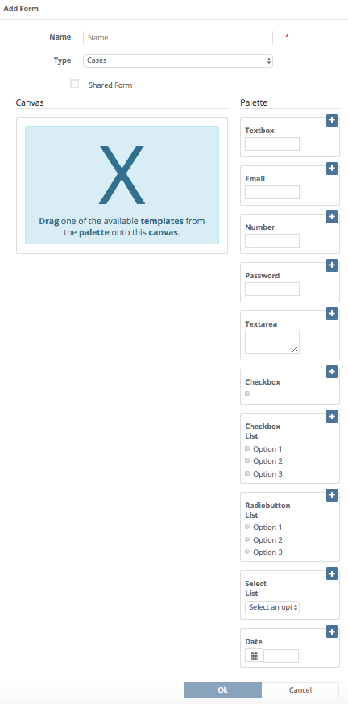
3. To Edit a Form, go to the Forms, Custom Data screen and highlight the Name of the Form you would like to Edit. Click the Actions box, then click Edit.

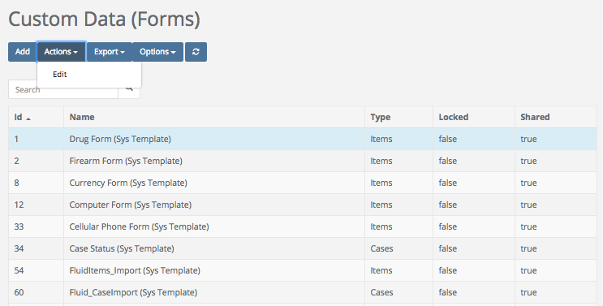

4. A warning box may appear letting you know that attempting to modify the form can change the historical use of that form.

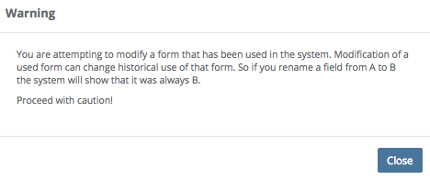

5. The Edit Form screen will then appear. You may now Edit the form. When you are satisfied with your changes, click Ok.

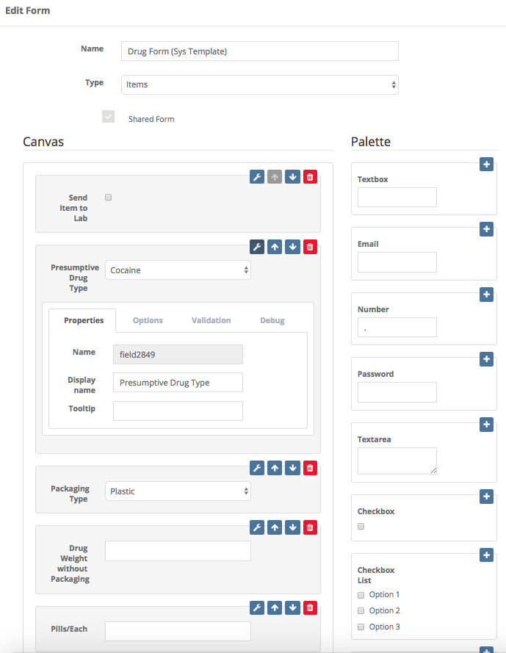

Settings \ Permission Groups
Quick Menu » Settings \ Permission Groups

1. From the Quick Menu on the left hand side of the screen, select the Settings Icon (it looks like a wheel), then from the menu select Permission Groups. You are now on the Permission Groups screen. From here, you can Add, Edit and Delete Permission Groups as well as assign Permissions.

Basic Users (by default) could have Permissions to View and Create but NOT Update
everything. Members of this group usually View and Add Cases, Persons and Items,
basically adding evidence and printing reports.
Power Users (by default) could have Permissions to View, Create, and Update everything.
Members of this group usually perform transactions like Check in, out, dispose, and transfer.
Read Only Users (by default) could have Permissions to View, but NOT Create and Update
everything. Members of this group can Only View Cases, Items and People in the Office
they’re assigned to.

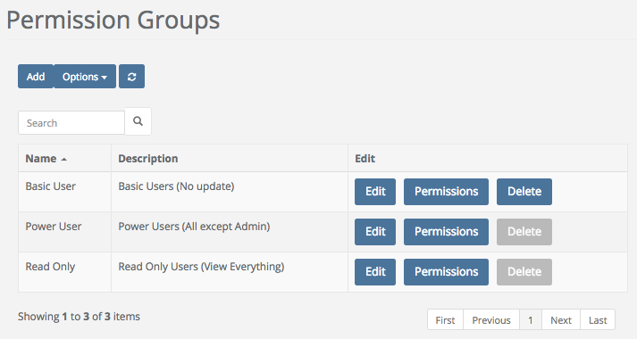

The last Permission Group which is not listed (or even shown) is the Org Admin Permission Group. It is the only Permission Group which has all Permissions and is allowed to access the Settings area of the software. An Org Admin is an Administrator of your entire Site. They have access to everything as well as the ability to create Offices, assign Permissions, create Custom Forms, Add/Disable Users, create User Groups, create Reports etc.

2. To Add a Permission Group, click the Add box. The Add Group screen will then appear.
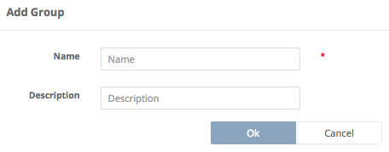

Give the Group you want to add a Required Name. You may also wish to give it a description.

3. To Edit an existing Permission Group, click the Edit box of the group you wish to Edit. This will take you to the Edit Group screen.

This example shows the Permission Group: Read Only. You may edit their information, such as changing their Name or Description here.

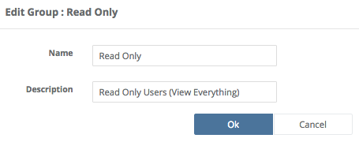

4. To change Permissions of a Permission Group, click Permissions of the Permission Group you would like to change. Then change the permissions of the Permission Group you chose by checking or unchecking the boxes next to the Name of the Item you would like to change. As shown below, the default settings for all Permission Groups including the Basic User group don’t include Auto Dispositions and Discrepancy Reports. You may grant these Permissions if appropriate.

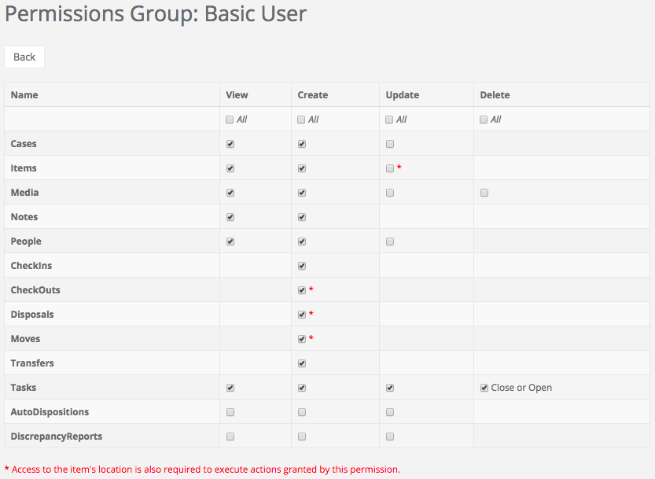

5. To Delete an existing Permission Group (if the Delete box has not been grayed out, indicating that Permission Group has already been used inside of SAFE), click the Delete box of the group you wish to Delete. This will take you to the Delete Group screen.

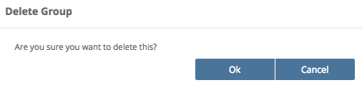

If you are completely sure you want to proceed, click Ok and the Security Group will be deleted.

Settings \ Permission Groups \ Office Based Permissions
Quick Menu » Settings \ User Admin

1. If you are using multiple Offices within the software, you can now set different Security Groups for each Office for each user. The software allows Office based Permissions! This will allow you to set one level of permissions for a User in one Office and a different level of permissions in another Office. Perhaps a User that is a Power User in one of your offices needs to be a Read Only user in a different Office.

Note: The only reason to have multiple offices is if you want to separate access to Items or Locations.

For example, let’s say we have a Narcotics Office and a Property and Evidence Office. I want those Users defaulted to Narcotics to have Power User access (check in, check out, etc.) in the Narcotics office but I only want those users to be Read Only access when the items are in Property & Evidence. The Office based permissions will allow you control this scenario. When the item is in Narcotics, Users have Power User access. Once the item is moved to another Office or Org they will only have access that is granted in that Office or Org.

First, you need to set up your Offices (as shown in the previous chapter Settings \ Offices).

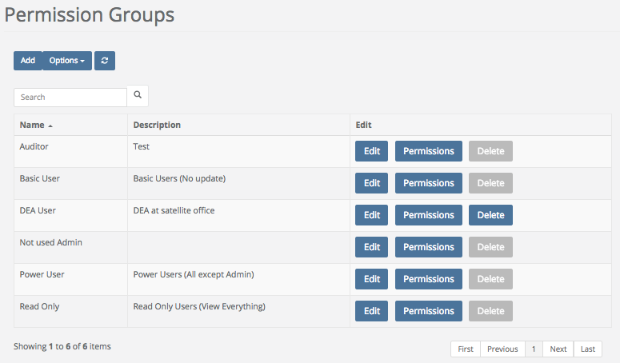

Go to Settings > Permission Groups and add any additional Permission Groups that you need. In most cases, the default options are more than enough.
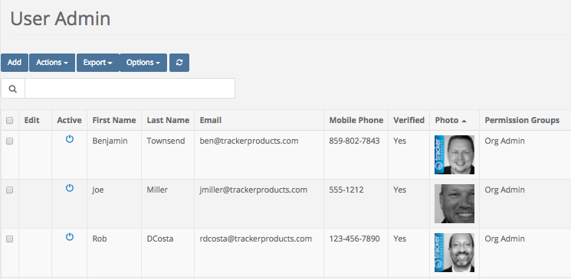

Now that you have your Offices and Permission Groups, we can now attach Users to these Offices, specifying a Permission Group for each User.

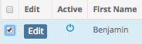

Go to Settings > User Admin. The Groups tab will show current Permissions for each User. To modify these Permissions (or add Permissions) select User(s) in a list.

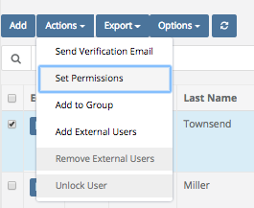

Go to Actions > Set Permissions

You are now on the Permissions Matrix page.

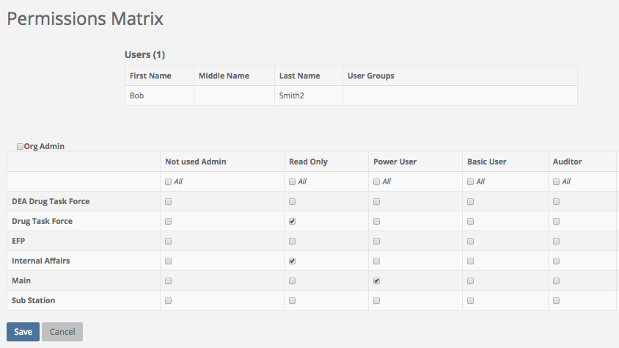

In this scenario two Offices are set as Read Only and the Main Office as Power User.

Settings \ Security \ Location Based Permissions
Quick Menu » Settings \ Security

Have you ever had a situation where you wanted to allow a User to dispose of an item but you did NOT want to grant them permissions for dispositions because it would allow them to dispose of all items in the system?

What about editing an item that they just entered into the system?

The new "Location Permissions" have you covered. You can now grant a User (Permission Group) the permission of Edit Item, Check Out, Dispose or Move and they are only allowed to complete these transactions in Locations where they have been granted access.

Simply go to Settings > Permission Groups and edit the Group you desire to modify. Select the permission you want to allow the group and you can rest assured that they can only complete this transaction if the item is in a location that they have access. Go to Settings > Storage Locations to grant access to Locations.

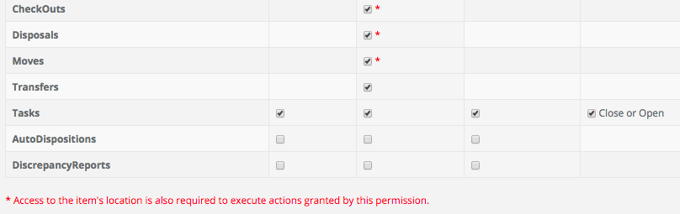

Settings \ User Admin
Quick Menu » Settings \ User Admin

1. From the Quick Menu on the left hand side of the screen, select the Settings Icon (it looks like a wheel), then from the menu select User Admin. You are now on the User Admin screen. From here, you can Add and Edit Users.

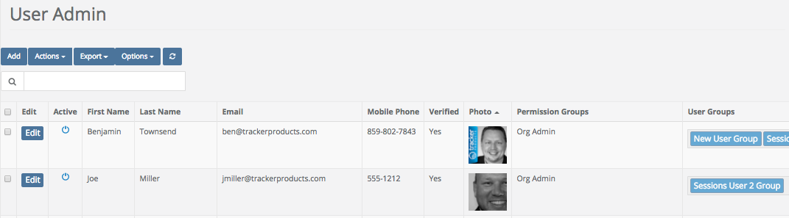

2. To Add a User, click the Add box. The Add User screen will then appear. Fill in the Required fields which are First Name, Last Name, Email address and Office. Add as much additional information as you can and a Photo if you wish.

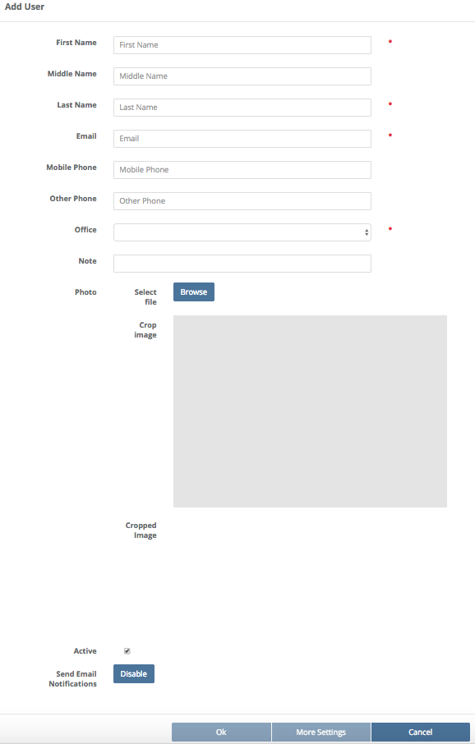
Next, assign the newly created User to a Permission Group by clicking the Actions box and clicking Set Permissions. For example, if you want the user to have Read Only access, choose Read Only from the menu for the Offices you’d like. After you are finished, click Save.

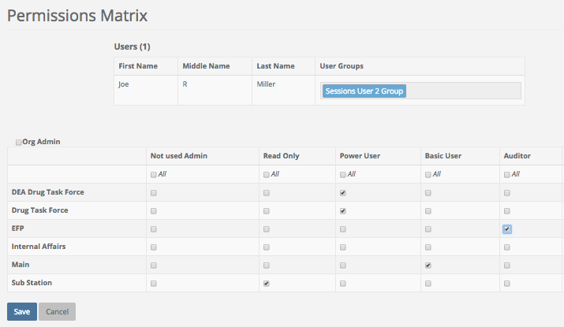

3. To Edit a User, simply click the Edit button next to the User’s Name.

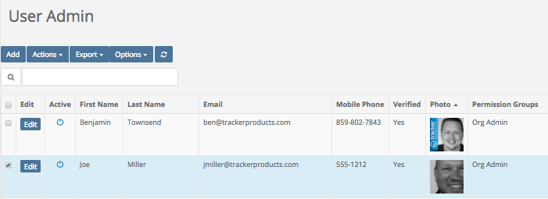

4. From the Edit User screen, you may change a user’s information. When you are satisfied with the changes, click Ok. You may also click the More Settings box to view and change the User Address and also add Notes and Media.

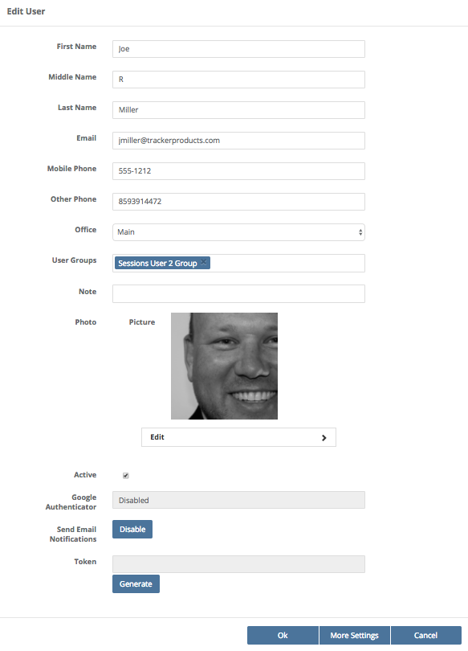
5. In the Settings screen, you can change a user’s status to Deceased or choose if they’re a Juvenile. You may also Edit the User by clicking the Edit box. You can also Disable the User by clicking on the Actions box and clicking Disable. If you have an address for this individual, click the Add Address box and fill in as much information as you can. Similarly, if you have Notes or Media to attach to this individual, click those Tabs and add that information.

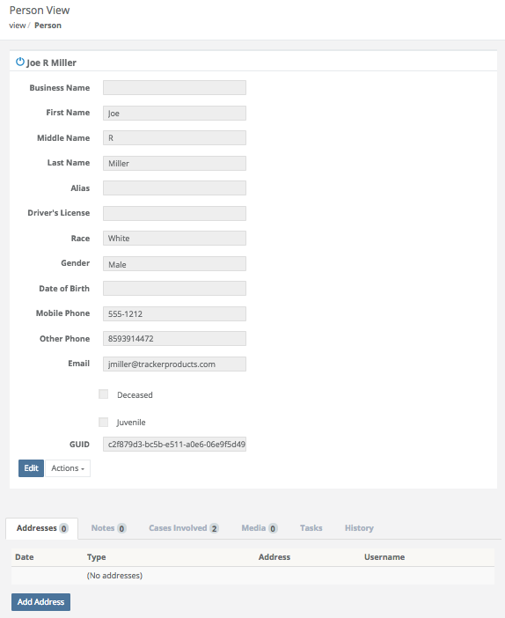

6. You can also send any User a Verification Email (which will force them to change their password) by clicking the Actions box and selecting that option. That will force the User to respond to that request, and make them verify their email address before they can access the system again.

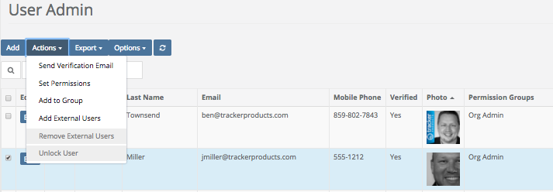

At this point they will be sent a different password than the one they were using before. As shown below, the user must now click the “Confirm your email address” link which will confirm their email address before they can proceed to the software login screen.

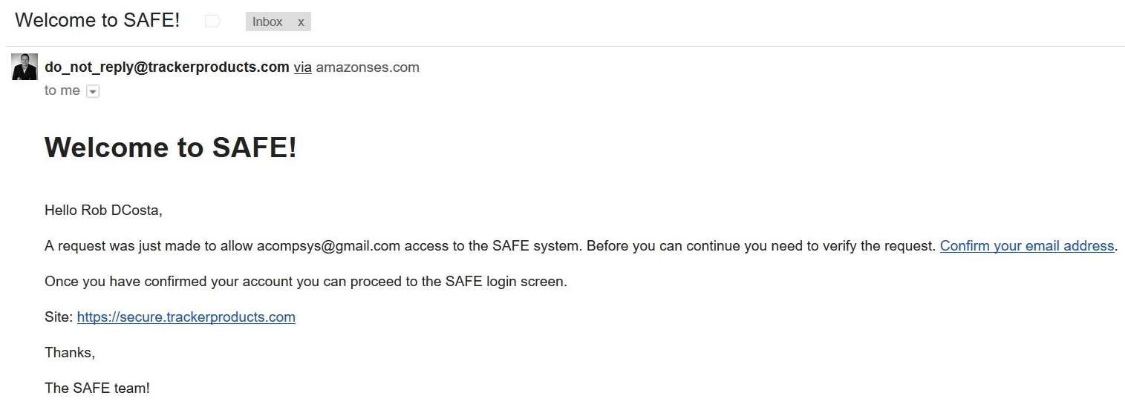

If you entered an incorrect name or password, the software will let you know that your “user name or password is incorrect”. If you have forgotten or wish to Reset your Password, CLICK THE WORDS “Forgot Password?”. Selecting this option will send you to the Password Reset page. After entering your email address and clicking the “Reset Password” box, an email with directions will be sent to you to reset your password.

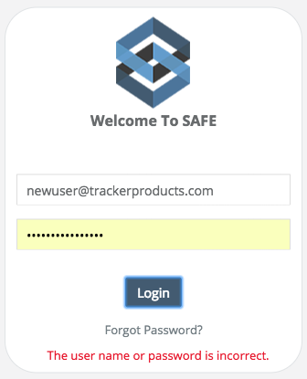
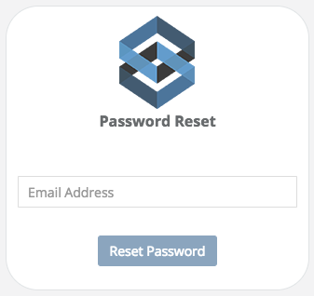

After entering your Email Address, this screen will be shown.

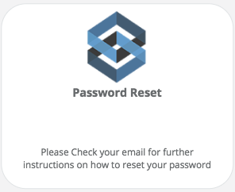

Once you receive the Password Change Request email, click the words “click here” and you will be taken to the Password Reset page.

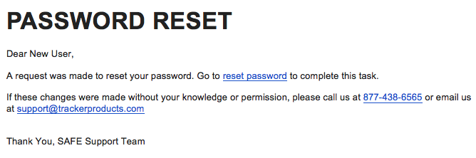

At the Password Reset page, enter a new password adhering to the listed criteria, then verify that password.
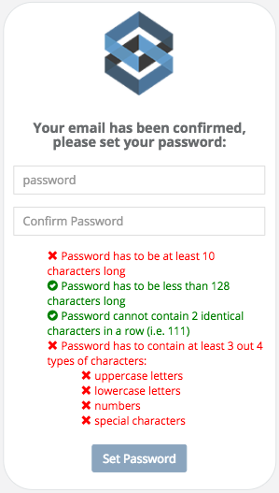

Upon successful new password entry and verification, you will be taken to a screen that says as much and you will then be able to log into the software.

7. To Add External Users, click the Actions box and choose Add External Users. Next, enter their email address and click Add External.

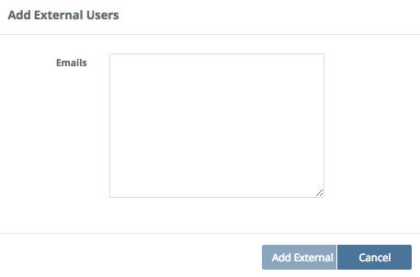

8. Click the Export box if you would like to export Selected Users list to a comma separated value (.csv) file.

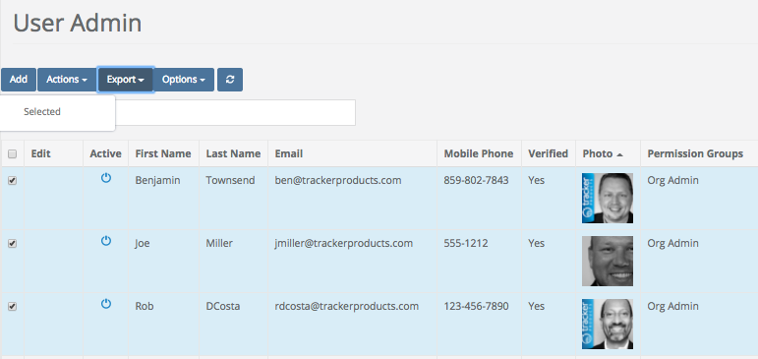

Settings \ User Groups
Quick Menu » Settings \ User Groups

User Groups are for assigning tasks to Groups of users. When a task is assigned to a group, all Users in the group will get the Task along with a notification email.

To create a User Group(s), click Settings \ User Groups. This will take you to the User Groups page. From here you can Add, Edit, and Make Inactive any User Groups that have been created.

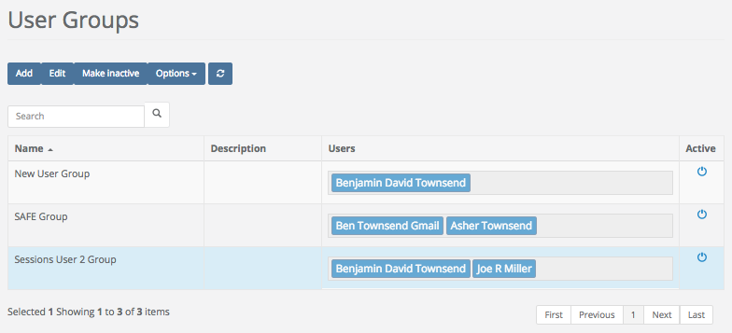

To add Users to a User Group, go to Settings > User Admin. Select the Users for the group and go to Actions > Add to Group.

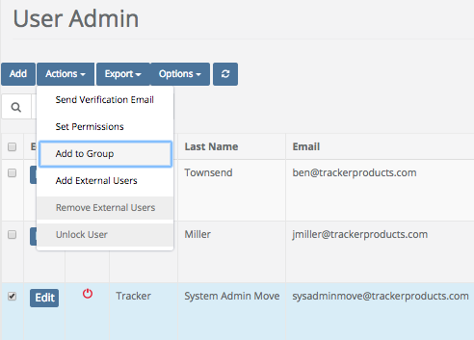
An Add to Group pop up window will then appear, where you can add the selected Users to a Group.

Users that are a part of a group will be shown in the User grid under the heading User Groups.

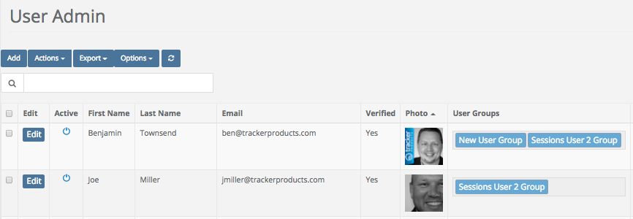

Settings \ Data Import
Quick Menu » Settings \ Data Import

From the Quick Menu on the left hand side of the screen, select the Settings Icon (it looks like a wheel), then from the menu select Data Import. You are now on the Flat Import, Data Import screen. From here, you can upload Cases, Items, and Users as long as it is in a format understood by the software. To get it into an understandable format, you may request an Import Template(s) (Cases, Items, Users) from our Client Care staff. You may do a free import yourself as long as the data can be put into the proper Import Template. All work to manipulate the data is the responsibility of your Agency. Or, you can request a quote from Tracker Products to do the work for you.

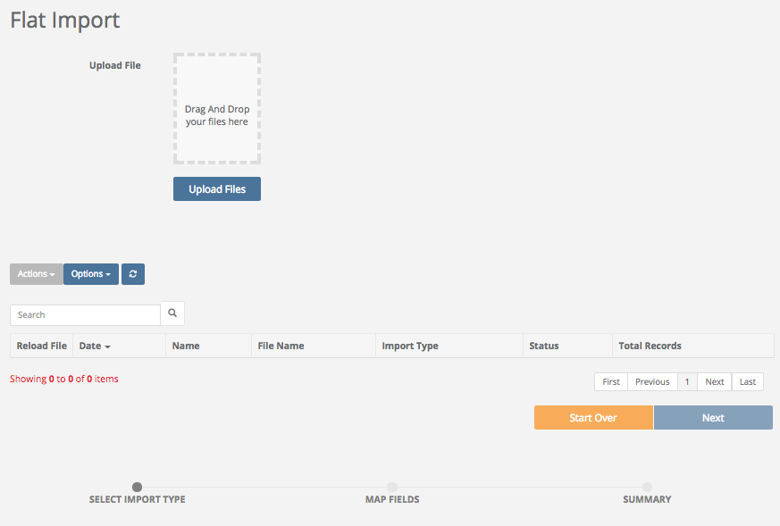

Assisted Data Import Instructions

Overview
When Tracker Products support staff is presented with the task of importing a client's data (as part of an original purchase agreement or additional compensation), the following conditions must be met prior to beginning the import:

Important information: Tracker essentially has four primary data tables... Case, Person, Item and Custody tables. Case is the primary table and all other tables relate back to this primary table except the custody table which relates to the item table.
- Case Table: One to many relationship with person's and item's.
- Person Table: Many to one relationship with a record in case table.
- Item Table: Many to one relationship with a record in the case table.
- Chain of Custody Table: Many to one relationship with a record in the item table.
We have to fit all data into this structure. The more you define how data will fit into this structure the easier the import will be.
- All data must be provided in one of the following formats: .xls, .xlsx, or MsSQL .bak file. Note: Any file that is more than 65,000 line items or 100mb in size needs to be submitted via a database file like MS Access (.mdb or .accdb) or MS SQL (.bak).
- Please provide a data definition file. Define all documents and tables as well as the data that resides within them.
This is especially important when data is in the form of a number and that number has a text definition. For example, 1=Evidence, 2=Found Property, 3=XXX. We need to know if a field is part of a drop down with assigned values.
- If more than one document, table or file is provided, please define their relationship to one another.
- Each column of data must be clearly labeled.
- Please provide clear information about where the provided data should be placed in the Tracker Products system. This includes the Case, Item, Person and Chain-of-Custody architecture. Please talk with your Tracker Representative if you need help with this.
- At a minimum please provide the following data:
- (Item Data) Case Number, Item Number, Item Category, Item Description, Item Status (Checked In or Out), Item Disposition (Disposed or Not), Item Storage Location and any existing barcode formats.
- (Case Data) Case number
- (Person Data) Name and type of person

Finally, how much does data import cost?
There are several variables that will determine the total cost of a data import.
- How many source docs or tables are involved.
- The number of columns in each of the docs or tables that are involved.
- The total number of records. (Are we importing 500 records, 500,000 or 5 million?)
- How many of the requirements in the previous section are complied with (or not).
- Type of file for source data. MsSQL file is far easier to work with then .csv, xls or .dbf. We have to import all this data into MsSQL and this process can be quite tricky.

Settings \ Sessions
Quick Menu » Settings \ Sessions

From the Quick Menu on the left hand side of the screen, select the Settings Icon (it looks like a wheel), then from the menu select Sessions. You are now on the Sessions screen. From here, you can see how many Licenses are currently in use at this exact moment in time as well as the users who currently have sessions in operation.

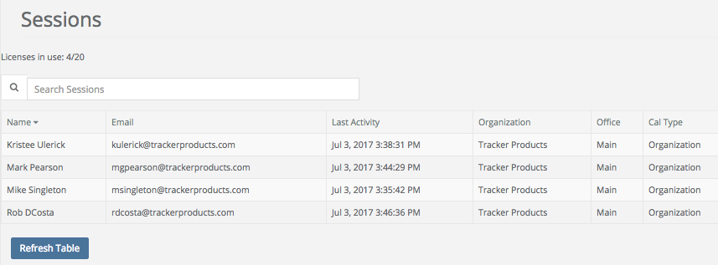

Settings \ License Allocations
Quick Menu » Settings \ License Allocations

1. From the Quick Menu on the left hand side of the screen, select the Settings Icon (it looks like a wheel), then from the menu select License Allocations. You are now on the License Allocation screen. From here, you can see the number of purchased licenses, and how many were Reserved for Offices and Individuals. You can also see the total number of Licenses available Organization wide.

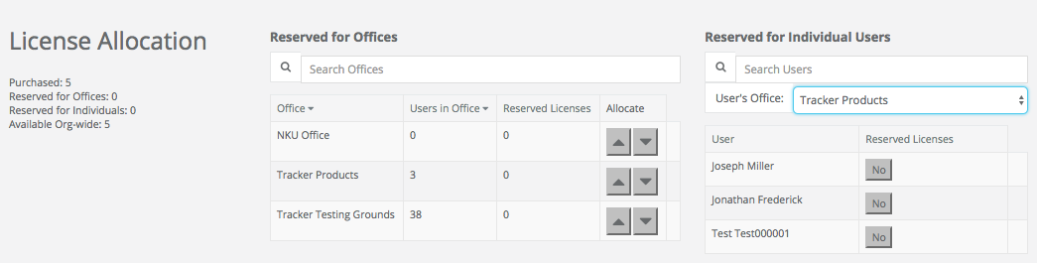

There are also two Tables on this page denoting which licenses are Reserved for Offices or Individual Users.

Under the Reserved for Offices Table, you can see the Office name, Users in that Office, and how many Reserved Licenses there are. This can be useful, for example, if have purchased 10 Licenses for an Organization and would like to reserve 5 for Office A and 5 for Office B.
Under the Reserved for Individual Users, you can select which Office you want to view by clicking in the Default Office field. Once done, you can view the Individual Users for whom a License was Reserved. This can be useful, for example, if have purchased 5 Licenses for an Office and would like to reserve 2 Licenses for particular individuals in that Office.

Settings \ Tags
Quick Menu » Settings \ Tags

1. From the Quick Menu on the left hand side of the screen, select the Settings Icon (it looks like a wheel), then from the menu select Tags. You are now on the Tags screen. From here, you can add Tags into your system. Tags are labels you can attach to a Case or Item for the purpose of identification. For example, you may wish to create a Tag called “Releasable” that will designate Items as such. This will aid the evidence custodian by eliminating any ‘gray area’. If and when a suspect/person attempts to claim property improperly or erroneously, the evidence custodian will immediately see if an item can/should be released.

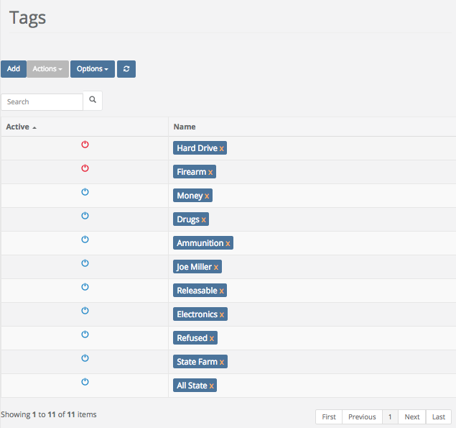

2. Click the Add box and the Add Tag screen will appear. Give the Tag a Required Name and click Ok to add your Tag to the list of available Tags.

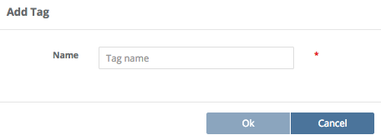

3. To Edit a Tag, first highlight the Tag by clicking on it’s Name, next click the Actions box, and finally click Edit. You can now edit the name of the Tag.

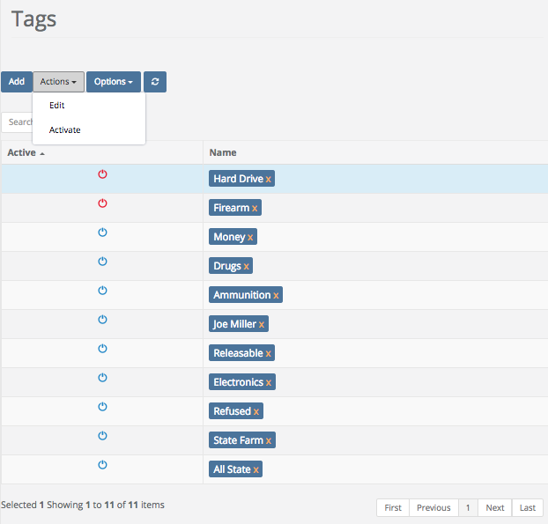
4. To Deactivate a Tag, first highlight the Tag by clicking on it’s Name, next click the Action box, and finally click Deactivate. The Tag’s power icon will then turn red, indicating that it has now been Deactivated.

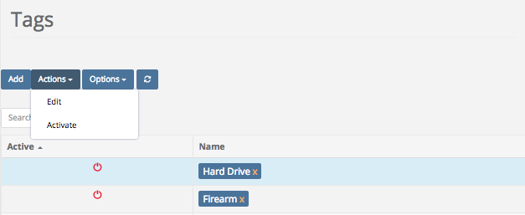

Settings \ Report Builder \ Creating Reports
Quick Menu » Settings \ Report Builder

1. From the Quick Menu on the left hand side of the screen, select the Settings Icon (it looks like a wheel), then from the menu select Report Builder. You are now on the Report screen. From here, you can Add or Edit your Reports and Labels. You can also View and Delete Reports and Labels. The software has some of the most popular template Reports and Labels for your use. Creating custom Reports and Labels are discussed in an upcoming section.

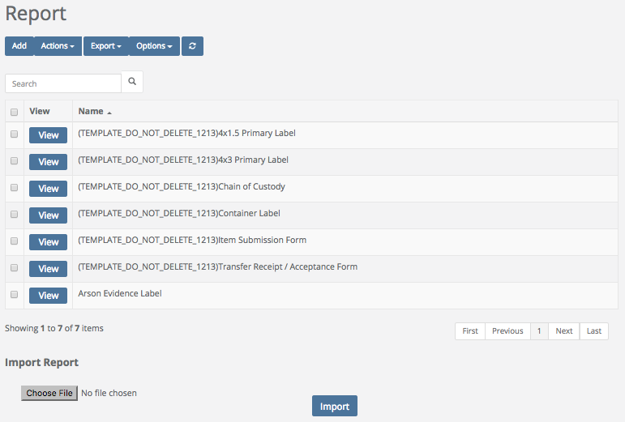

2. To View a previously built Report, click the View box next to the Report you would like to use. You may also choose this from the Actions box.

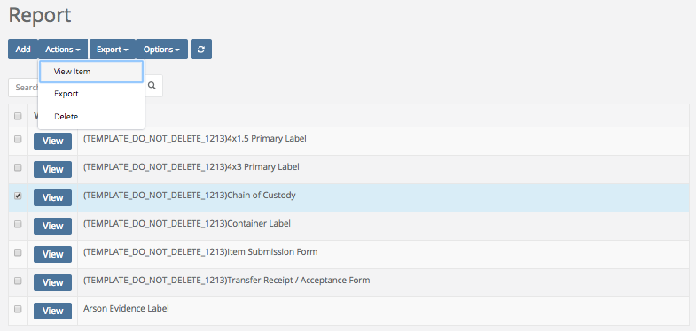

You will then be taken to the Report Header & Footer Tab on the Reports screen, and you will see the (Report Header & Footer) html code for the Report you have chosen.

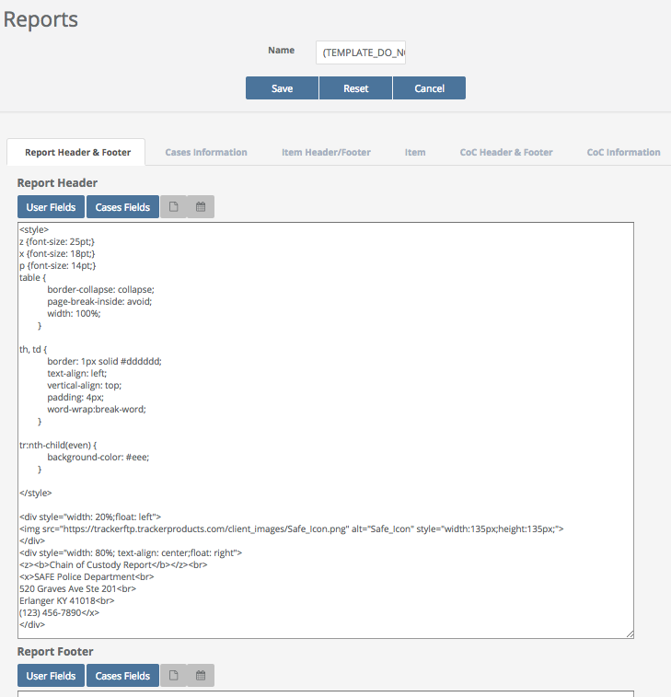

3. If you don’t wish to use one of the ready made reports, you can always create your own. To Add a Report, click the Add box. The Add Report screen will appear. Give your Report a Required Name. When you are finished, click Ok.

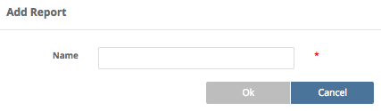

Once you click Ok, you will be taken to the Report Header & Footer Tab. A system template is shown below. If you wish, give your report a Report Header and a Report Footer using html code. On the off chance that you’re not fluent in html code, feel free to copy the code from another Report and change it to suit your needs. You can also choose to include items from the User or Cases Fields boxes, such as User Name or User Email etc. Next, click the Cases Information Tab.

If creating a Custom Report is out of your ‘comfort zone’, let our Support Staff know. Depending on the time required to complete, and the complexity of your request, we will provide you with a quote to do the job for you.

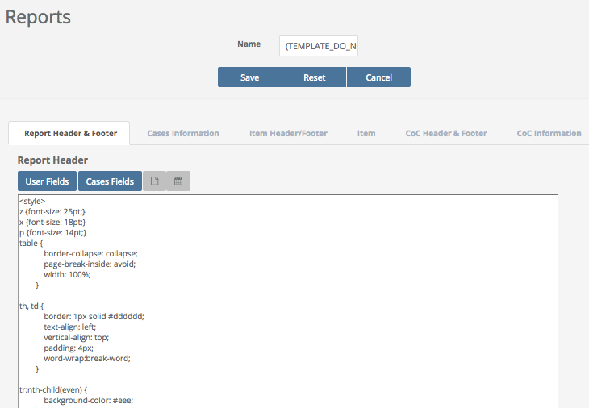
Under the Cases Information Tab, enter the Report criteria, once again in html code. Click User Fields, Cases Fields, or Case Custom Fields and choose selection(s) to be automatically included in your Report.

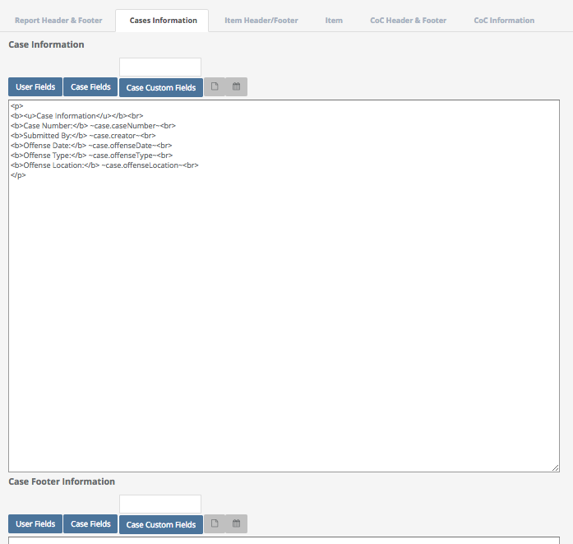

You can also enter Item Header/Footer and Item criteria, as well as Chain of Custody (CoC) Header & Footer and CoC Information under their respective Tabs. Take into account which selection(s) you would like to be automatically included in your report.

When you are finished, click Save.

4. To Delete a Report or Label, highlight the Report or Label you are interested in. Click the Actions box and from the drop down menu, select Delete. Once you Delete a Report or Label, it is gone permanently!

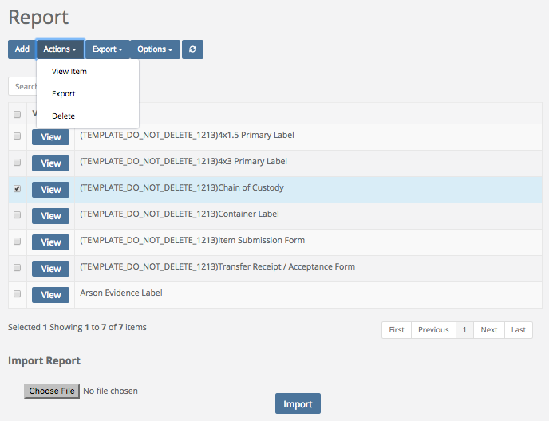

Settings \ Report Builder \ Creating Labels
Quick Menu » Settings \ Report Builder

1. From the Quick Menu on the left hand side of the screen, select the Settings Icon (it looks like a wheel), then from the menu select Report Builder. You are now on the Report screen. From here, you can Add or Edit your Reports and Labels. You can also View and Delete Reports and Labels. The software has some of the most popular template Reports and Labels for your use. Creating custom Reports and Labels are discussed in an upcoming section.

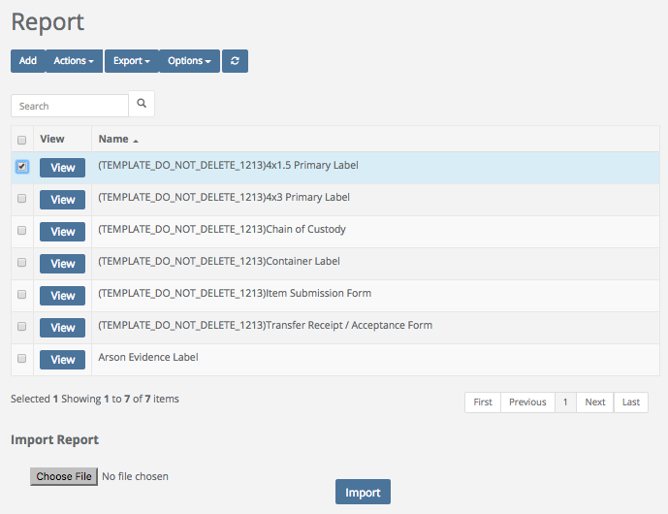

2. To View a previously built Label, click the View box next to the Label you would like to use. You may also choose this from the Actions box.

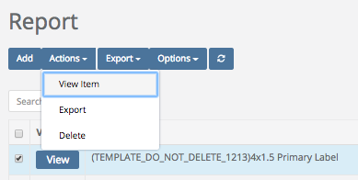

You will then be taken to the Report Header & Footer Tab on the Reports screen.

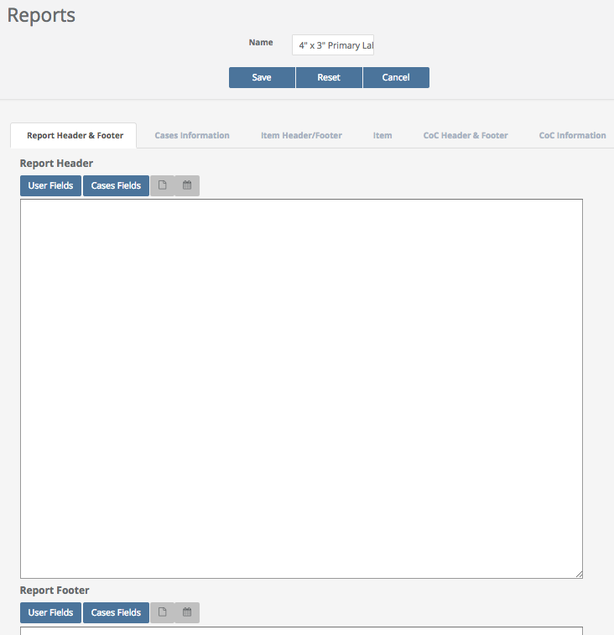
3. If you don’t wish to use one of the ready made labels, you can always create your own. To Add a Label, click the Add box. The Add Report screen will appear. Give your Label a Required Name. When you are finished, click Ok.

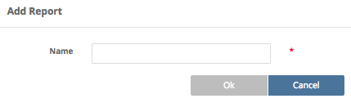

Once you click Ok, you will be taken to the Report Header & Footer Tab. Labels don’t typically have headers and footers, so for an Item Label, click the Item Tab and input your criteria using html code (a Container Label may have html code in both Cases Information and Item Tabs). On the off chance that you’re not fluent in html code, feel free to copy the code from another Label and change it to suit your needs. You can also choose to include items from the User, Item Fields, or Item Custom Fields boxes.

If creating a Custom Label is out of your ‘comfort zone’, let our Support Staff know. Depending on the time required to complete, and the complexity of your request, we will provide you with a quote to do the job for you.

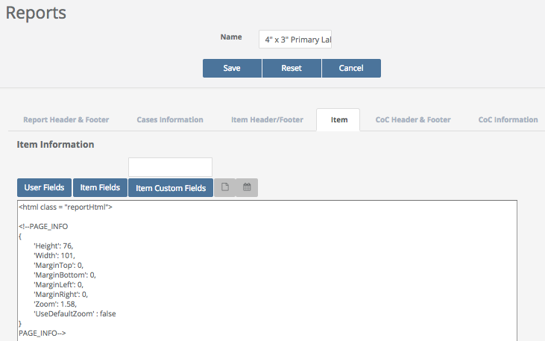

4. To Delete a Label, highlight the Label you are interested in. Click the Actions box and from the drop down menu, select Delete. Once you Delete a Label, it is gone permanently!

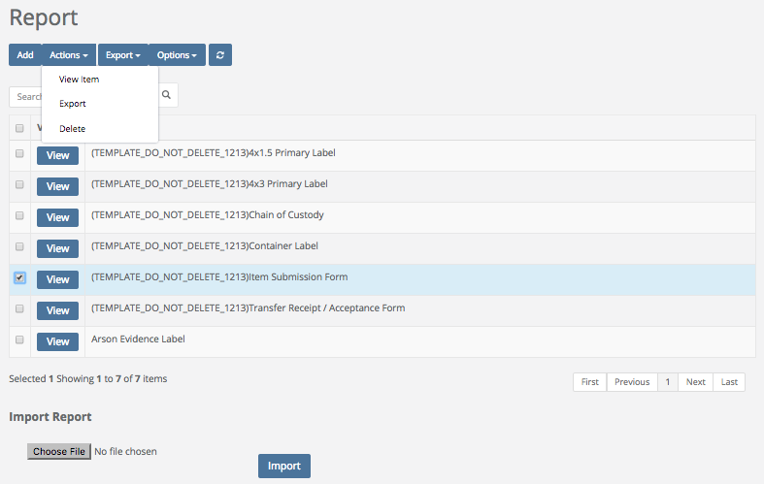

Discrepancy Reports
Quick Menu » Discrepancy Reports

1. From the Quick Menu on the left hand side of the screen, select the Discrepancy Reports Icon (it has an exclamation point inside a triangle). You are now on the Discrepancy Reports screen. From here, you can choose which Storage Location you’re interested in running a report on.

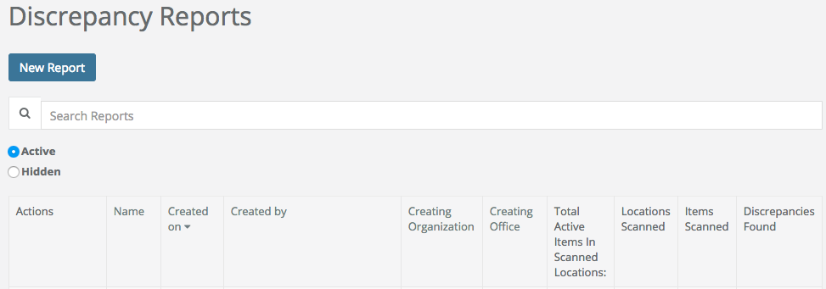

First click New Report and give your report a name and then scan or enter the barcode of the location you would like to audit.

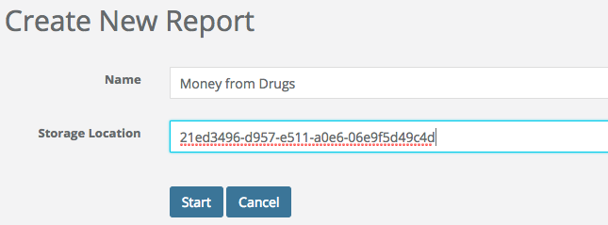

Next, click Start, or <Enter> and scan in barcodes from that particular Storage Location.
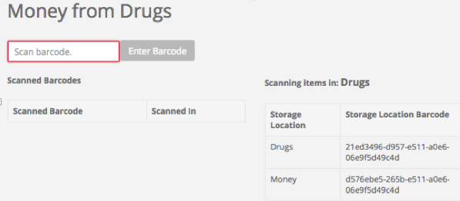
* Note where it says “Scanning Items in: __________ “. This is the current Storage Location where the Items are currently located. To change to a different (Nested) Storage Location, scan (or copy and paste) another Storage Location from the Storage Location Barcode (Nested List). In the above example, the only other Storage Location you may choose to scan is Money (since it is a Storage Location Nested under Drugs). Once the Storage Location has been changed, you may continue scanning Items, before finally running your report. *

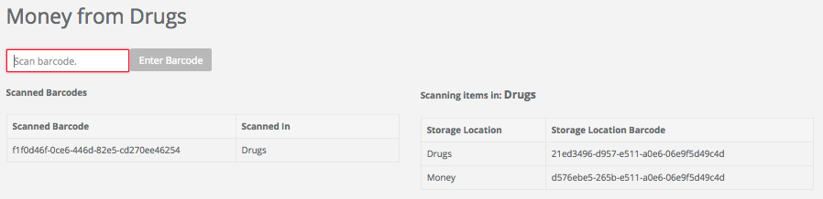

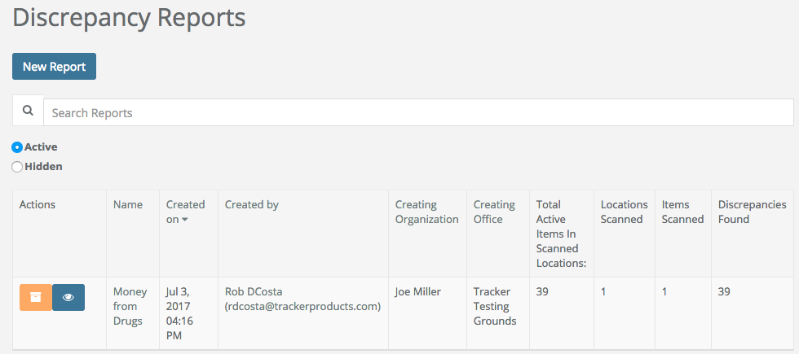

Once a report has been run, you will see a Discrepancy Report for the Storage Location(s) you specified. You may then view and print the report, go through the checklist, fix any discrepancies listed, sign and date it.

Creating a Manual Inventory Report from an Item Search
An alternate method for creating an Inventory Report is to create one manually by doing an Item Search.

1. From the Quick Menu screen, click Search then click Items.

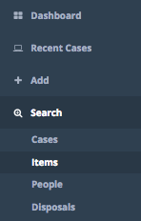

2. Next, enter your search parameters. For example, you may wish to specify a date range by choosing Created Date, or whether items have been Disposed of. Make sure to enter the Location(s) you would like to perform an Inventory on. When you are finished entering in your parameters, click Search.

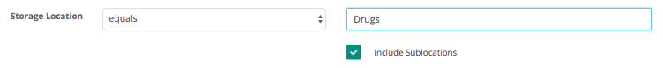

3. A list of Items has now been generated for that Location.

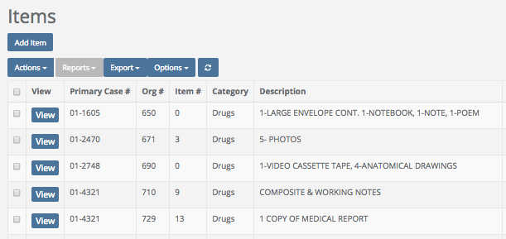
4. Finally, click the Export box and choose either All, or a Subset of Search Results. This will create a task to Export the results into a .csv (comma separated value) file, which can be downloaded and manipulated with Microsoft Excel or Word, for example.

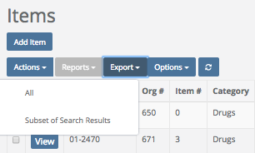

If you chose to export a Subset of Search Results, you may then select either a (random) Percentage or a (random) Number of Items you would like to export.

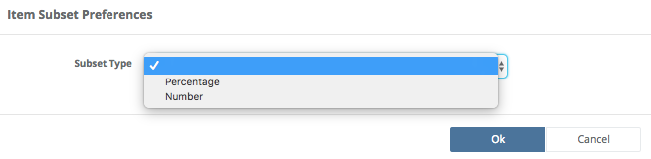

5. To Download your file, wait until it states “Download” in the Download Link column (you may have to refresh your screen). Once you click the “Download” link, it may bring up a dialog on where to store the file on your computer (if you’re using a Mac, it will send the file to your Downloads folder).
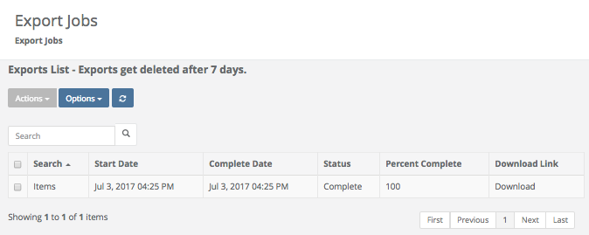

You can now open the file in Excel, create a column of checkboxes for “Present”, print the spreadsheet and Audit or do your Inventory for the Location.
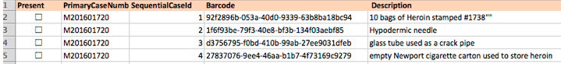

Note: In the “Present” column (in Microsoft Excel), you can select the first cell and insert a symbol for the checkbox. Then copy that down the sheet if you’d like have an area to place a checkmark beside Items as you go through your list.

Logging Out of the software (Shared Archive For Evidence)
To Logout of the software, simply click the Logout field located in the lower left hand corner of the screen. If a User does not Logout of the system, they will remain logged in until they are automatically logged out (by default) 30 minutes after their last activity. They will be given a 2 minute warning before they’re logged out.

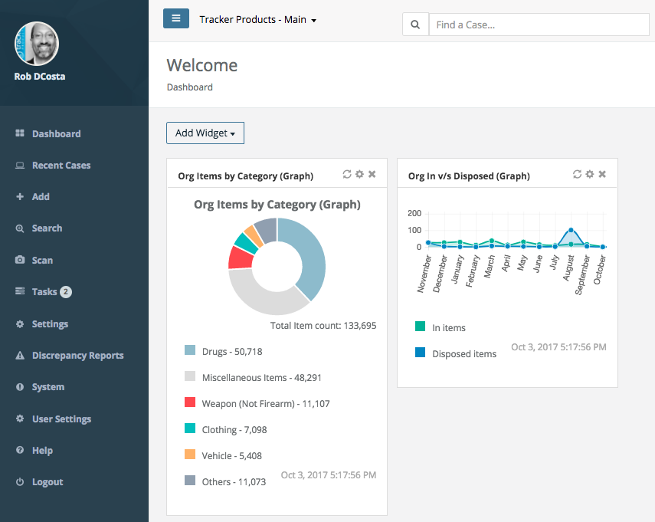

To change the default Automatic Logoff Settings, go to the Quick Menu then go to the Settings\Organizations menu.

Each User logged into the system is utilizing 1 Concurrent Access License (CAL) until they Logout. Make sure Users are logging out of the system once they’re finished using it, or additional Users won’t be able to log into the system if a CAL Limit is reached. Users will then see a message stating that the Maximum Number of Concurrent Access Licenses has been reached.

